When you first log in to Agile and start your shift for the day, each user will need to Cash In to their User Batch. The User Batch allows you to track your sales for the day.
- Log in to Agile Ticketing Solutions with your username and password. If you haven't received your user credentials, please contact your system administrator to set up your username and password.
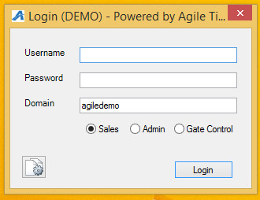
- Click on “Point of Sale” in the top, left corner.
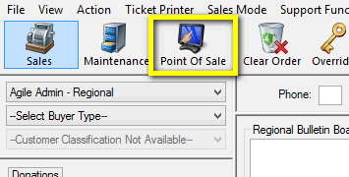
- Once in POS, you will see an “Action,” gears icon at the top of the screen. Click on the gears icon and then click on “Cash In/Out” at the bottom of the drop down menu.
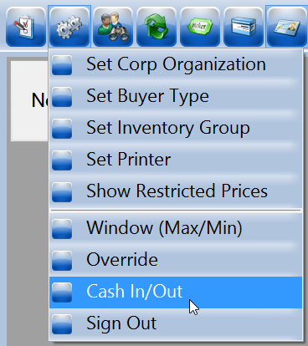
- The "Agent Cash In/Cash Out" pop up screen will appear.
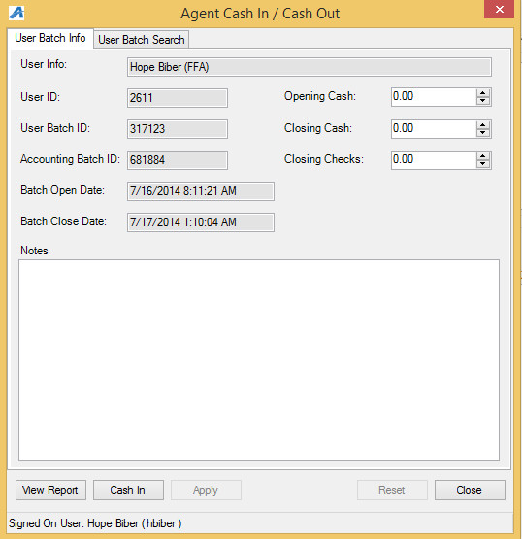
- Click on the “Cash In” button at the bottom of the screen to start your batch for the day.
- Count your beginning cash bank and enter it in the Opening Cash field at the top of the screen.
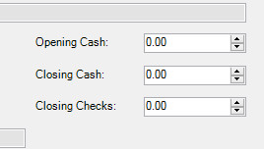
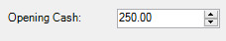
NOTE: Entering in your cash bank will allow you to not only track your cash sales, but also allow you to balance your drawer at the end of your shift.
- Once you have entered your Opening Cash, click on Apply at the bottom of the screen.
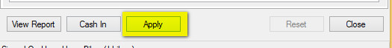
- Add any special notes in the Notes field (i.e Manager for the day, time you started your shift, any important information that has to do with you opening your batch).
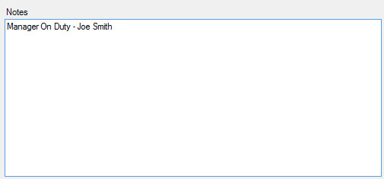

- Once you have entered in your Notes field, click on "Apply" at the bottom of the screen to save your information.
- Once you have completed your opening procedures for your user batch, click on the "Close" button to close the screen to start processing orders.

