MENU ITEMS
Settings
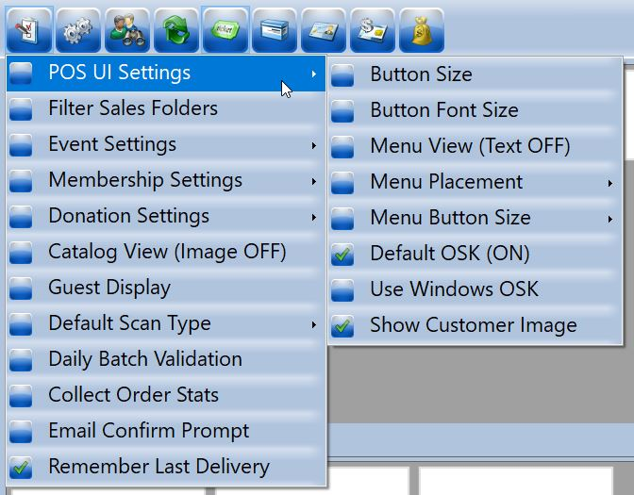
- Filter Sales Folder: allows you to select and deselect folders to choose what items you want to see in the POS interface.
- Button Size: choose the size of the buttons on the screen. The default is “210 x 100.” Buttons with “+5” or “-5” are available for manual customization.
- Button Font Size: choose the size of the font on the buttons. The default is “Regular/Bold Regular.” Buttons with “+0.2” and “-0.2” are available for manual customization.
- Menu View (Text ON/OFF): displays the titles of the menu buttons if on.
- Menu Placement: changes where the menu is located. The default is “Top.”
- Menu Button Size: changes the size of the menu buttons. The default is “48 x 48”.
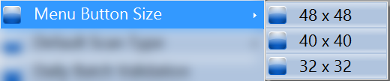
- Default OSK (ON/OFF): displays the On-Screen Keyboard when checked.
- Use Windows OSK: uses Windows On-Screen Keyboard when checked.
- Show Customer Image: displays customer account images in bottom right corner of POS screen when checked.
- Event Settings:
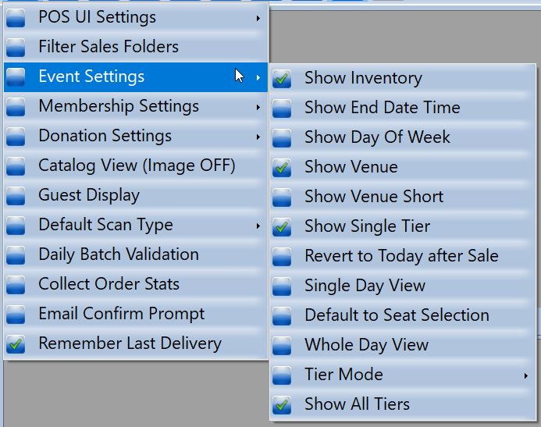
-Show Inventory: displays the inventory remaining for the event.
-Show End Date Time: displays the end time of the event.
-Show Day Of Week: displays the day of week the event occurs on.
-Show Venue: displays the venue of the event.
-Show Venue Short: displays the short name of the venue.
-Show Single Tier: displays a single tier, if you have multiple tier inventories and pricing.
-Default to Seat Selection: automatically pulls up seat selection map for reserved seating events.
-Single Day View: allows you to see events that are currently on-sale for today's date. As events pass, the screen will refresh and the past event will drop from the screen.
-Whole Day View: displays all the events that occur within a day, even after that event has gone off sale.
-Tier Mode: allows you to display tiers and pricing if you have multiple tiers. These views can add or decrease button click through.
-Tier And Price: shows the tier and price with one click.
-Tier Only: shows the tier that you will choose and then shows the price under that tier.
-Event Then Tier: shows the event, the Tier, and then the price under the tier (multiple clicks to get to the price).
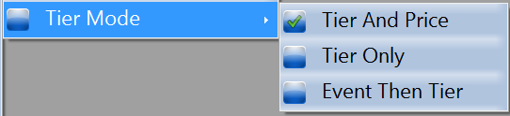
-Show All Tiers: shows all tiers built under an event instead of one tier at a time.

- Membership Settings:
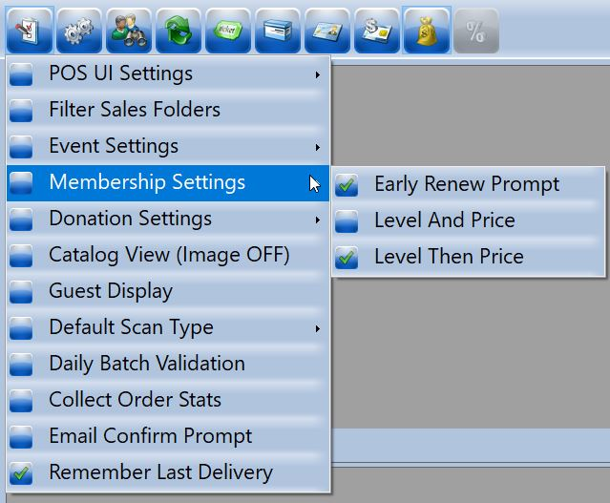
- Early Renewal Prompt: When this is set up, it will notify the cashier that a membership is due to expire at a predetermined number of days. (i.e. "Membership is due to expire 30 days from today"). This allows the cashier to remind the member that they are about to expire and ask if they would like to renew so there isn't an interruption of their benefits when they renew at that point.
- Level And Price: displays the memberships all together with the pricing.
- Level Then Price: displays the memberships grouped by level, then price.

Donation Settings:
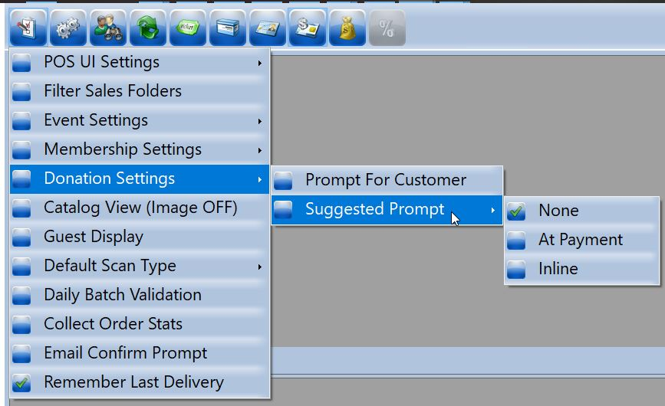
- Prompt For Customer: If you have a donation set up in the system, this prompt will collect customer information. This is recommended for DonorPerfect clients.
- Suggested Prompt:
None: The POS will not automatically prompt for donations, when checked.
At Payment: A donation prompt will pop up whenever payment is applied to an order, when checked.
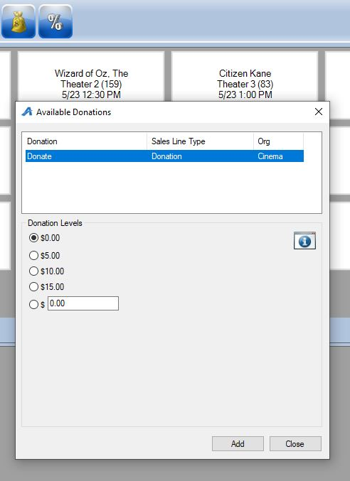
Inline: When items are added to the order, a blinking green "Ask For Donation" button will appear at the top of the order summary, which, when clicked, will open a pop-up window where the sales agent can select a donation level.
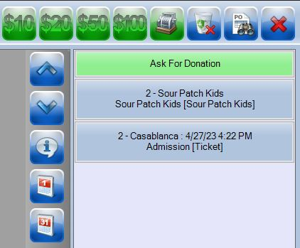

- Catalog View (Image ON/OFF): displays images of catalog items when checked. Great for showing concessions items images on the pricing buttons.

- Guest Display: If you have a POS that has a Display panel on the back of the terminal, you can set up display messages that will appear for the customer to see (i.e. "Thank you for supporting us!", "Welcome to the Theater", etc.).

- Default Scan Type: indicates to the system what type of barcode is scanned.
Ticket: Set to Scan Tickets Only.
Membership: Set to scan Membership cards only.
Catalog: Set to scan Catalog items only.
Order Search: allows you to search for Orders when scanning either a confirmation QR Code or a Barcode of a ticket.
Order Print: allows you to scan a confirmation QR Code and print that order.
Validate: Allows you to scan a ticket and validate that it is a valid ticket.
Prompt: Allows you to scan any barcode or QR code then gives you a pop up menu to choose what function you would like the system to do. *Most used as it gives all options listed above.
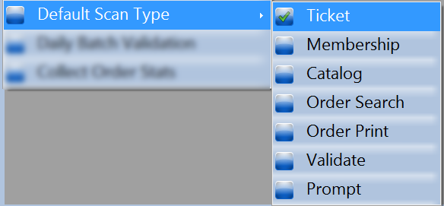
- Daily Batch Validation: allows the ticket to be validated as soon as it is printed. No need to scan.
- Collect Order Stats: allows the cashier to collect an email, phone number or zip code without having to capture customer information. Used for marketing statistics.
- Email Confirm Prompt: activates an automatic prompt to enter a customer email address and send them an order confirmation whenever an order finalizes.
- Remember Last Delivery: instructs Agile to remember the Delivery Method last used for an order and apply it on future orders.
Action
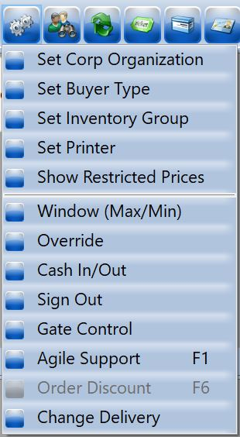
- Set Corp Organization: Select the organization you wish to sell from.
- Set Buyer Type: Select the correct buyer type.
- Set Inventory Group: Select the inventory group you wish to sell from.
- Set Printer: select the printer.
- Show Restricted Prices: Check this box if restricted prices should always be available.
- Window (Max/Min): maximizes or minimizes the POS window.
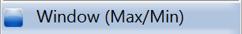
- Override: available for a manager to override and allow a sale. The manager enters in their login information and can select either “Single Order” (meaning the override will only be good for one order) or “Until Cleared” (meaning the override will be good until it is cleared).
- Cash In/Out: This is where you cash in and out. See Cashing In to use POS and create a Daily User Batch for more details.
- Sign Out: signs out of Agile and returns to the login screen.
- Gate Control: Opens the Gate Control panel and allows you to scan tickets, memberships, and Passes for entry.
- Agile Support: opens up Agile Help Desk in your browser.
- Order Discount: When at least one item is on the order, allows you to open the "Order Discount" window to take a percentage off the total amount of the order.
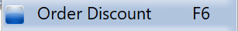
- Change Delivery: If multiple delivery options are available for an item on the order, allows you to select which delivery method is used on the order.
Search
Use this to search for an existing customer or member. See the POS section of this article for more details.
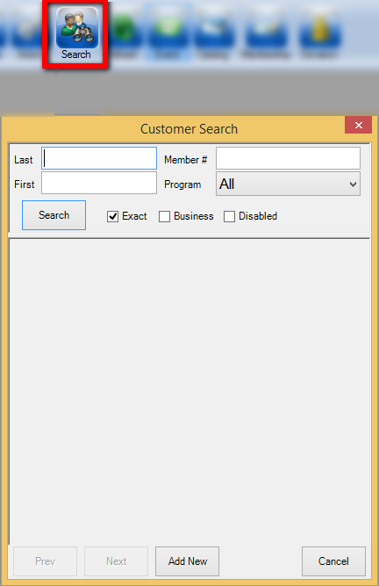
Refresh
Refreshes Agile. Use this, if changes have been made, to see the most updated information.
Event
Displays events available for purchase.
Catalog
Displays catalog items available for purchase.
Membership
Display memberships available for purchase.
Gift Card
Displays gift cards available for purchase.
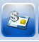
Donation
Displays available donations.
Discount
At the top of the POS Screen, this button allows you to apply a discount to an order. At the bottom right of the screen, this button allows you to discount the next price you click.
Information
You can click this icon and then on the event that you would like more information about. A pop-up will appear with information about the show or event.
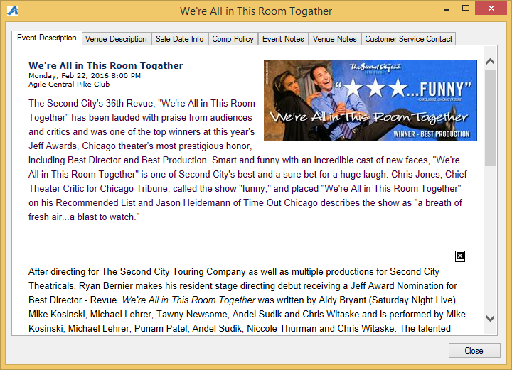

Daily View
Shows that day's events.
Daily View (by month)
This allows you to choose a future date to look at events on that day. Allows you to sell advanced tickets for a future event.
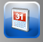
Page Up/Down
Use these buttons to scroll up and down.
Exact Change
Payment button to process orders with exact change or zero priced tickets.
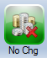
Cash Amount
Allows you to select a cash dollar amount that the customer gives you and then the system will show you the change amount that the customer is due.
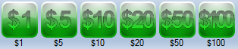
Enter Payment
Allows you to manually enter a payment amount and type. Can also be used if the customer is paying with multiple forms of payment (i.e. Partial payment on Visa and the remainder on a Gift Card).
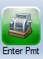
Clear Order
This icon will clear out the entire order.
Order Search
This icon opens up the order search screen in POS.

Enter Desired Quantity
Allows you to enter a large quantity of tickets without having to click the button multiple times. Click the icon then click the ticket price. A pop-up window will appear that will allow you to enter the number of tickets that needs to be added to the cart.

Inventory Summary
Gives you a quick view of what inventory is available for a specific event or events.
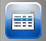
Manual Assign
If you have an event that has assigned seating, clicking this icon will bring you to the seat map. From here you may select the seat that the customer wants.

Order Summary
As you add items to your order, they will appear on the side of the screen in the Order Summary.

Payment Summary
This is where you can view the breakdown of the payment information. As you add or delete tickets from an order, you can view the changes in the payment. After you have processed the order and the payment has gone through, the box will turn orange.
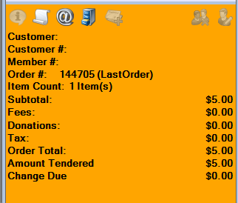

This Icon allows you to print the last order receipt.
Before you process the order, you are able to edit the customer that you have attached to the order by clicking on this icon. This will bring up the customer editing page.
Before you process the order, you are able to remove the customer from the order by clicking on this icon.
This icon turns on maintenance mode for the last order sold.
This icon prints the order receipt for the last order sold.
This icon allows you to send or re-send an order confirmation of the last order sold.
This icon allows you to add a credit card tip to an order as it is placed. If the customer decides to leave a gratuity, click this icon to open a Tip Adjust window where you can type in the tip amount. Tip processing like this is not available on all merchant types. Check with your Agile Ticketing Support Representative if you are interested.

