Tracking Spoilage
Concession and product spoilage can be tracked in Agile Ticketing.
In Administration open your concessions or products Folder where you created your Catalog Items
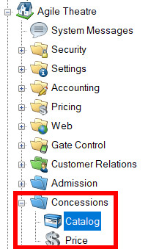
While you are building your Concessions items in the SKU section under Inventory you can Set your Par Quantity and your Reorder Quantity. The Par Quantity is the minimum amount of inventory you wish to have in your concessions booth at any given time. The Reorder quantity is the number of inventory you plan to reorder every time you reach or are close to the Par Quantity.
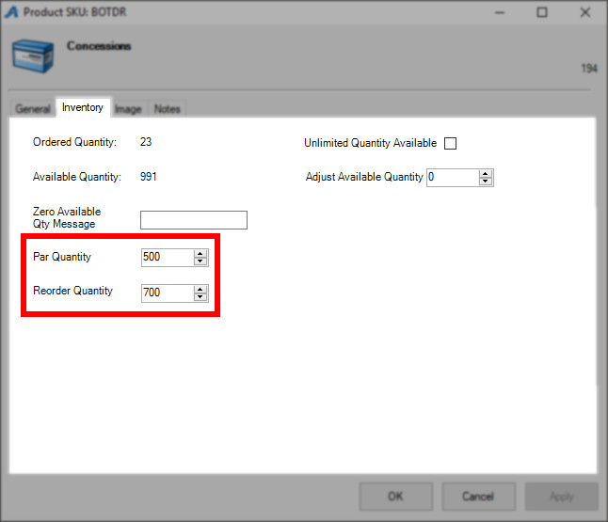
Once you build your concessions item and you add the SKU with the Reorder and Par Quantities you need to build your Spoilage price. The Spoilage price should be set to $0 and is a placeholder for reporting purposes.
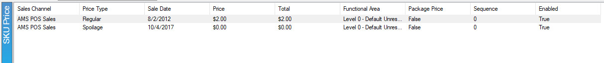
You should now find that there is a Spoilage Price under that concessions item on the POS screen. Click on the spoilage price and process the order when it is needed.
This will then provide a tracking mechanism through reports to determine the amount of spoilage for each item. Also, the inventory of the item will be decreased to make sure that reordering can occur at the proper time.
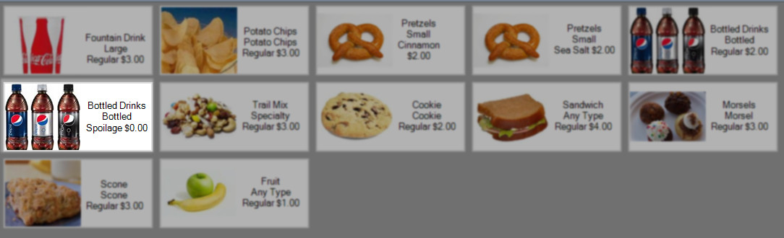
You will be able to see the spoilage in the Catalog reports such as the Catalog/Event Sales Analysis Extract and Product/SKU Inventory Audit Extract.

