Creating Order Questions

How to Create Order Questions:
1. Log in to Administration.
2. Select the Corporate Organization icon .
3. Click on the Questions icon.
Note: Questions can also be built under specific Sales Organization Folder(s) by adding this option to the tree management of that folder.
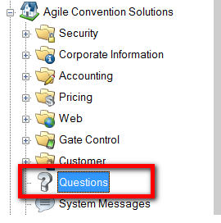
4. Right click and select New Order Question.
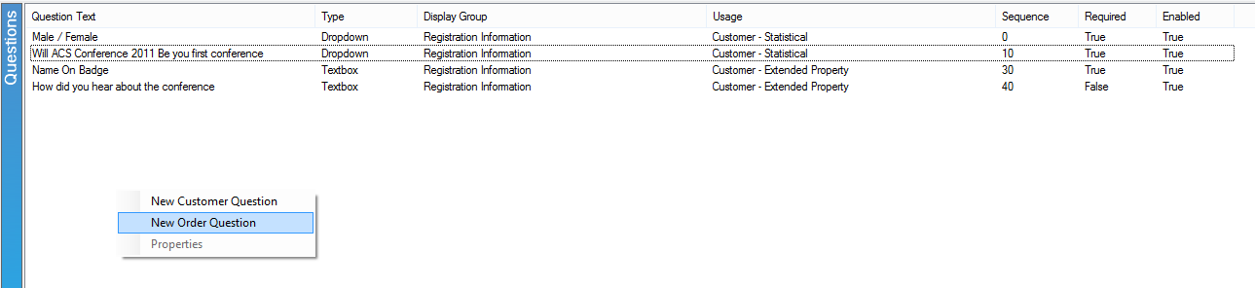
5. Under the General tab:
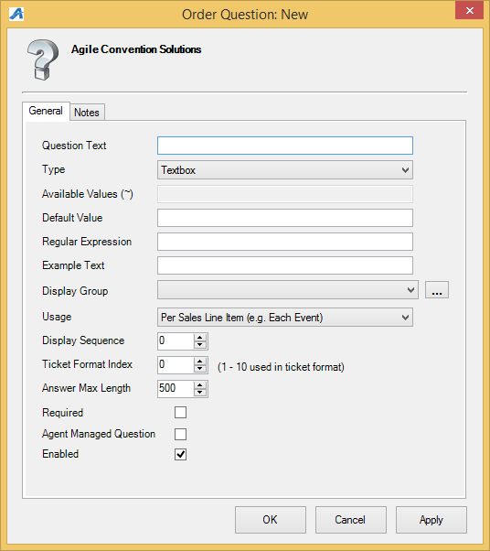
A) Question Text: This is the Question that will appear online.
B) Type: These are the options for how the customer will answer the question.
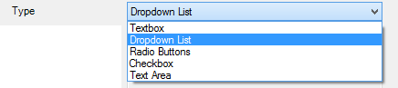
C) Available Values (~): enter in the select-able answers to the question. Separate each answer with a Tildie ~.
D) Default Value: this answer will be automatically selected. If left blank, no answer will be automatically selected.
E) Regular Expression: Defines how the data should be entered and defined.
F) Example Text: If the answer requires a Regular Expression Format, give an example here (i.e. enter birthday as 01/05/1980).
G) Display Group: select the appropriate item from the drop-down, or add a new one by clicking on the ellipses. Note: You can Create a new group by clicking on the 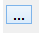 icon.
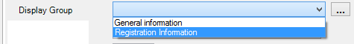
H) Usage: "Per Sales Line Item (i.e. Each Event)" should be selected if the answer is only required per event. "Per Each Quantity (i.e. Each Ticket)" should be selected if the answer is required for each ticket.
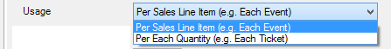
I) Display Sequence: use this to order the questions. This also controls the order online.
J) Ticket Format Index: Allows you to assign the answer to the question as text on the ticket format.
K) Answer Max Length: enter in the max answer length in characters.
L) Required: Check this if the question must be answered by the customer before finalizing the order.
M) Agent Managed Question: select this if the question should only be asked by ticket agents.
N) Enabled: check if this should enabled.
6) Notes: use this space for internal notes, these will not be seen by the customer.

