Adding Delivery Fees
1) Log in to Administration.
2) Click on the Corporate Organization icon.
3) Open the Pricing folder and click on the Delivery Fees icon.
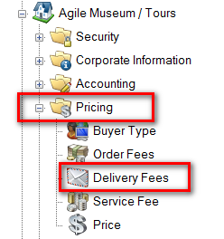
4) Right click and select New Delivery Price.
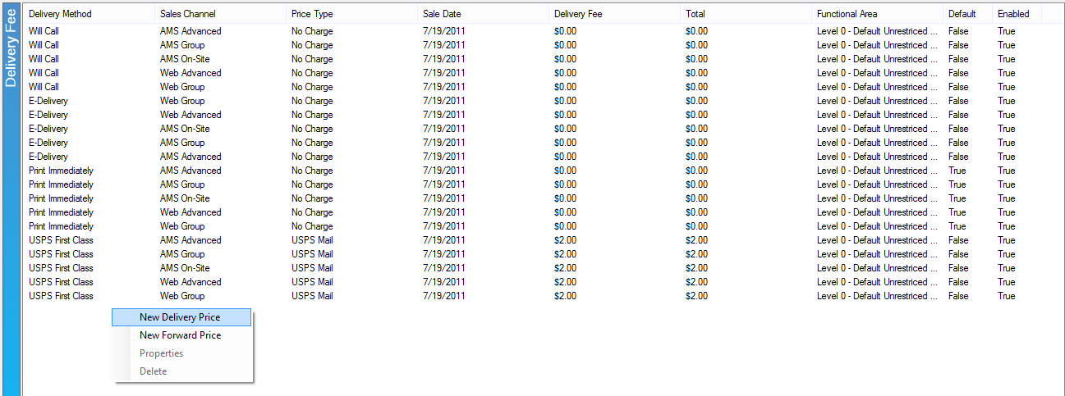
5) In the General Tab: right-click in the white box and add a new price.
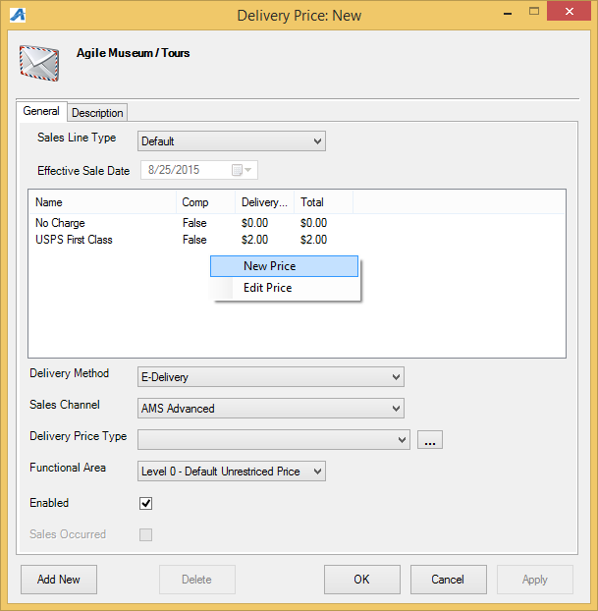
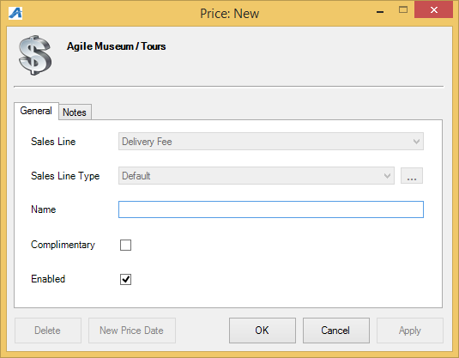
- Sales Line Type: select the appropriate option from the drop-down.
- Delivery Method: select the appropriate option from the drop-down. (ex. you may charge $2 for mail but $0 for will call pick-up.) See the article: Creating a New Price
- Sales Channel: select which sales channels this delivery method should be available for.
- Delivery Price Type: select the appropriate type from the drop-down. There may be a need for multiple delivery fees for with the same name. The Delivery Price Type helps to specify which may be complimentary or charged.
- Functional Area: gives the ability to limit the availability of some delivery fees.
- Enabled: make sure this is checked if the fee should be available.
6) Description tab: add a description of the delivery fee here. This will be available for customers to see online if they click on the delivery fee
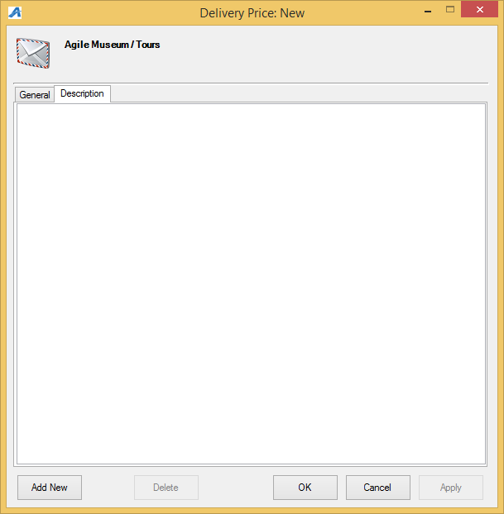
7) To apply the delivery fee, on the Showing Level or Event, go to the Delivery tab. Check the appropriate delivery methods, and add the start date (the number of days prior to the showing the delivery method is available) and the cutoff date (the number of days prior to the showing the delivery method becomes unavailable).

