Creating A Price
Template/Event/Showing
1. Log in to Administration
2. Click on the Corporate Organization icon
3. Find the template, event, or showing where the new price belongs.
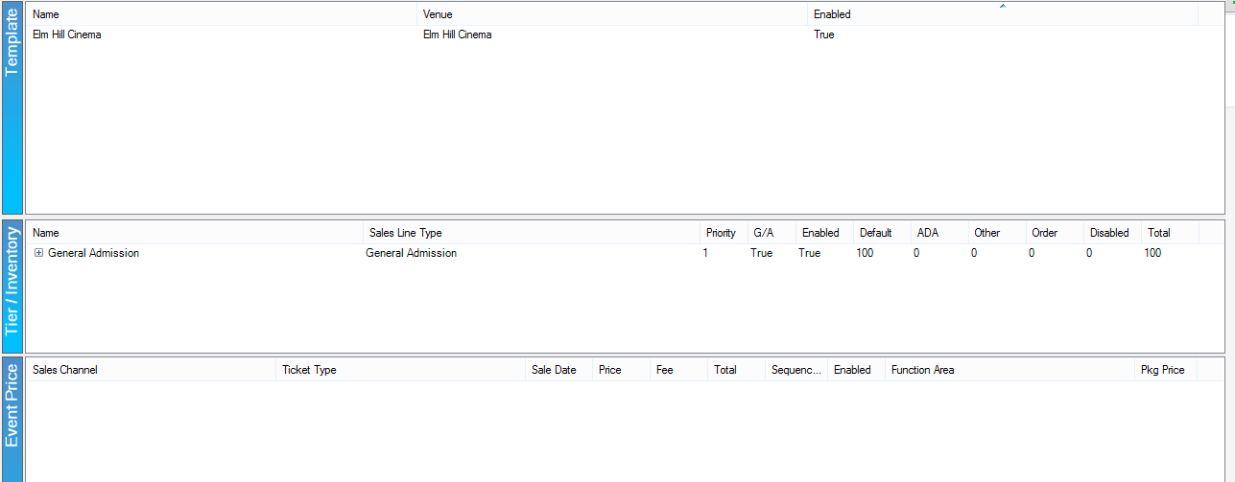
4. Highlight the Template or the Showing (if already built) then the Tier/Inventory. In the Event Price section right-click and select New.
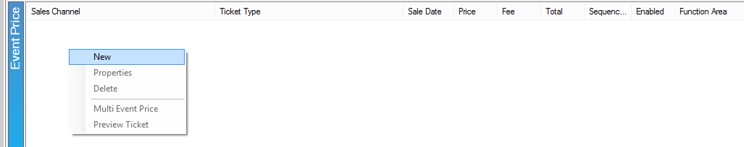
5. Event Price: New: right-click in the Price box and select New Price.
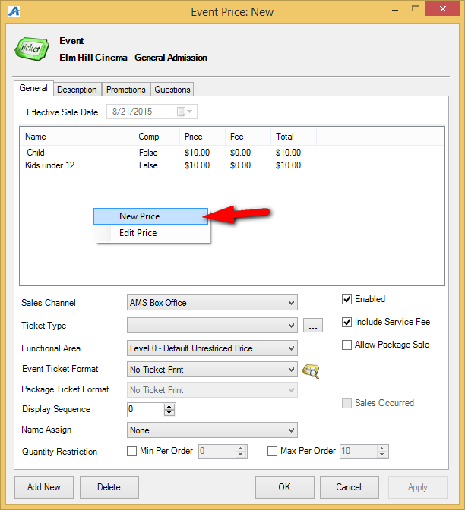
6. The Price: New window will appear.
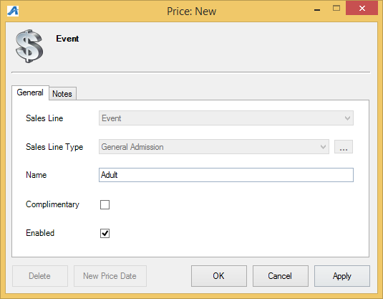
A. Choose the applicable Sales Line and Sales Line Type.
B. Enter in the name. This will not be seen by the customer but should be easily identifiable for accounting purposes. We recommend being very detailed in the price name (i.e. ABC Venue Adult, Subscription Adult, Gold Member Price, etc.).
C. If it is a complimentary price, check the box next to Complimentary.
D. The Notes tab is for internal use only and will not be seen by the customer.
7. Click Apply then OK.
8. In the Price Distribution: New window right click and select New.
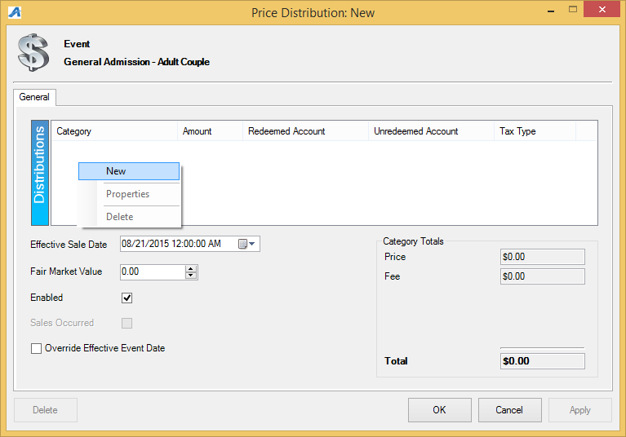

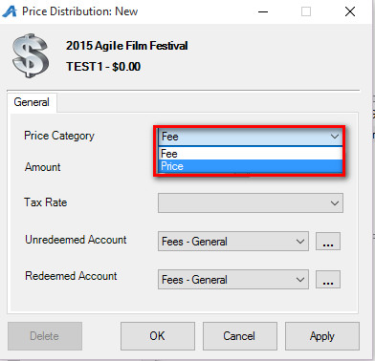
-Price Category: choose Price.
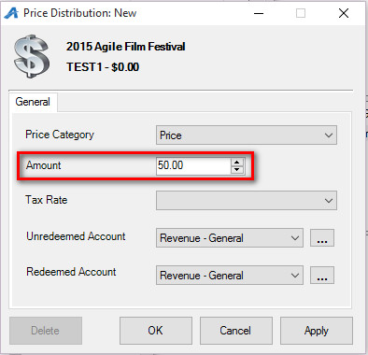
-Amount: enter in the amount of the item being sold.
-Tax Rate: select the correct tax rate, if applicable.
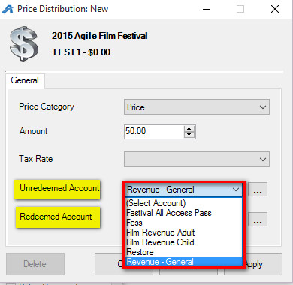
-Unredeemed/Redeemed Account: choose the appropriate account from the drop-down.
-Select Apply then OK.
*If the price also includes a fee, repeat the above steps but choose Fee in the Price Category.
-Effective Sale Date: choose the date the price should be effective. This can be set in the future and Agile will automatically change the price at the set time.
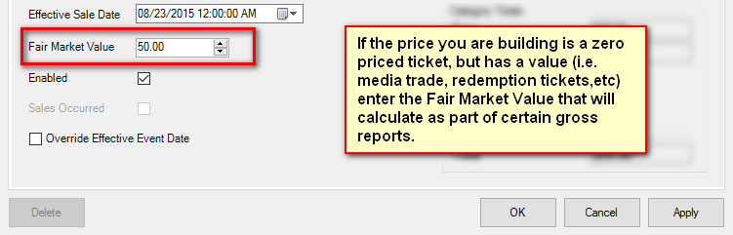
-Fair Market Value: enter in the value of the item being sold. Fair Market Value shows up on certain Gross Revenue Reports.
10. Click Apply then OK once all the pricing information has been created.
11. In the Event Price: New window select the price that you just created from the list of prices, and fill out the information below.
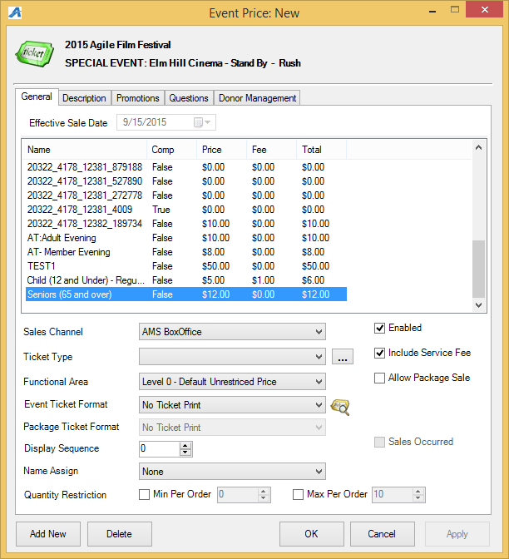
- Sales Channel: the Channel through which you sell the ticket such as Web sales, Box office sales etc.
- Ticket Type: This is the name of the ticket that will appear to the customers both online and on their tickets.
- Functional Area: determines who has the ability to sell/buy these tickets (i.e. Level 0 -Default Unrestricted Prices are available for everyone to purchase, but Level 1- Restricted Price(s) are generally hidden from view unless a permission or benefit is set for purchase)
- Event Ticket Format: are preset formats that pulls select information that prints on the ticket
- Package Ticket Format: If this price is bundled in a Package, you can choose a specific ticket format to print.
- Display Sequence: allows you to determine in what order the list of prices appears on the Box Office screen as well as online.
- Name Assign: Allows you to capture names for each ticket (not required).
- Quantity Restriction: Allows restricting the number of tickets that can be sold at this price per order (i.e. Minimum of 2 Maximum of 8 ticket per order).
- Enabled: allows you to use the price.
- Include Service Fee: This allows you to include any service fee that you have set up. See Creating a Service Fee for more information.
- Allow Package Sale: Must be checked if you are bundling events together for a package.

Price Icon
1. Log in to Administration.
2. Click on the Corporate Organization icon.
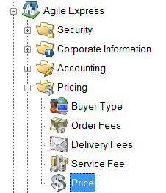
3. If you are building a price that can be applied to all levels or events (i.e. complimentary), it can be built under the Pricing folder. But if the price will be specific to the events (i.e. 2015 film festival pricing), then click on the folder and use the Price icon within.
4. Right-click in the Price tier and select New.
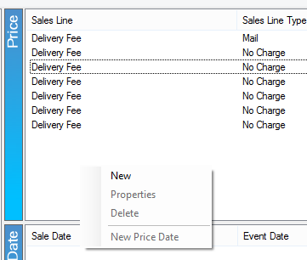
5. Follow steps 6-11 as described above.
*Note: prices cannot be deleted if they have been used. If a price needs to be changed, a new Price Date will need to be created. To do this, follow steps 8-10.
6. The breakdown of the new price now appears in the Price Distribution tier.

Simple Price Mode
Simple Price Mode allows you to create a new price quickly each time it is needed.
How to Set up Simple Price Mode:
1. Right click on the Sales Organization folder and select the Tree Managementtab. Check Simple Price Mode in the Other Options. Click Apply and OK to save and close the window.
2. Click on the Corporate Organization
3. Find the template, event, or showing where the new price belongs.
4. Walk down the item to the Event Price tier. Right-click and select New.
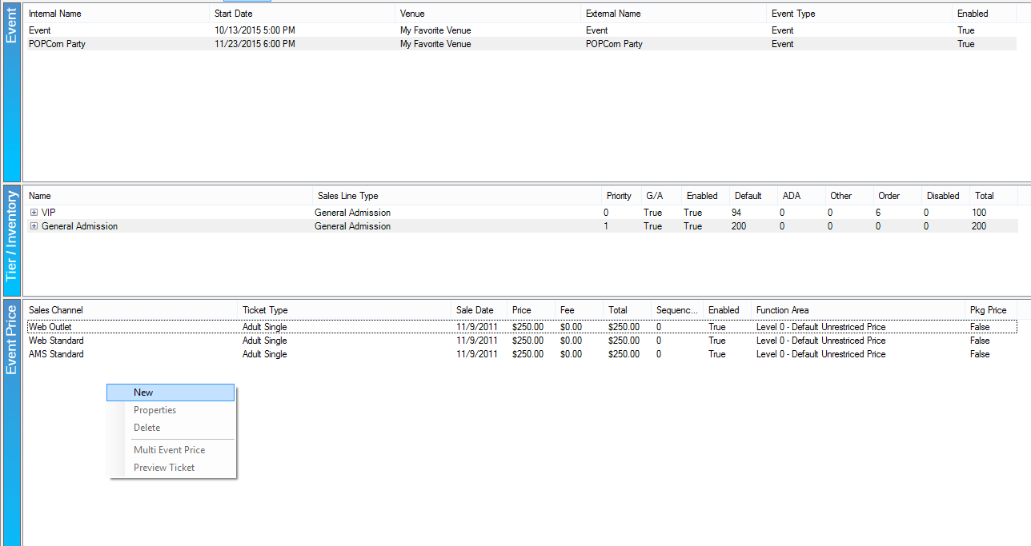
3) In the Event Price: New window, add the Price (and Fee, if applicable).
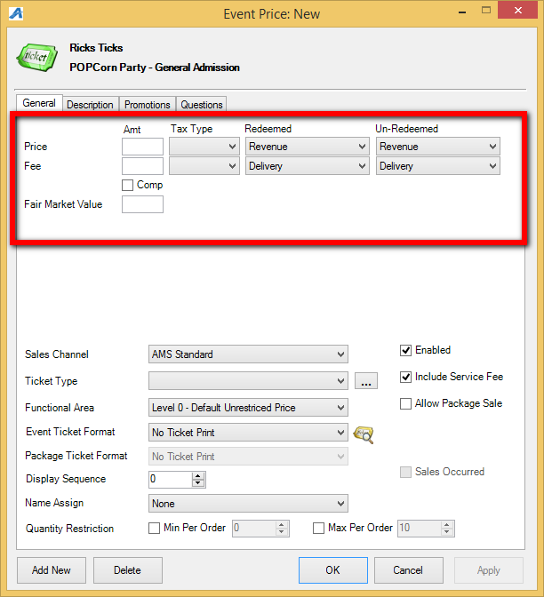
6.Choose the correct Tax Type, if applicable, and the Redeemed/Unredeemed accounts.
7. If it is a complimentary ticket, check the box next to Comp. Finish building the price as normal.

