Creating an Order Fee
1. Log in to Administration
2. Click on the Corporate Organization icon, and select the Pricing folder.
3. Click on the Order Fee icon
4. Right click in Order Fee and select New.
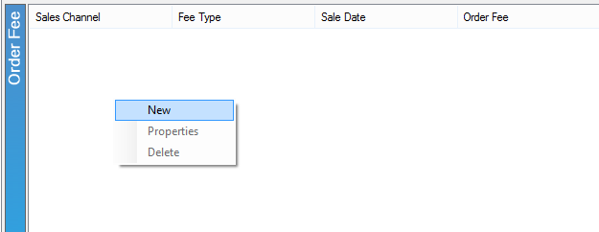
5. In the pop up screen right click in the white box and select New Price.
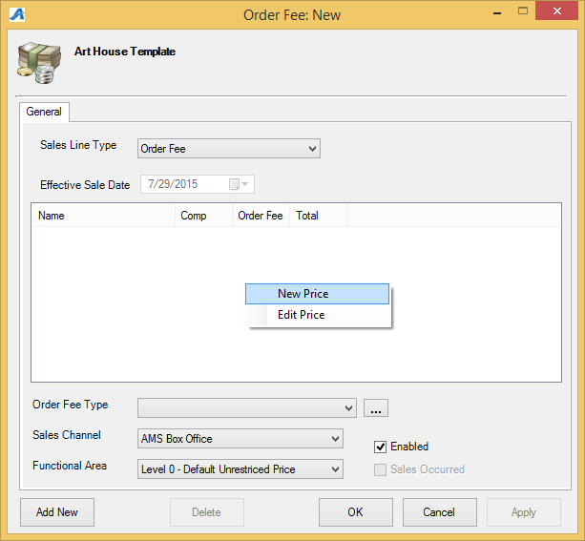
6. Create a new price. For instructions, see Creating a Price.

