How To Retire A Corporate Or Sales Organization

Retire an Organization

1.Log into Administration.

2. Right Click on the Corporate or Sales Organization that you wish to retire, and select properties.

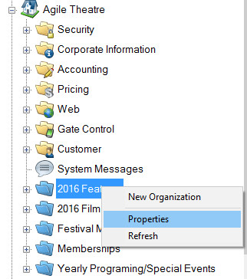

3. Check the box at the bottom next to retire.

[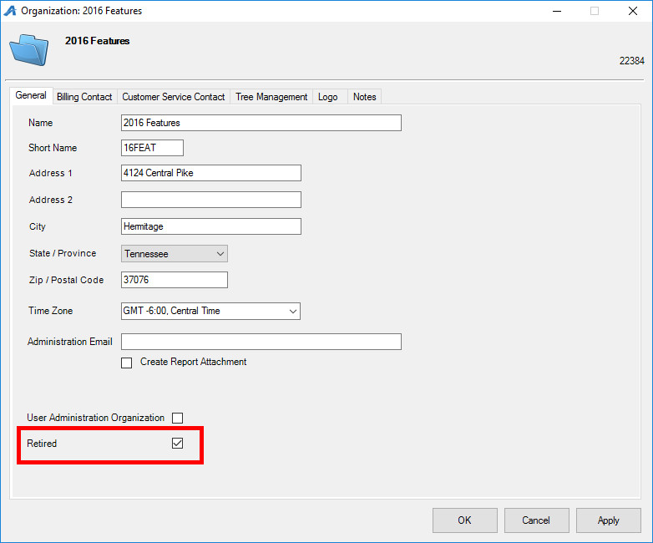](https://support.agiletix.com/hc/en-us/article_attachments/208415046/Image_2_retired_org.jpg)

4. Click apply and ok

To see the Organization again

1. In administration click on View.

[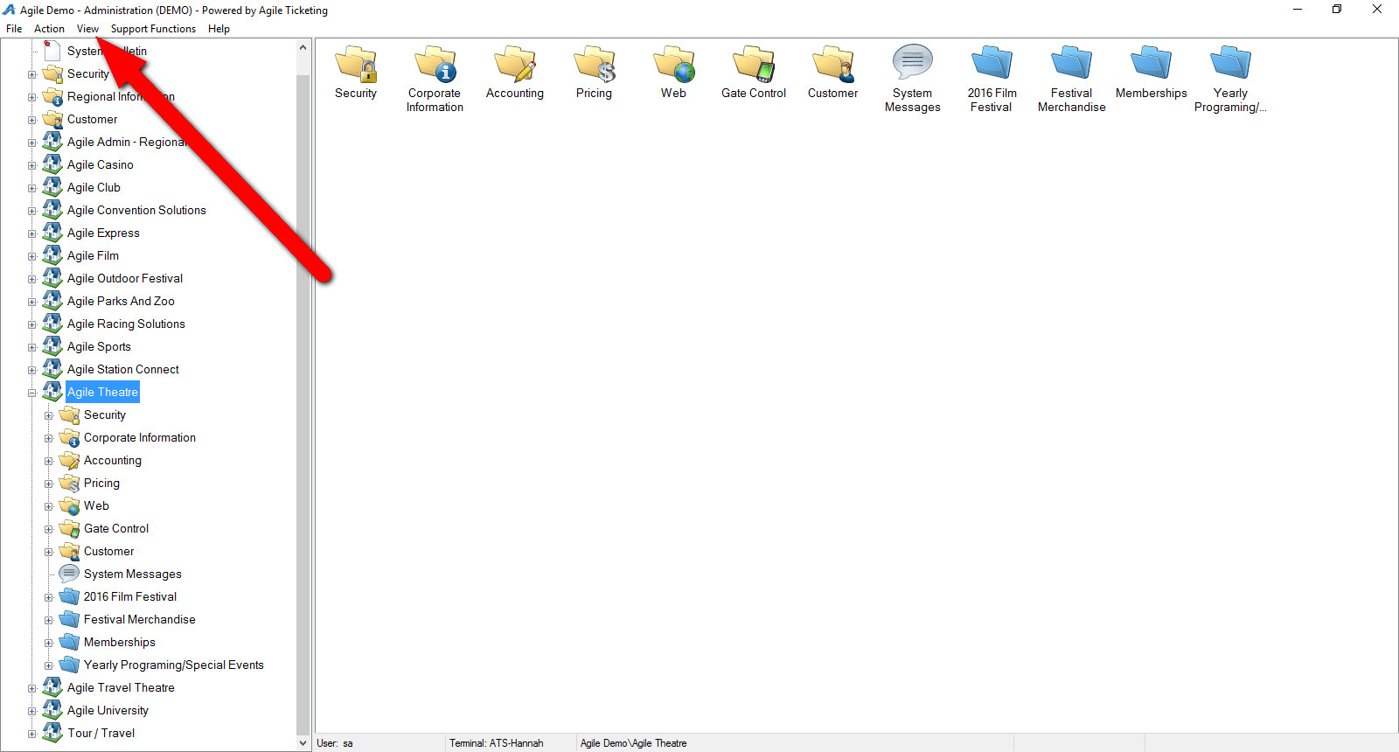](https://support.agiletix.com/hc/en-us/article_attachments/208415106/Image_4_View.jpg)

2. Select Retired Orgs

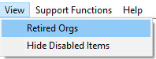

3. All retired Organizations should be shown now with a yellow triangle.

