Assigning A Pass Printer In Agile
1. Download the print driver for your inkjet or laser printer to your computer.
2. Once you have the driver downloaded, log in to the Administration in the Agile Ticketing Software.
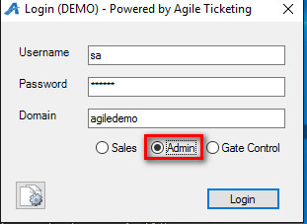
3. Click on the Regional Information folder.
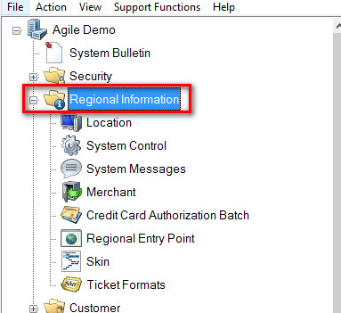
4. Click on Location.
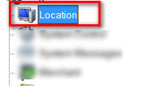
5. Select the Location Group that your terminal is assigned to.
6. Right click and select Properties on the Terminal that the printer will be assigned to.
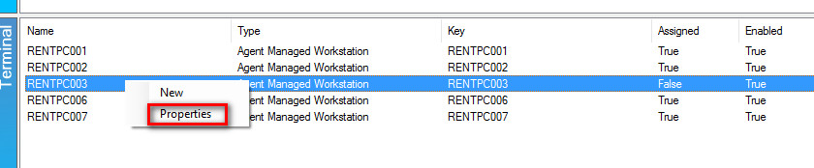
7. In the Terminal window, click on Ticket Printers tab.
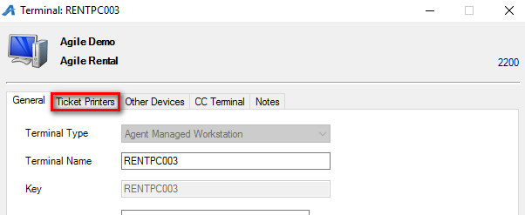
8. In the printer field, right click and select New.
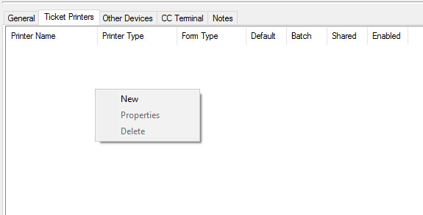
9. In the Printer Type drop down, select Ink Jet Printer.
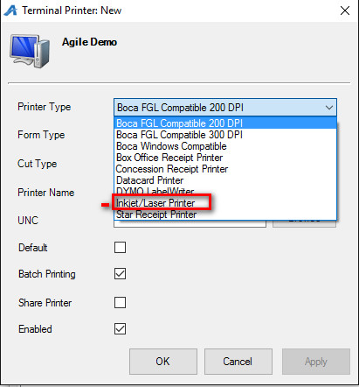
10. In the Form Type, select Tickets.
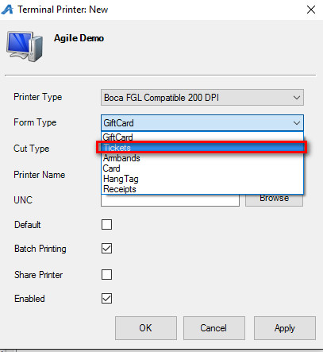
11. Enter the what the name of the printer should be in the Printer Name field.
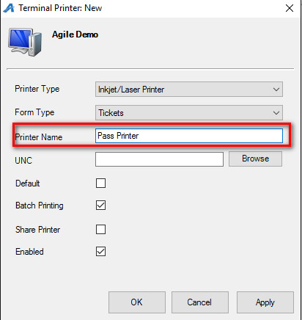
12. Click the Browse button to see the Browse Local Printers.
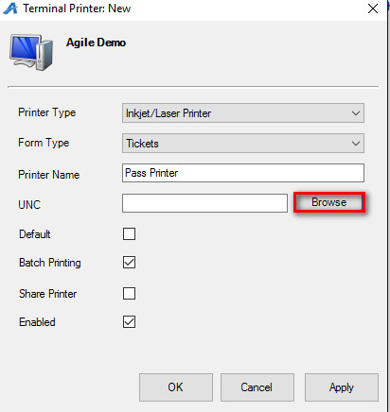
13. In the Local Printers drop down, select the printer that you will be using to print your passes.
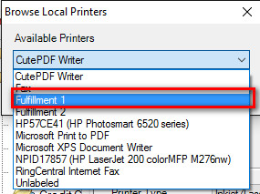

14. Check Default Printer, click Apply and then OK.
