Setting Up Your ComScore Swift Automation
Agile Ticketing Solutions now has the ability to send automatic nightly reports to ComScore Swift. In order to take advantage of this functionality, there are a few setup steps that need to happen before this information can be pushed to Swift.
Adding your ComScore/Rentrak Theatre ID
1. Log in to Administration
2. Click on the Organization House icon
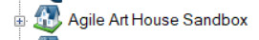
3. Open the Settings folder
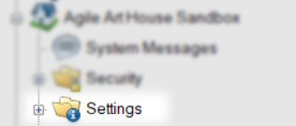
4. Select the Venue icon
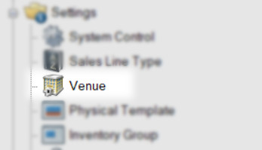
5. Right click on a Venue and select Properties
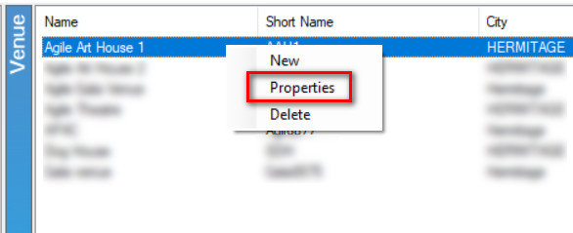
6. On the bottom of the Venue Information window, enter the comScore Theatre IDand the comScore Theatre Name that was assigned to your organization. NOTE: Organizations that have multiple venues need to make sure that the Theatre ID is populated for all venues even if you only have one Theatre ID for your entire Organization.
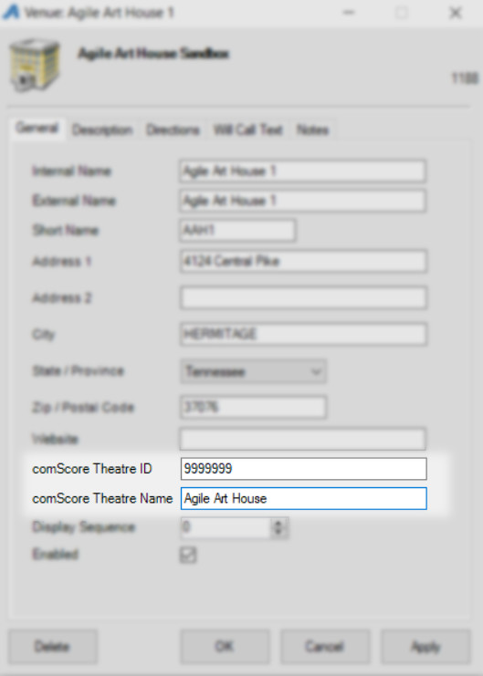
7. Click Apply to save the information.
Adding Distributors List and Marking Events For Reporting
Since Swift is being adopted by the various distributors, it is very important that you add the name of the distributor to the Show for proper reporting. Follow these steps to add the Distributor name to your Show(s). NOTE: You will need to do this for all films for your organization.
1. Open the Blue Folder where your Shows are built.
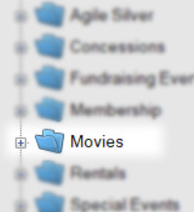
2. Click on the Show icon.
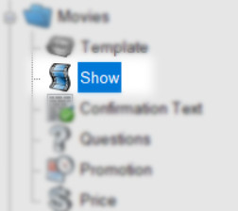
3. Right click on the Show and select Properties.
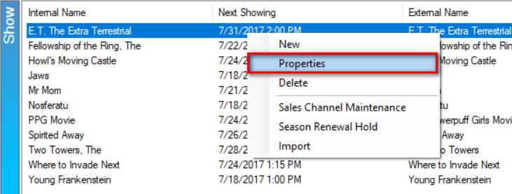
4. To add a Distributor to the list, click on the Ellipsis button to the right of the drop down menu.
5. In the Organization Type Maintenance Properties window, enter the name of theDistributor and click Add New.

6. Select the Distributor for this Show (Film)from the drop down menu.
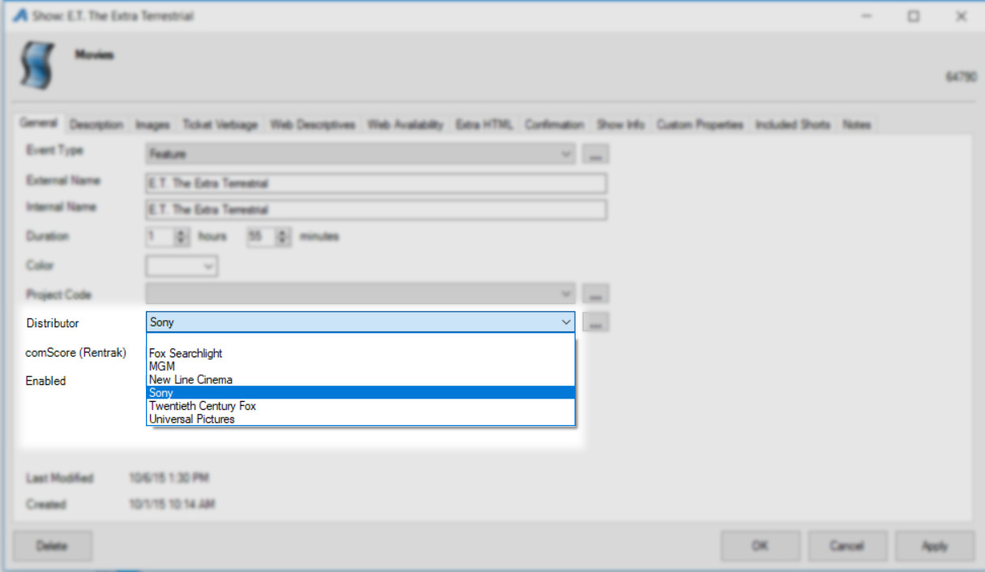
7. Check the box next to comScore (Rentrak).
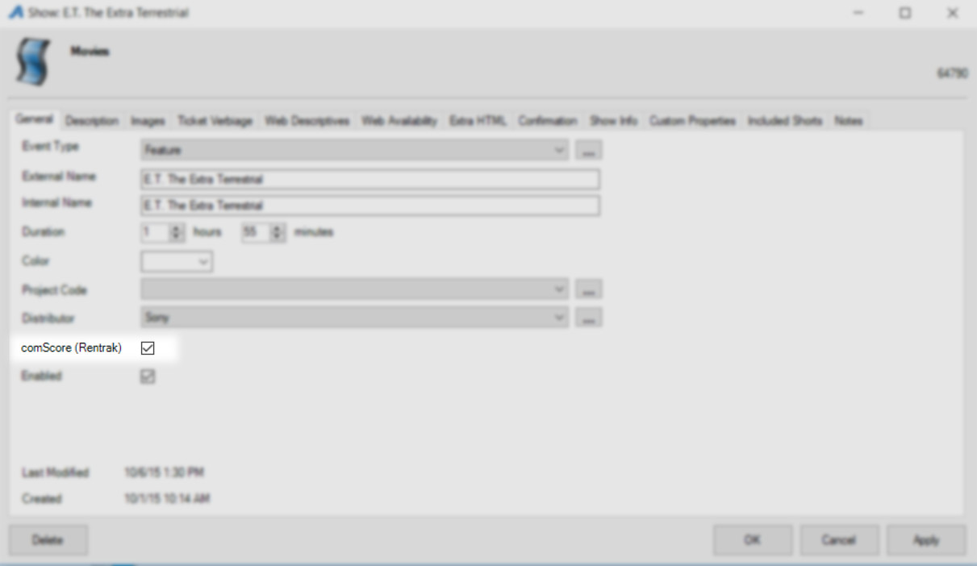
8. Click Apply to save the information.
Do these steps for any new film that you build.
Turn on the Automation Switch
Once you have set up the Theatre ID and added the Distributor to your films, you are now ready to turn on the automation switch. NOTE: The previous days' information is pushed to Swift around 4:00 AM Eastern/3:00 AM Central/2:00 AM Mountain/ 1:00 AM Pacific time. It is sent nightly. No need to manually enter the information through the Swift portal. We do recommend that you pull the nightly box office report out of Swift.
1. In Administration, open the Organization House icon.
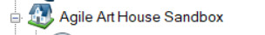
2. Select the Settings folder.
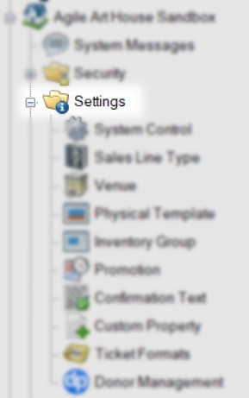
3. Click on System Control.
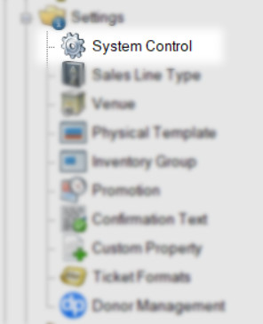
4. On the General tab, scroll to the bottom of the page to the comScore Swift Electronic Box Office Reporting.
5. Check mark Enable Automatic Reporting.
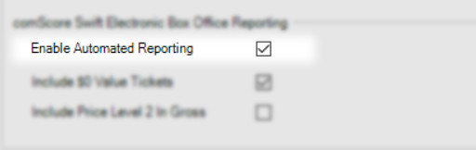
6. Check mark Include $0.00 Value Tickets if you want these to be reported.
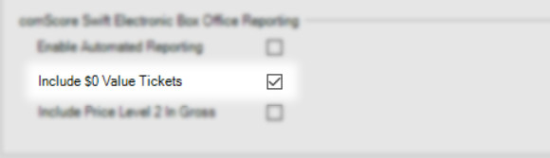
7. Check mark the box next to Include Price Level 2 In Gross if you want that to be reported.
