How To Create Entry Point Groups

1. Log into **Administration**.

2. Select the Corporate Organization.https://support.agiletix.com/hc/en-us/article_attachments/211937323/HouseIcon.png

3. Open the **Web** folder.

4. Select the **Entry Points** icon.

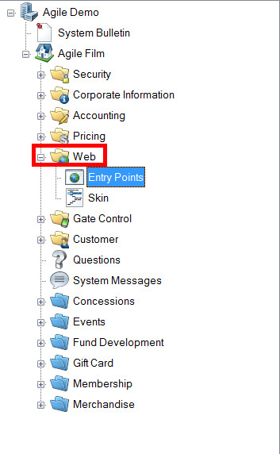

5. Right-click in the **Entry Point Group** area and select **New**,**Internet Group**.

[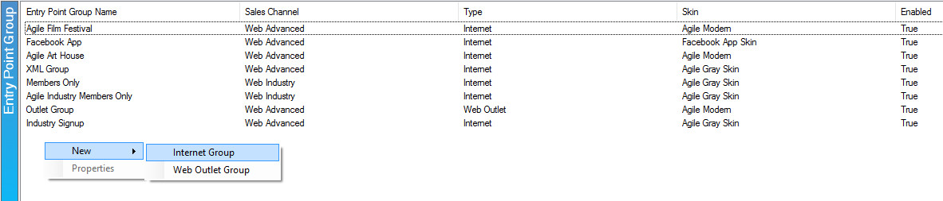](https://support.agiletix.com/hc/en-us/article_attachments/212177066/Image_2_New_Internet_Group.jpg)

6. Fill out the following areas on the **General** tab (not all will be applicable to your needs):

[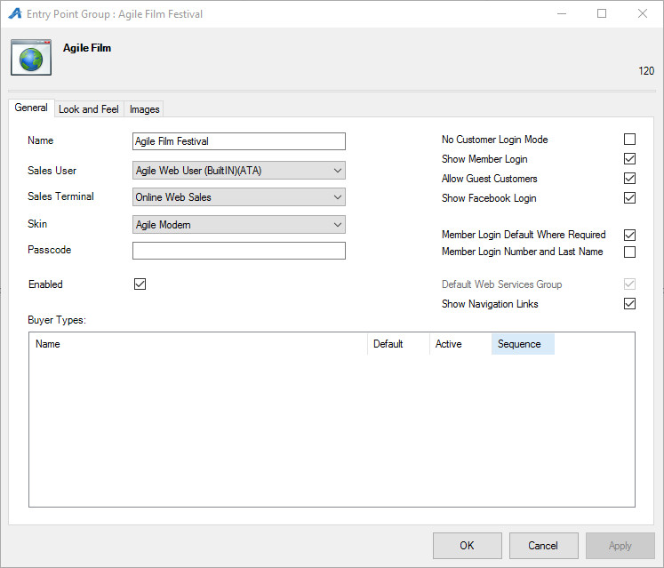](https://support.agiletix.com/hc/en-us/article_attachments/211939223/Image_3_General_Tab.jpg)

* **Name** is for internal use only. If a new entry point group is created yearly, then we highly recommend adding the date into the name.
* **Sales User** specifies which user should have access to this. Select the **Web User** option from the list. If you do not see this option, ask your Agile Support Representative for assistance.
* **Sales Terminal** specifies which terminal is used for sales. Select **Internet** from the list. This information is tracked in reporting. If you do not see this option, ask your Agile Support Representative for assistance.
* Select the **Skin** that should be used for the entry point group. The Skin will determine how the URLs will look online. For information on setting up an Agile Modern Skin, [click here](https://support.agiletix.com/knowledge/articles/212513546/en-us?brand_id=38784). If you are interested in having Agile match the look and feel of your current website, contact your Agile Support Representative for a quote.
* Add a **Passcode** only if you need the URL to only be available to customers who enter the passcode. Leave blank if the URL can be accessed by the general public.

7. At least one **Buyer Type** must be created on the Entry Point Group. This determines which prices are available online. Typically, this is **Web Standard**. To add this, right-click in the Buyer Type area and select **New**. Choose the Buyer Type from the drop-down (**Web Standard**), then click **OK**. The Buyer Type will be added to the list.

[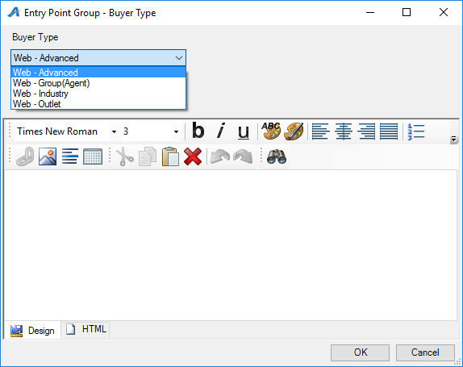](https://support.agiletix.com/hc/en-us/article_attachments/212177046/Image_4__buyer_tyoe.jpg)

8. Check the following boxes on the right-hand side if they are applicable to your organization:

[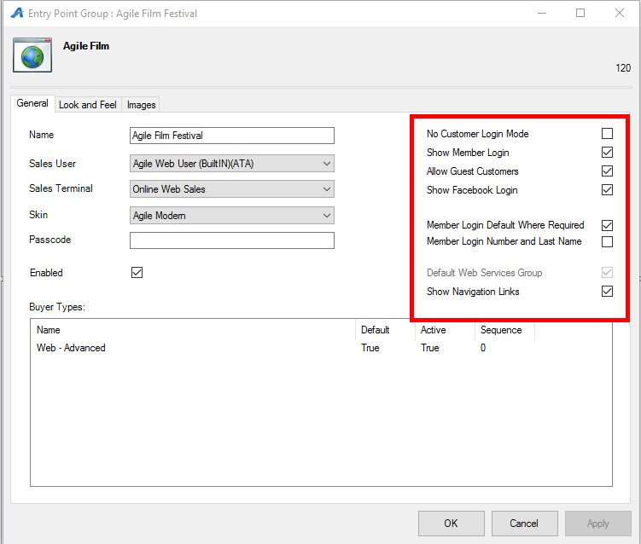](https://support.agiletix.com/hc/en-us/article_attachments/212177086/Image_5_General_Tab_pt_2.jpg)

* **No Customer Login Mode** does not allow customers to log into their customer account. Not recommended for any client that uses benefits.
* **Show Member Login**displays the member login button.
* **Allow Guest Customers** does not force customers to sign in or sign up for a customer account when making a purchase. (Note: it will still require customers to enter address information but a customer account will not be created.)
* **Show Facebook Login** adds a Facebook box to the bottom of each Entry Point where Facebook users can log in and comment on the event.
* **Member Login Default Where Required** forces members to login to their membership using their member number and password.
* **Member Login Number and Last Name** forces members to login to their membership using their member number and last name.
* **Default Web Services** should be checked if this is the main Entry Point Group used for your organization. Only one group can have this box checked.
* **Show Navigation Links** hides all navigation links in the navigation bar if unchecked. We recommend keeping this checked at all times unless you are making major changes to your web links.