Testing A Member's Online Benefits
Sometimes it may come in handy to sign-in as a member to make sure they are receiving the correct benefits. The following process will allow you to perform this check without having to get the member's current password.
- Pull up the customer in the Agile Admin or Sales app.
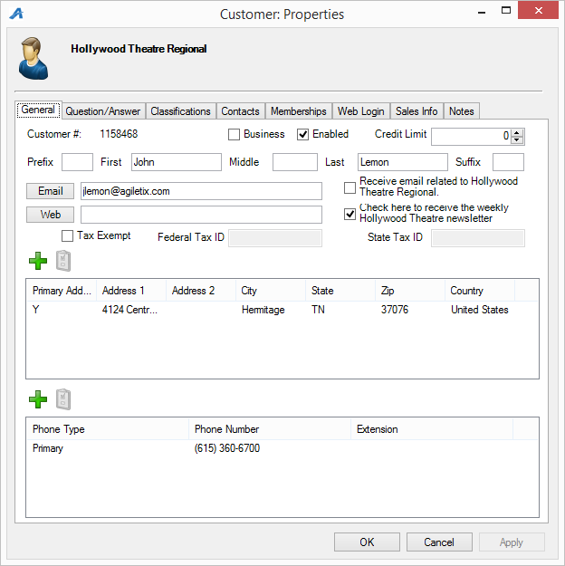
- Go to the Web Login tab to view current sign-in information.
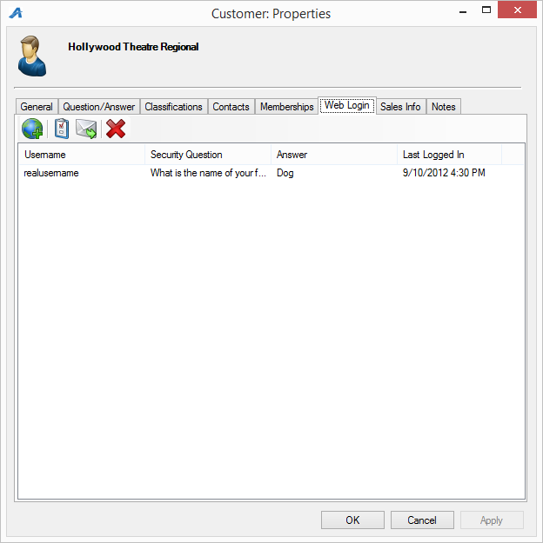
- Click the Add Web Login button to add an additional set of login credentials to this account.
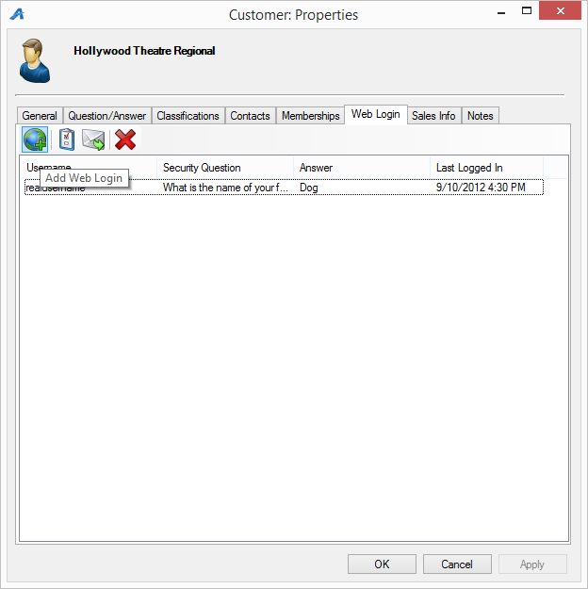
- Fill out the web login information with a test Username, Password, and Security Answer (testusername, testpassword, answer, etc). The username must be unique within your organization.
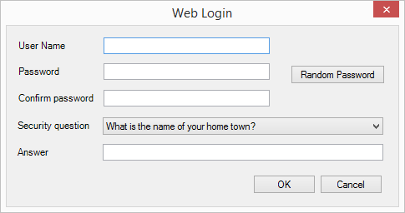
- Use this new username and password to log into the web site to check that benefits show up as expected.
- Make sure to go back to the customer and remove the test sign-in by highlighting the new sign-in from the list and clicking the Delete Web Login button.
