Changing A Delivery Method In An Existing Order
1. Log in to Sales. (Image 1)
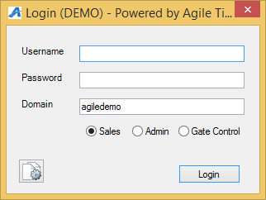
Image 1
2. Select Maintenance on the top toolbar.(Image 2)

3. Search for the customer by entering an Order # or Last Name. (Image 3)
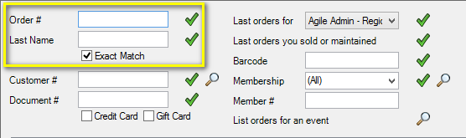
Image 3
4.Double click on the order you want to change. (Image 4)
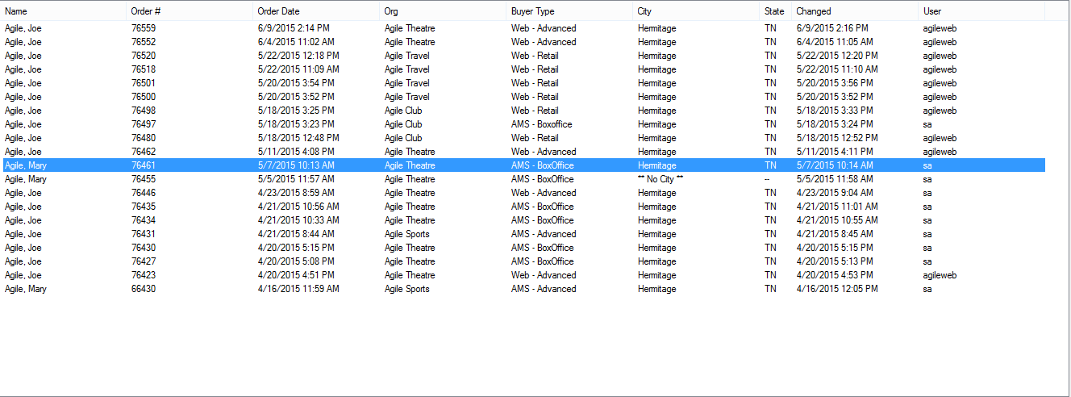
Image 4
5.Click on the green check mark at the bottom of the screen to select all items within the order. (Image 5)
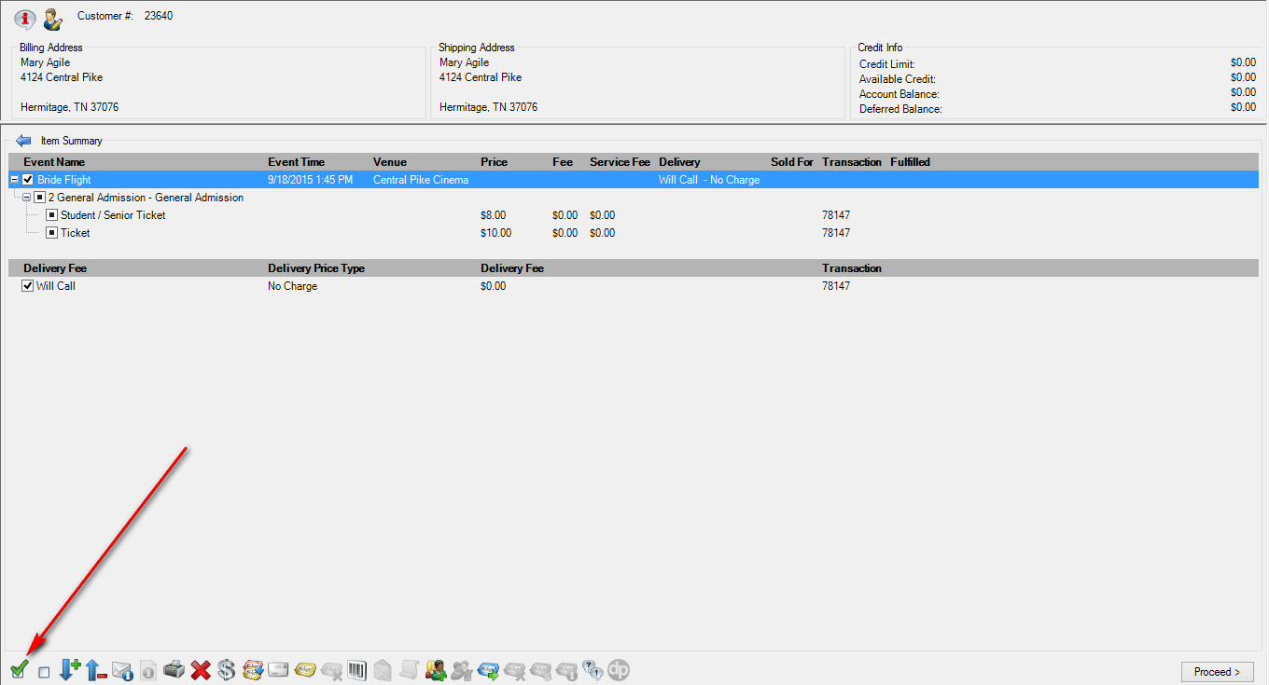
Image 5
6. Once all items are selected, click on the Envelope icon at the bottom of the screen. (Image 6)
Image 6
**Note: If your tickets have already been printed there will be a pop-up warning that states some of the selected items have already been fulfilled. Go ahead and click “All” so the delivery method can be changed. (Image 7)
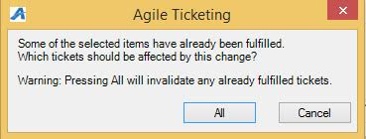
Image 7
7. The Change Delivery Methods window will appear click on the show all button and then select the desired delivery method from the drop down menu. Once you have made your selection click OK. (Image 8)
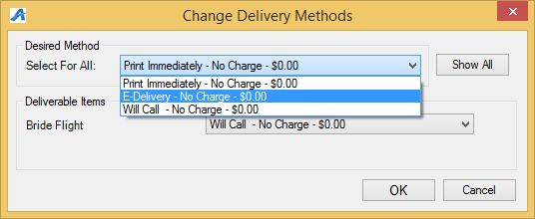
Image 8
8. Your new delivery method should now be displayed on the screen within the order. Once verified select Proceed (Image 9)
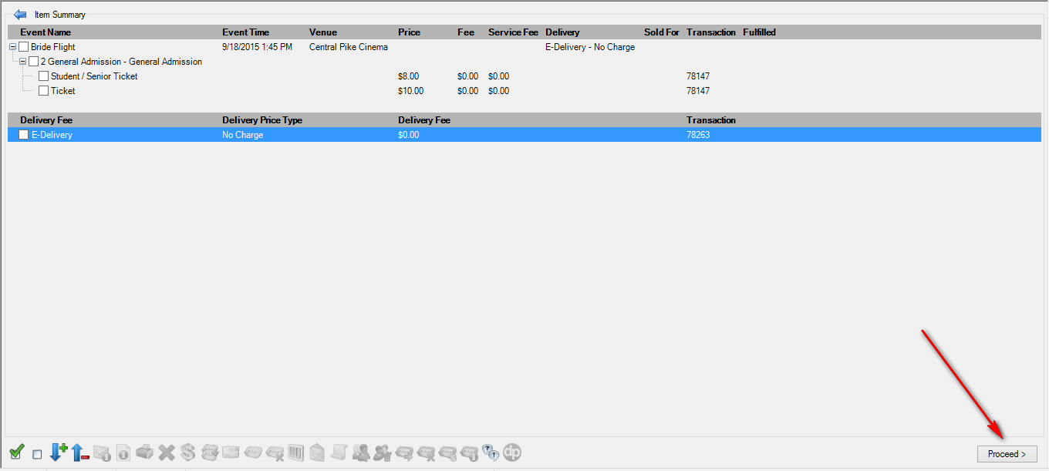
Image 9
9. If this is an even exchange and no money is due click Finalize to complete the changes made. If there is a balance due or a refund owed to the customer process the payment/refund to finalize the order. (Image 10)
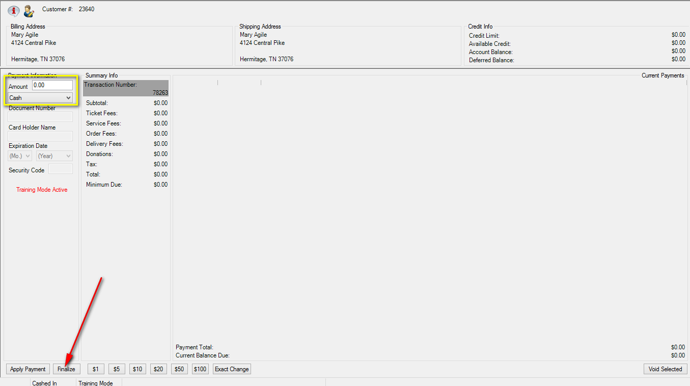
Image 10
***Note: When your changes have been finalized you may get a confirmation pop-up screen. This will allow you to send a confirmation and/or print at home ticket(s) to the customer.

