Agile Message Notification Board
Agile is pleased to announce a new and easier way to send notes to your staff using the Agile Message Notification Board. Messages can be added with an expiration date that will appear to your staff when they log in. They can also click on the Notices button to see all of the past notes. This is a perfect way for Administrators and Box Office Managers to send event, front of house, fan club, and customer notes to your stuff.
1. Log into Sales.
2. Click on the Notice icon 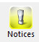 in the upper right-hand corner of the screen.
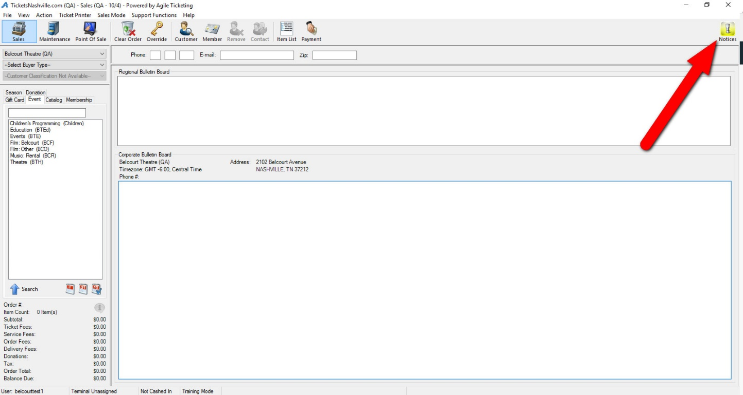

3. Click the Create a New Message button at the bottom of the pop-up.
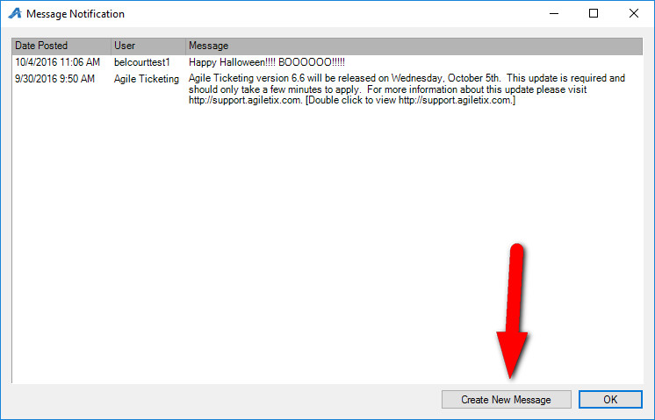

4. In the Message field, type the message you wish to share with all of your staff.
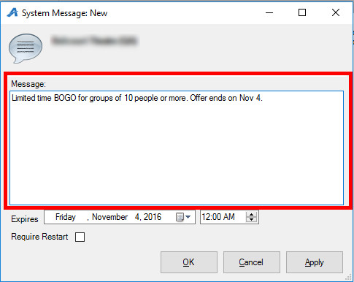
5. Set the Expiration Date and Time you wish for your message to expire, and click OK.
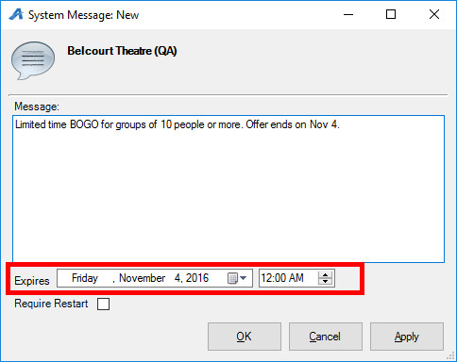
5. When your box office staff logs into Agile the message window will pop up with the notification.
