Exchanging Tickets

1. Log in to the Sales.
2.Select the Maintenance icon (Image 2)
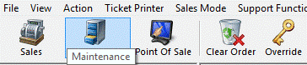
Image 2
3. Search for the customer by entering the Order # or the customer’s Last Name. Then click the appropriate green check mark. (Image 3)
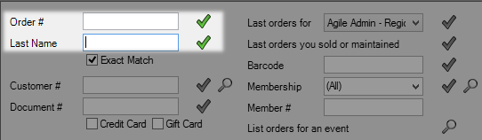
Image 3

4. Double click the correct order to bring up order contents on the Item Summary page. (Image 4) (Image 5)
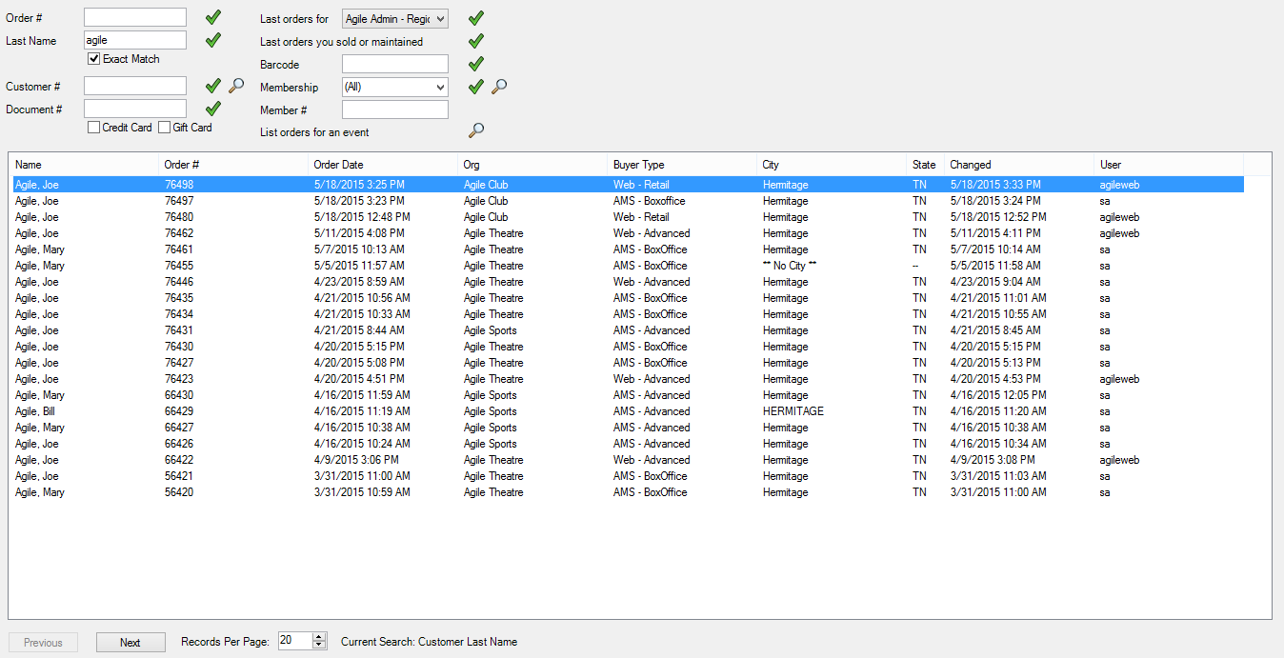
Image 4

5.While looking at the order select the Event tab (Image 5) to the left.

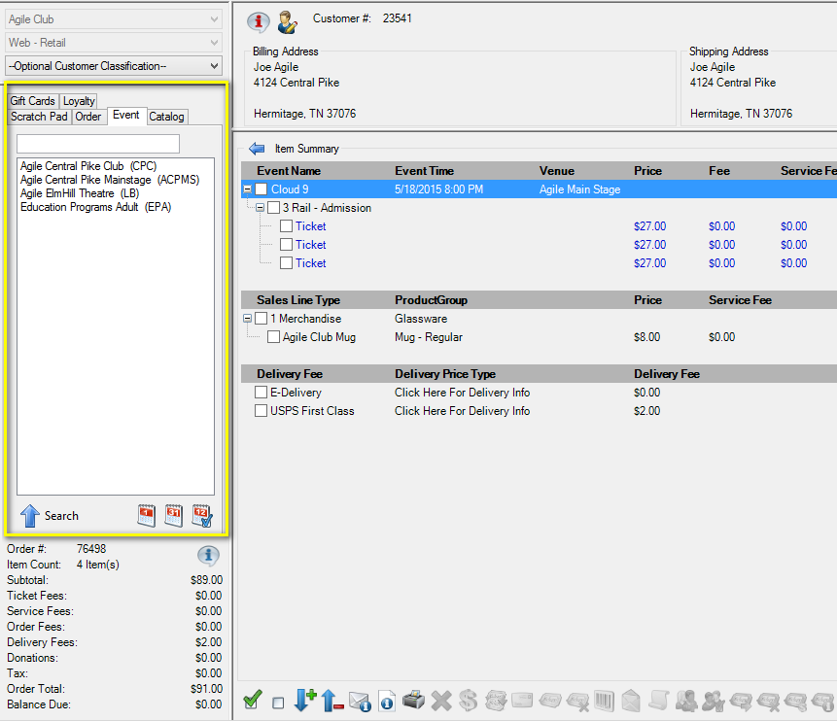
Image 5
6. Select the line item you wish to sell to. Then select the event or show from the list on the right. Add the quantity of tickets for your new event. (Image 6).
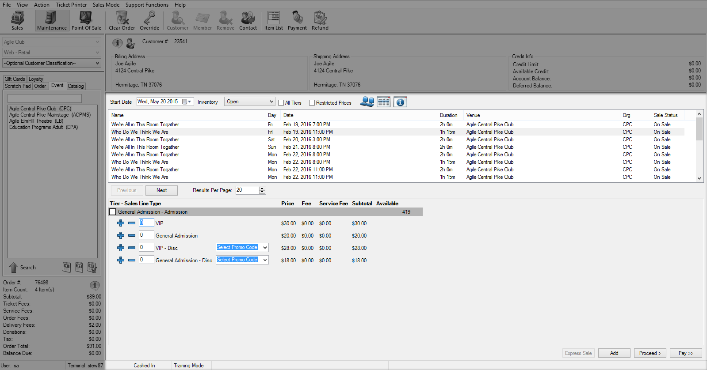
Image 6
7. Click Proceed to get to the Item Summary list. The order will now have the original tickets as well as the new tickets. (Image 7)
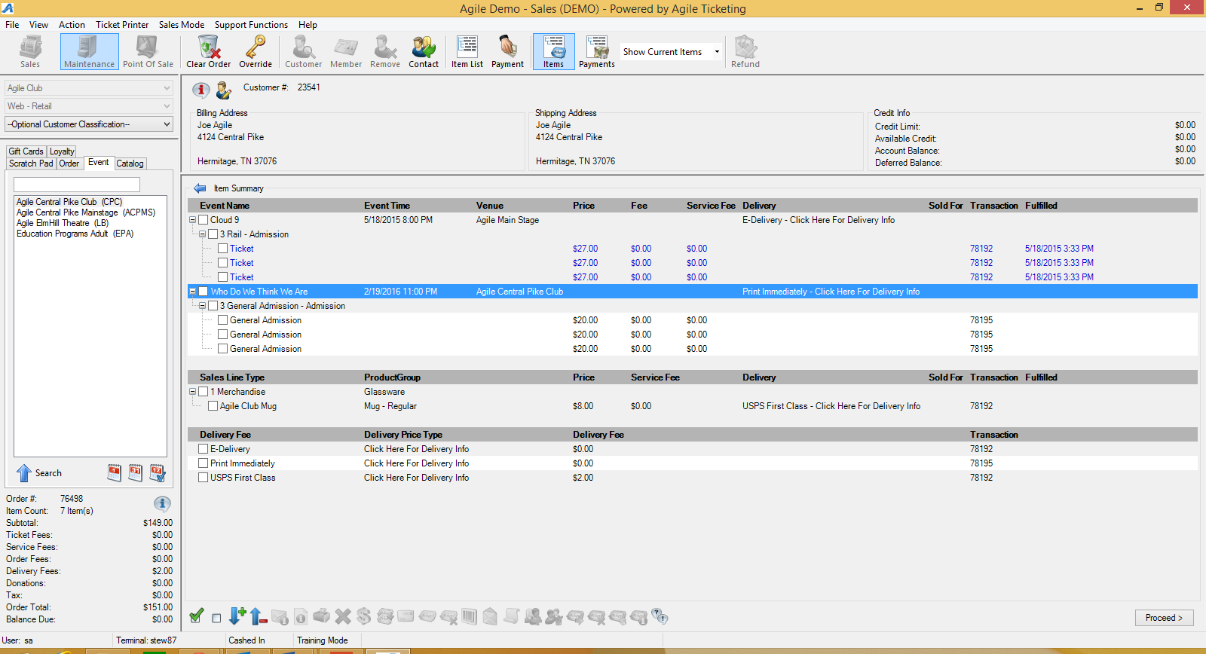
Image 7
8. Check mark next to the event that will be removed from the order and click the to remove these tickets from the order. (Image 8)
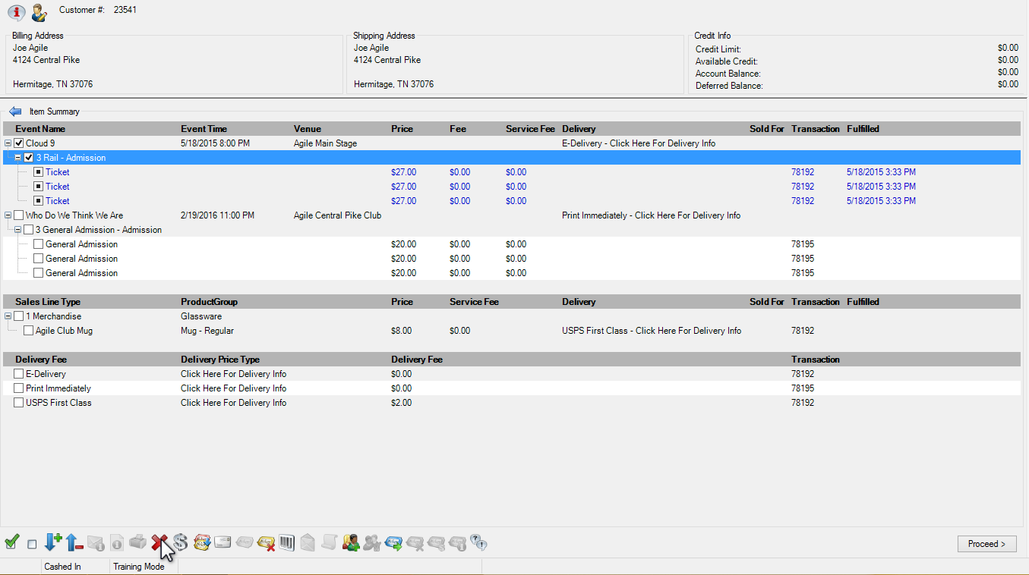
Image 8
**Note: If the original tickets have already been printed there will be a pop up warning. That states some of the selected items have already been fulfilled go ahead and click all to void out that transaction. (Image 9)
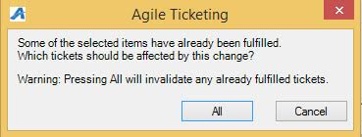
Image 9
9. once you have removed the items from the order and have confirmed the new tickets you are now ready to Proceed to the payment screen. (Image 10)
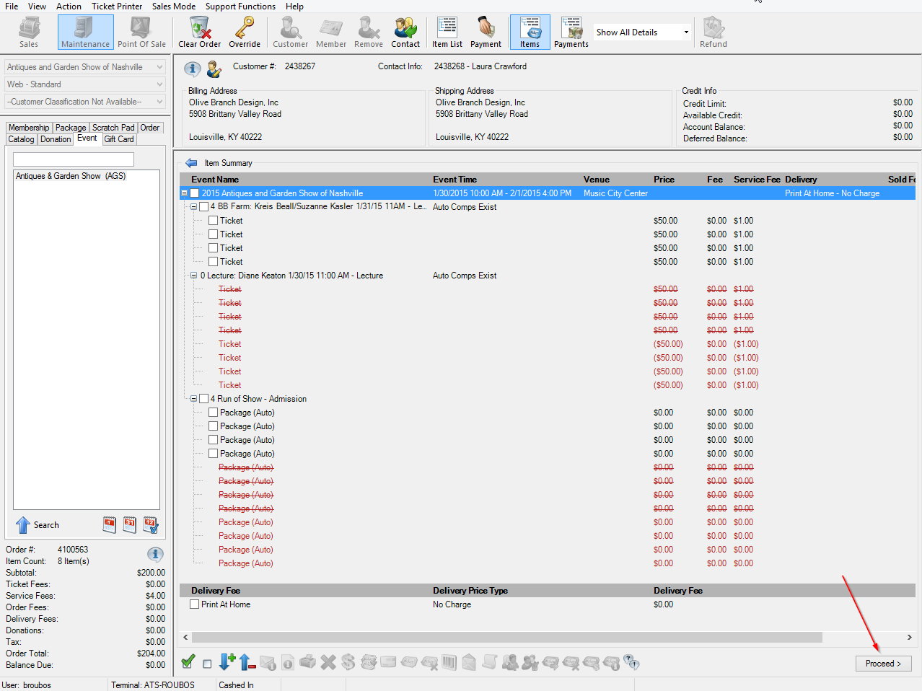
Image 10
10. If it is a even exchange and there is no money due select Finalize to complete the exchange. IF there is a balance due of a refund owed to the customer process the payment/refund to finalize the order. (Image 11)
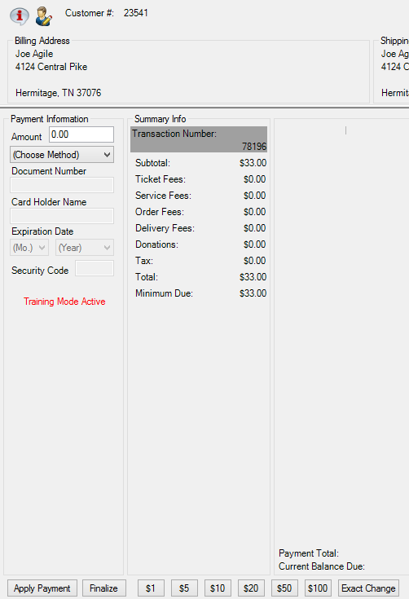
Image 11
11. After Finalizing,you many get a confirmation popup screen this will allow you to send a confirmation and/or a print at home ticket(s) to the customer.
**If at any time, you believe you have made a mistake or cannot complete the transaction, you can select the Clear Order icon at the top of the screen. This reverts the transaction back to its original state.

