Managing Reserved Seating Inventory
1. Log into Administration.
2. Click on the House Icon.
3. Open the blue folder that houses your shows.
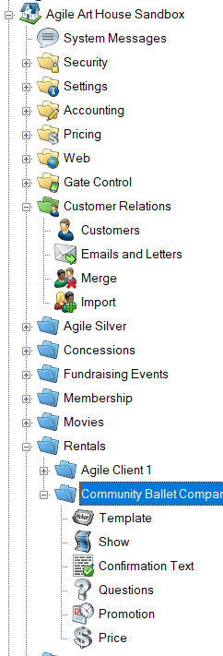
4. Click on the Show icon.
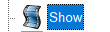
5. Select the Show that needs inventory holds.
6. Right click on the showing and select Seat Maintenance.
7. This will open tthe seat map. At the top of the screen select the Area and the Section. Select the Inventory Group View radio button.
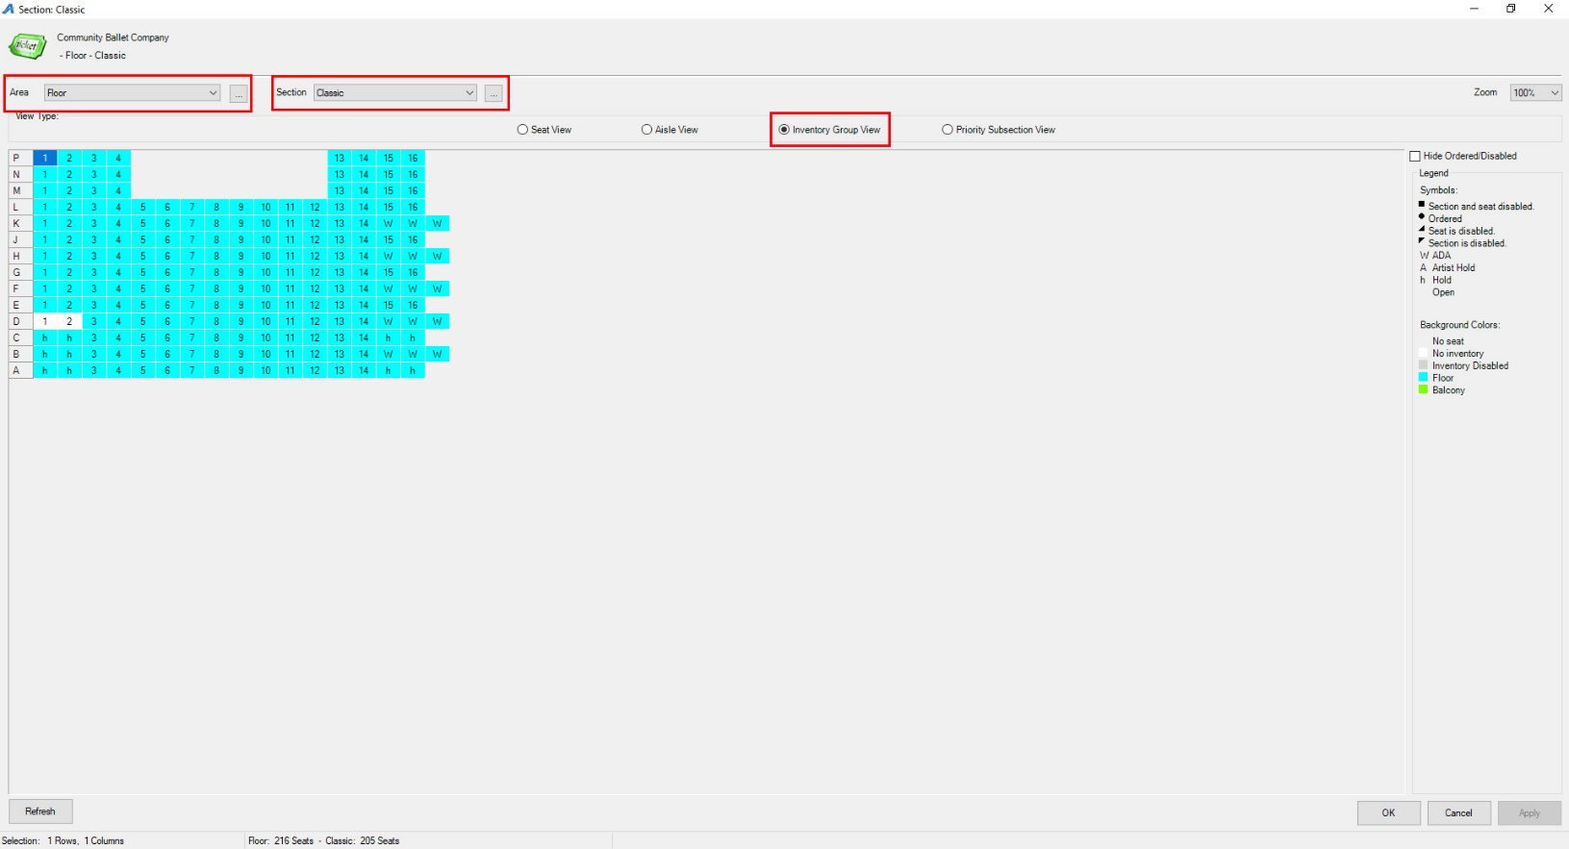
8. Select the seats that will be placed on Hold. (Once you have selected the seat it should become highlighted.) Right click and select Set Inventory Group/Tier.
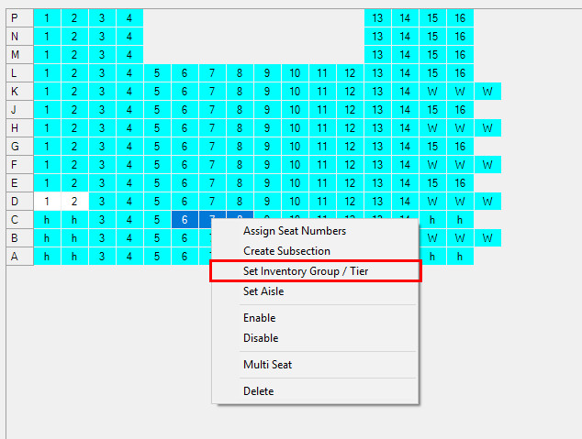
9. The Inventory Group/Tier window will open. In the Inventory Group drop-down, select the Hold Type for those specific seats(i.e. Hold, Artist Hold, ADA, etc.).
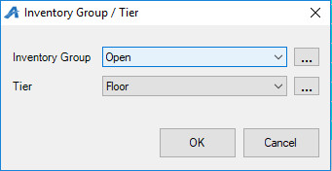
a. If you need to add an additional inventory group, click on the ellipsis button next to the drop-down.
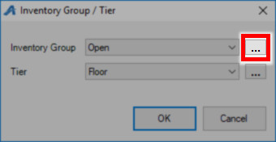
b. Enter the Name for the new Inventory Group.
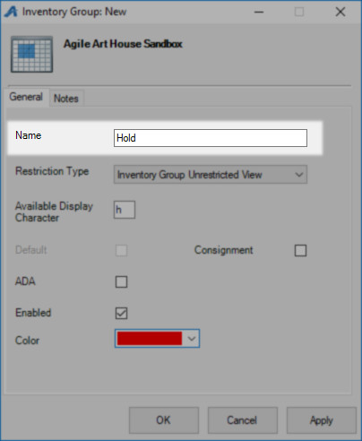
c. You will need to designate a restriction type. This will manage who is able to see these types of holds.
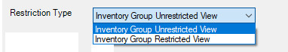
d. Enter the character you wish to represent that hold in the Available Display Character box (example: h = Holds, A=Artist Hold, etc.).
e. Once you have all of that information filled out you can click Apply and OK.
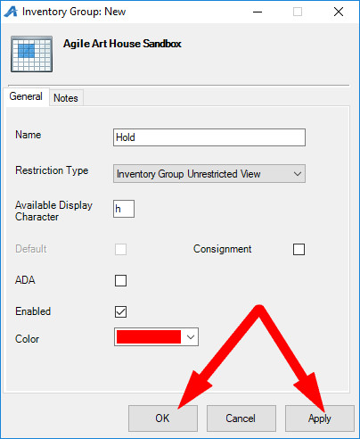
10. Once the Inventory Group has been selected, make sure to choose the correct Pricing Tier and click OK to close the window. The character on the selected seats will now change to that hold character.
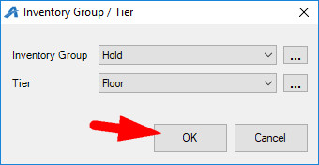
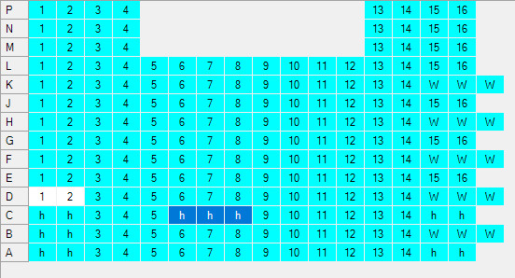

11. Once all of the changes have been made click on Apply and OK in the corner to save your work.
