Setting Up A Revenue Payment Account
1. Log in to Administration.
2. Click on the Corporate Organization icon.
3. Open up the Accounting folder and click on Revenue-Payment Account.
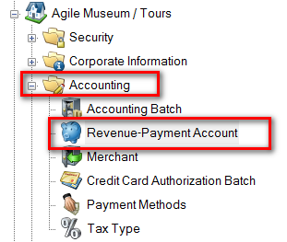
4. Right-click and select New.
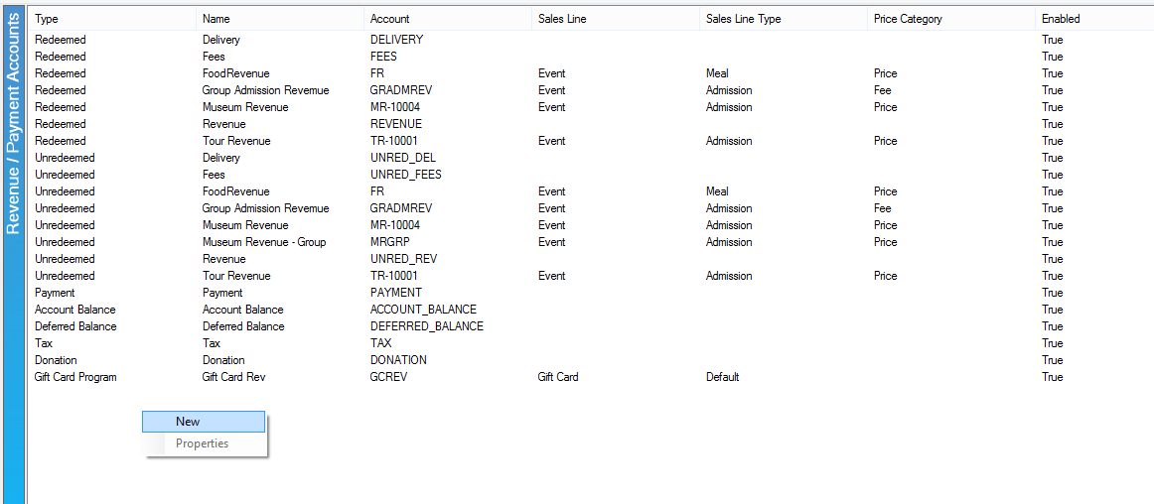

5. General tab:
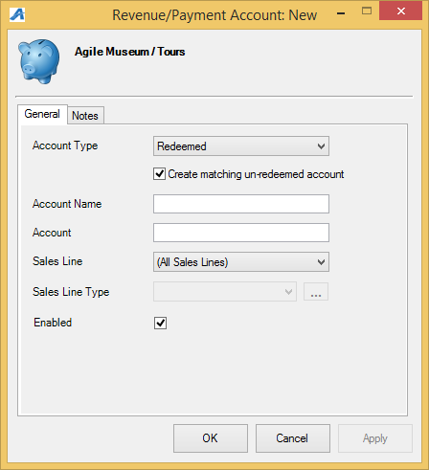
- Account Type: select the appropriate item from the drop-down. For most accounts, Redeemed is appropriate. The other options are more specific.
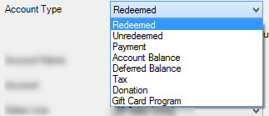
- If selecting Redeemed, check the box next to Create matching un-redeemed account to create an identical account with Unredeemed as the Account Type.
- Account Name: name of the account. Examples: 6-pack revenue, movie revenue, special event revenue.
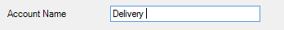
- Account: a shortened name of account.
- Sales Line: Select the appropriate item from the drop-down.
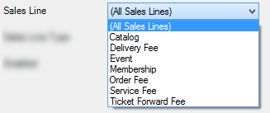
- Sales Line Type: select the appropriate item from the drop-down.
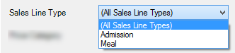
- Price Category: select the appropriate item from the drop-down, usually Price or Fee.
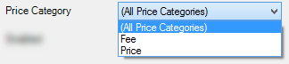
- Donor Perfect Account: This is for Donor Perfect clients ONLY. Select the correct account or click on the green plus sign to add a new one.
- Enabled: make sure this box is checked if the account should be enabled.
6. Notes: this tab is for internal notes only.
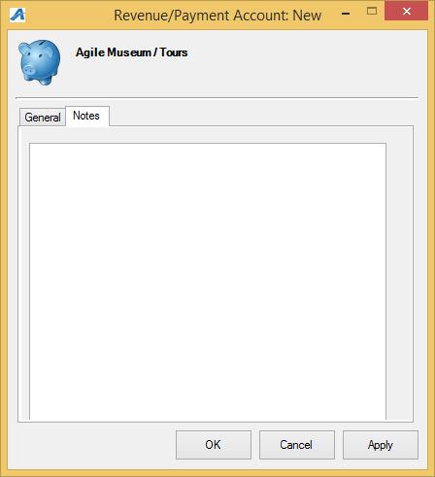
7. Click Apply and OK to save and exit that screen.

