Editing An Image In Agile
1. Log into Administration
2.Click on the Corporate Organization Icon.
3. Open the folder that houses the Event, Template or Show.
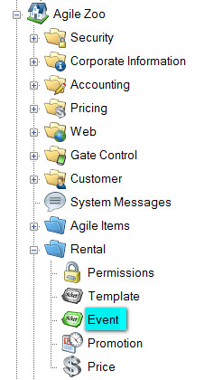
3. Right click on the Event/Template/Show and click Properties.
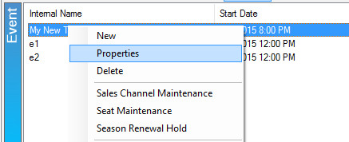
4. Open the Image tab.
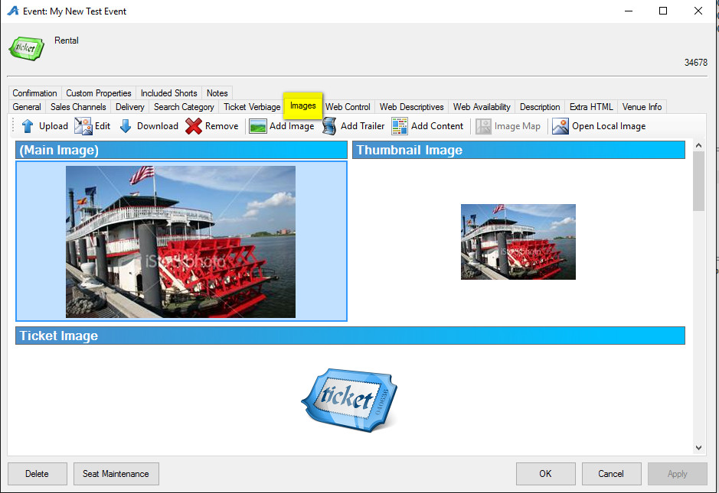
5. Click on the Image to highlight it and select the Edit icon.
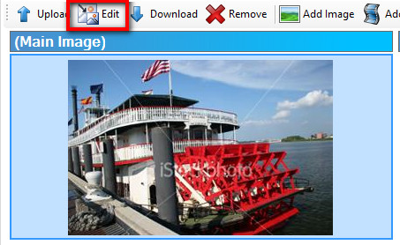
6. The Image Editor will pop up.
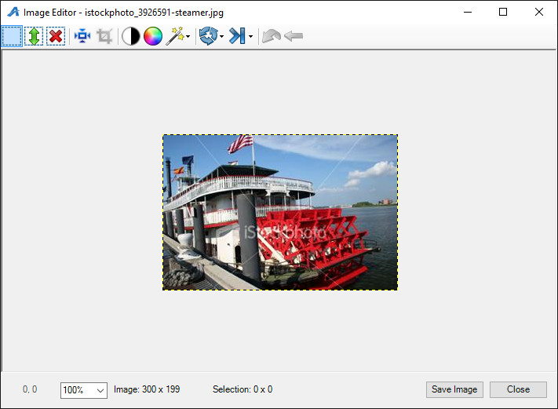
A. Resize icon: clicking this will cause the Resize Image pop up to appear. To adjust the image size click the arrows next to Width and Height. To adjust the quality select the Interpolation from the drop down
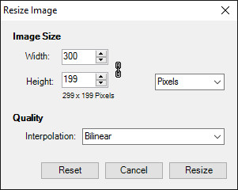
B. Crop: in order to use the crop button select an area of the image that you would like to Keep. Then Click the icon to crop the image.
C. Brightness/Contrast: This icon allows you to adjust the contrast and brightness of the image.
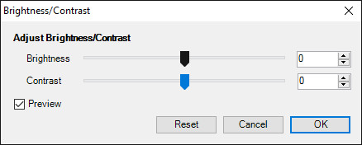
D. Opacity: 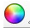 This will adjust the opacity of your image. Click the arrow on the slider to adjust the opacity or click the up and down arrows next to the number.
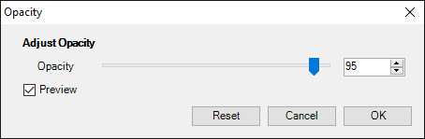
E. Filter: This icon offers two filter options for your picture. Grey Scale will convert your photo to a black and white and Negative will give you the negative of the photo.
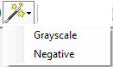
F. Rotate: Rotate will allow you to rotate your image either clockwise or counter clockwise.
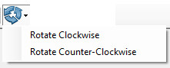
G. Flip: This icon will allow you to flip your image either vertically or horizontally.
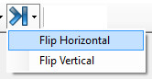
H. Undo: If you make a mistake this icon will allow you to undo the last mistake that you made.
I. Undo All: If you make more then one mistake or you want to start over again with the original image undo all will get rid of all your changes.
7. In order to save your edited image click the Save Image button at the bottom of the screen

