Adding A Captions To Images
1. Log into Administration
2. Select the Corporate Organization
3. Select the folder that houses your Event/Show/Template.
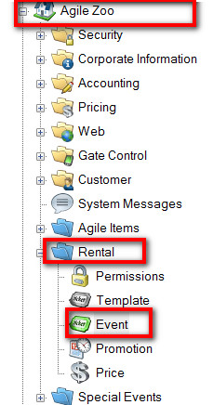
4. Select the Event/Show/Template right click and select properties.
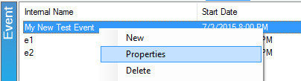
5.Click on the Image Tab.
6. Double click on the Blue box above the image you want to add a caption to.
