Importing Renewal Holds From A Previous Season Into A New Season

1. In **Administration** click on the **Corporate Organization** icon.

2. Open the **Sales Organization** folder that has your packages.

3. Click on the**Package** icon.

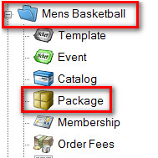

4. Right click on last season's package and select **Properties**.

[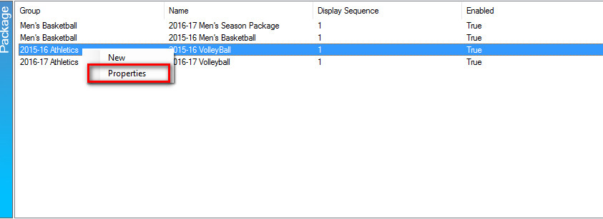](https://support.agiletix.com/hc/en-us/article_attachments/206619743/renewalhold2.jpg)

5. On the General tab of the package, check the box next to **Enable** and **Allow Renewals**.

[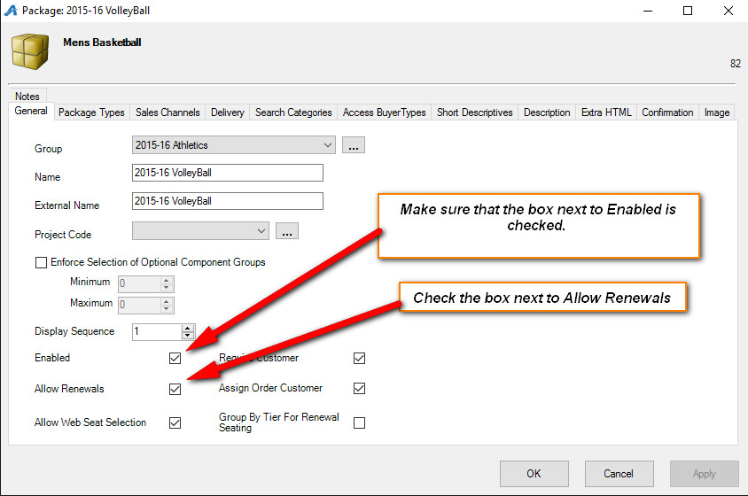](https://support.agiletix.com/hc/en-us/article_attachments/206619963/renewalhold3.jpg)

6. Click **Apply** to save the information and then **OK** to close last year's package.

7. Next, go to the **Sale Organization** folder that your new season **Show/Events**have been built.

8. Click on the **Event** or **Show** icon (depending on how you built your events) to see the list of your **Events**.

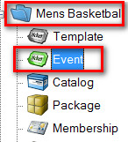

9. Select all of the **Events** that are in this year's season package.

[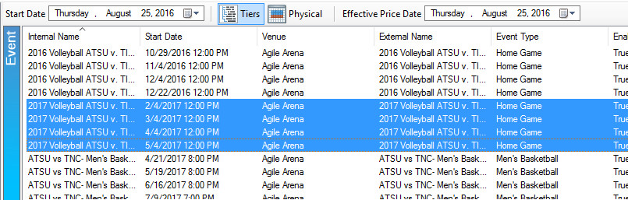](https://support.agiletix.com/hc/en-us/article_attachments/206611166/renewalhold5.jpg)

10. Right click on these events and select **Season Renewal Holds**.

[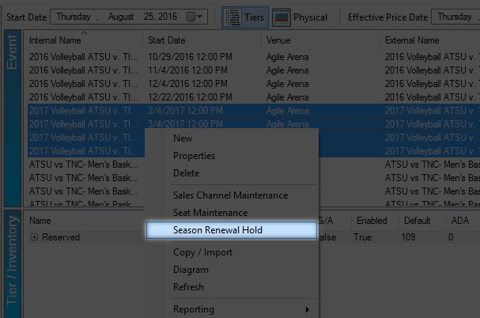](https://support.agiletix.com/hc/en-us/article_attachments/206611186/renewalhold6.jpg)

11. In the **Season Data to Match** drop-down, select last year's season.

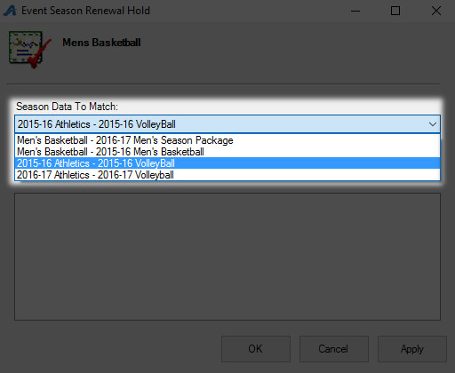

12. In the**Inventory Group to Set** drop-down, select the hold status. **NOTE:** We recommend that you create a Season Renewal Hold that is separate from your day-to-day holds.

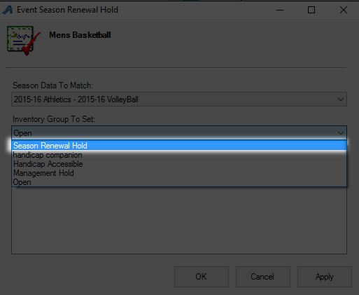

13. Click **Apply** to start the hold status function for your **Events/Shows**.

14. Once all of the holds have been placed, you will see the notification for all of the events. The notification will tell you if you successfully added your holds to each event.

