Pulling A CRM Report For UnFulfilled Print At Home Tickets

Clients can pull a **CRM** list of customers who have not received their **Print At Home Tickets**.  Follow these instructions to pull this list.

1. In **Administration** click on the **Corporate Organization** (the house icon).

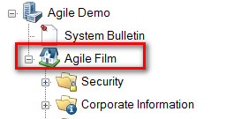

2. Click on the **Customer** organization folder

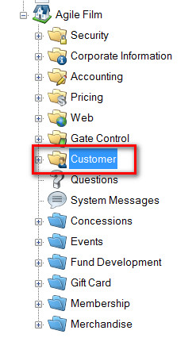

3. Select **Customer Relations**.

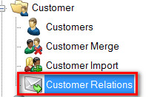

4. In the **CRM Query** list, select **Event Print-At-Home Unfulfilled**.

[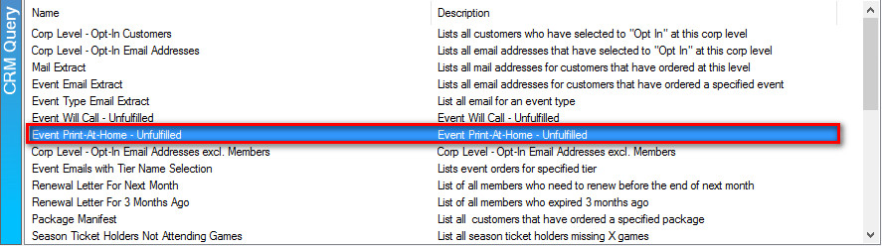](https://support.agiletix.com/hc/en-us/article_attachments/203537056/4CRMPAH.jpg)

5. In the **CRM Query Email** field, right click and select **New**.

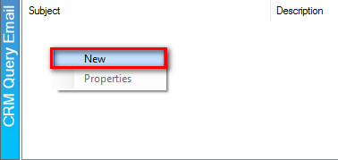

6. Click on the **Set Parameters** button.

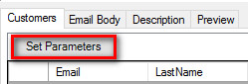

7. Select the **Sales Organization** folder from the list provided.

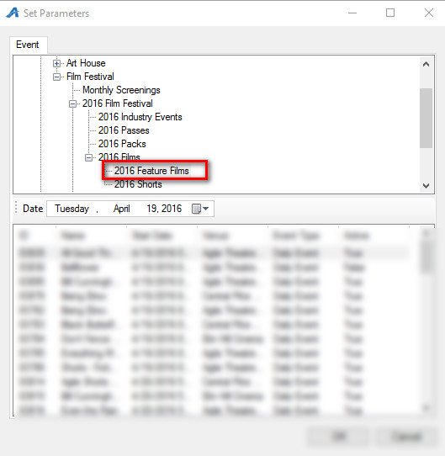

8. Select the **Event Name** and then click on **OK.**

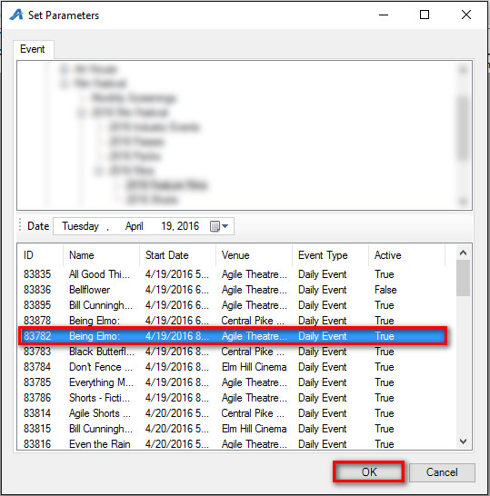

9. The list of customers that have not received their print at home tickets will appear.

[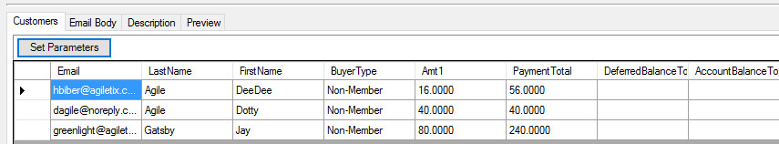](https://support.agiletix.com/hc/en-us/article_attachments/203683963/9CRMPAH.jpg)

10. Click **Export Data to CSV** to save the information to a spread sheet.

[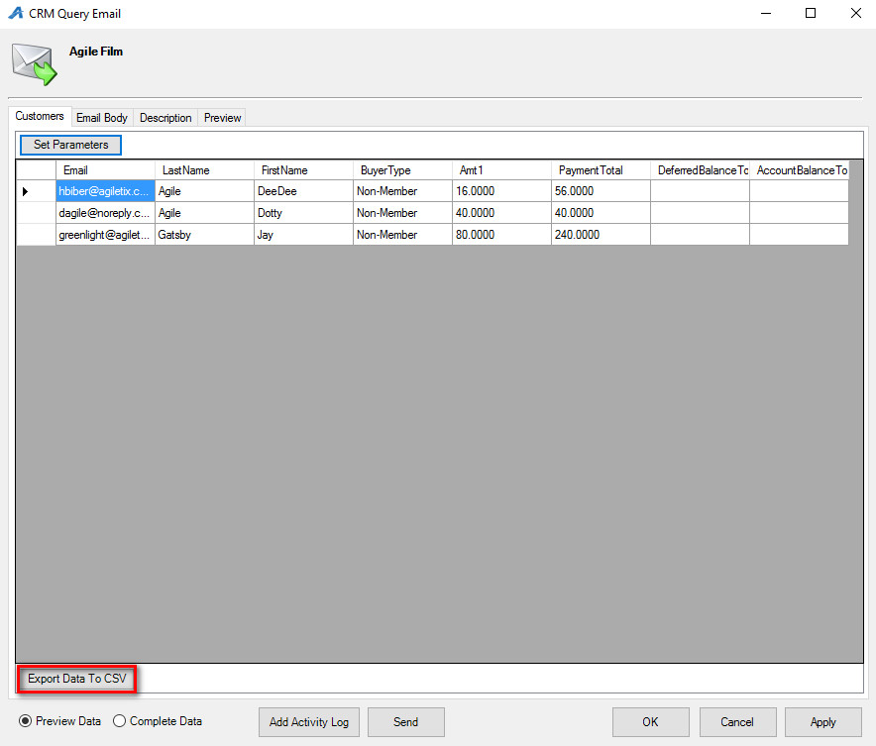](https://support.agiletix.com/hc/en-us/article_attachments/203683973/10CRMPAH.jpg)

11. Switch to Sales and click on **Maintenance** to look up their order.

13. Send their tickets to them via email ([See Re-sending Print At Home Tickets](https://support.agiletix.com/hc/en-us/articles/205370724-Re-sending-Print-at-Home-Tickets))