Adding/Removing General Admission Seat Inventory

1. [Log in](https://support.agiletix.com/hc/en-us/articles/200617005-Log-In) to **Administration**.

2. Select the **Corporate Organization** icon. https://support.agiletix.com/hc/en-us/article_attachments/202904764/HouseIcon.png

3. Open the **Sales Folder**.https://support.agiletix.com/hc/en-us/article_attachments/202964590/BlueFolderIcon.png

4. Click on the **Template** icon.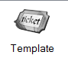

5. Select the **Template**with the seat inventory you want to adjust.

[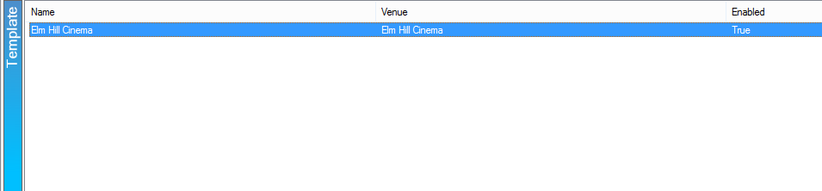](https://support.agiletix.com/hc/en-us/article_attachments/202904784/Select_template.png)

5. Click on the **Tier** and expand it down.

[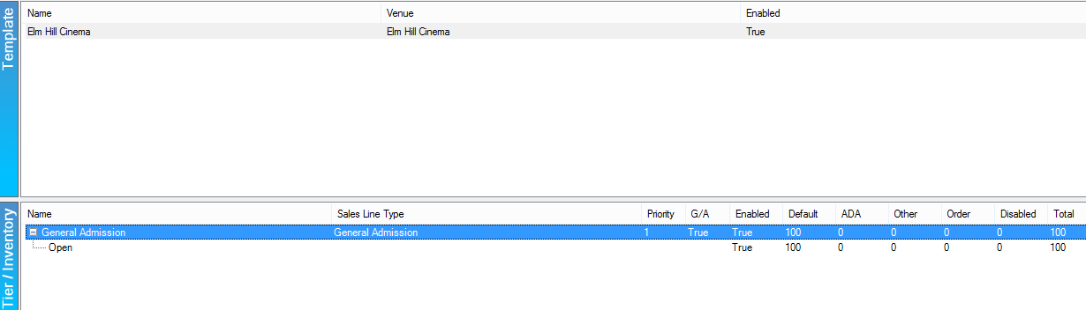](https://support.agiletix.com/hc/en-us/article_attachments/202904794/Expand_tier.png)

6. Right-click on the **Inventory Group** and select **Adjust Inventory**.

[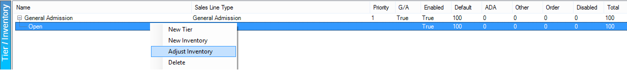](https://support.agiletix.com/hc/en-us/article_attachments/202904814/Adjust_Inventory.png)

7. Change the quantity in the **Adjust Available Qty** box.

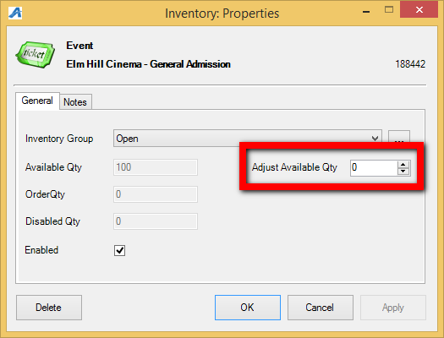

***Note:****The total available quantity will be reflected in the Available Qty box.*

*To subtract quantity: https://support.agiletix.com/hc/en-us/article_attachments/202964600/Subtract.png*

*To add quantity: https://support.agiletix.com/hc/en-us/article_attachments/202904774/Add.png*

8. Click **Apply** then **OK** and the inventory will be updated.