Membership Import Instructions
1. Log in to Administration.
2. Click on the Corporate Organization icon.
3. Select the Membership folder and click the Membership icon.
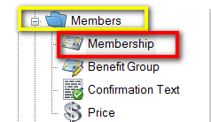
4.Right click on the Membership Name and select Import.
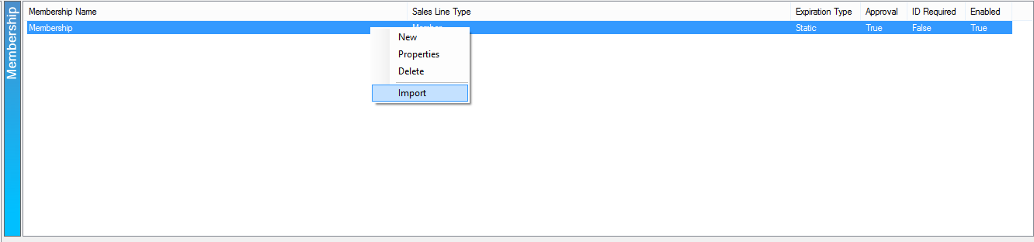
5. Click the Import Example to save the import spreadsheet.
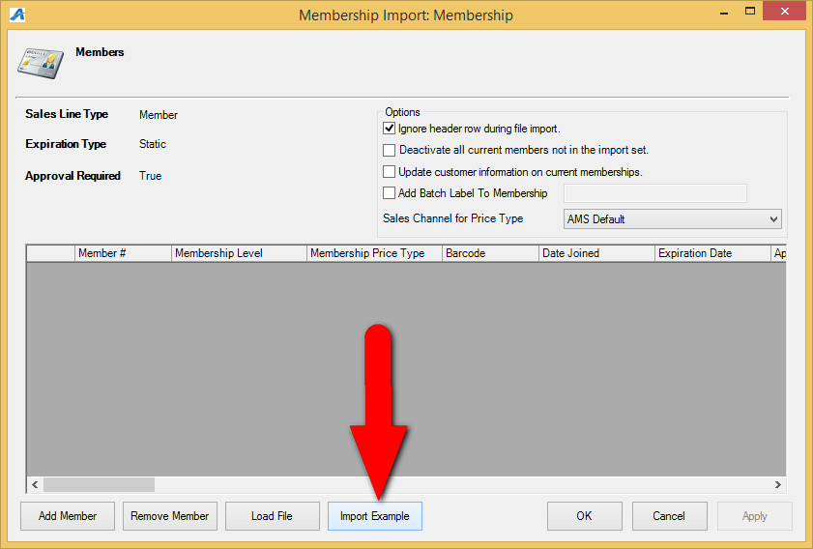
6. Save the example to the computer's desktop.
7. Fill out the member information in the spreadsheet.
Note: Not all fields are required for the import. Optional columns are marked in the header.
8. Save and close the completed spreadsheet.
9. When you are ready to import your members, go back to the membership program, right click on the Membership program and select Import.
9. Click on the Load File button and select the completed spreadsheet to import the membership information.
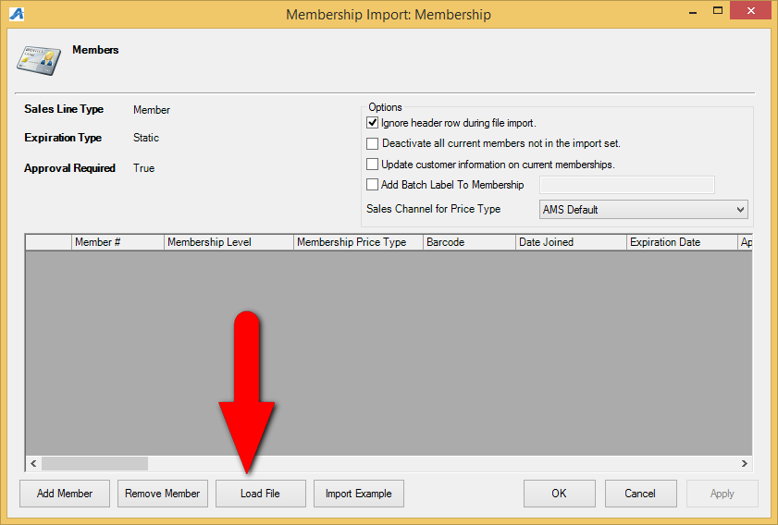
10. All of your member information will appear within the window. You can scroll through to make edits and check for any errors.
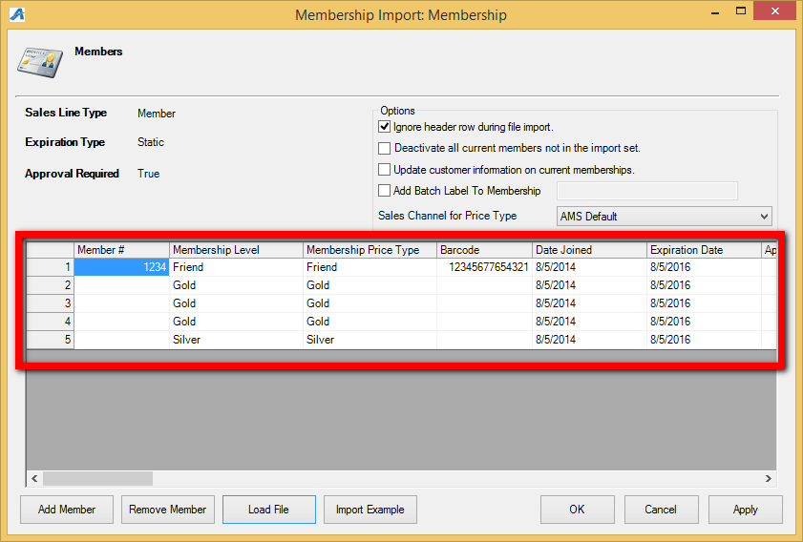
Note: If you do see any errors you can make the necessary corrections on the Member Import page. Simply click the field that needs to be changed and type in the changes.
11. Make sure that you have the correct Sales Channel for Price Type selected in the drop down.
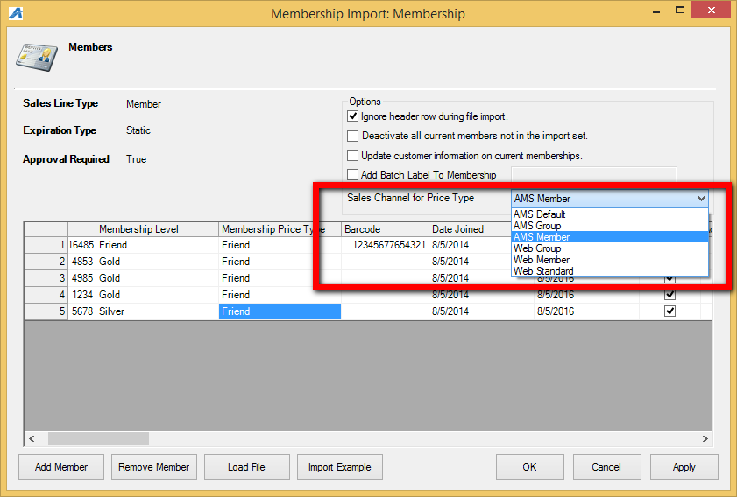
12. Once everything is correct click on Apply and OK.
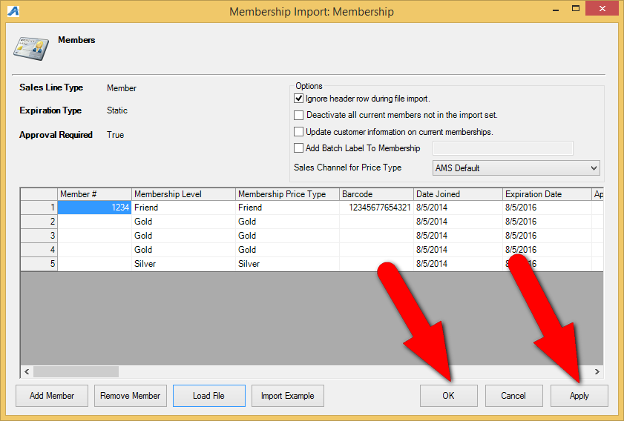
13. The progress pop up will appear.
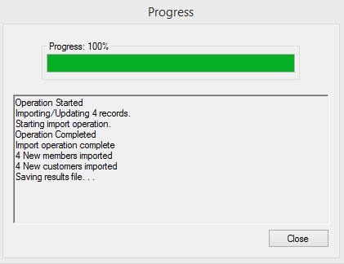
14. Once you have reached 100% the Save Import Results pop up will appear. This will tell you about the results of your import (i.e. if there were any errors or if it was successful). Save this spreadsheet to your computer for future reference.
