Importing Memberships Or Passes In AMS To Generate Orders
You now can import memberships or passes in the sales application with each time on its own order.
1. Log in to Agile in the AMS Sales area.
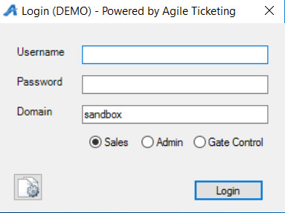
2. Click on the Membership tab and choose the Membership or Pass program from the list.
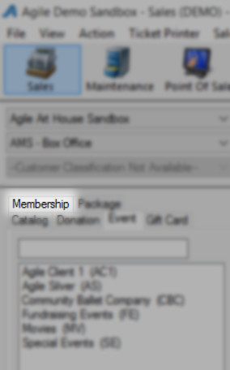
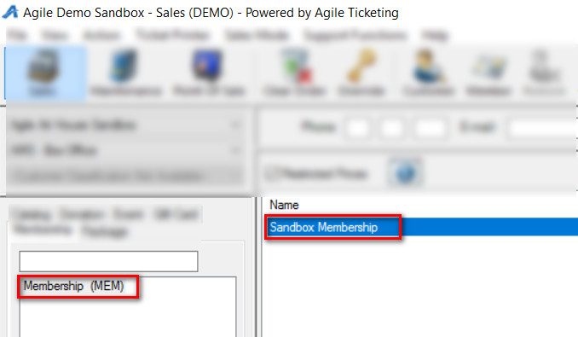
3. Right Click on the Membership and select Import.
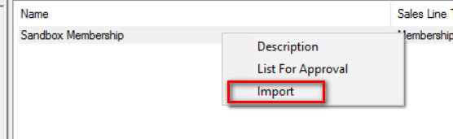
4. Click on Import Example and save the spreadsheet to your Desktop
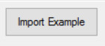
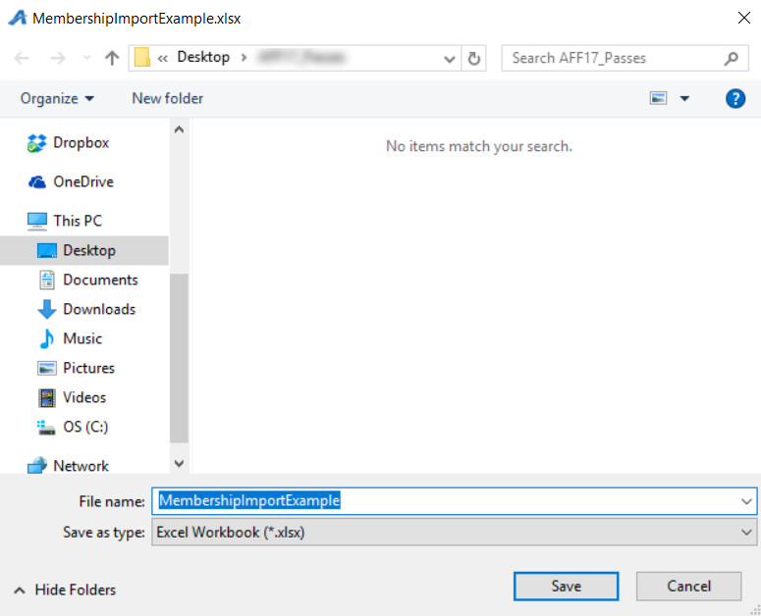
5. Fill out the Member/Pass information in the spreadsheet.
Note: Not all fields are required for the import. Optional columns are marked in the header.
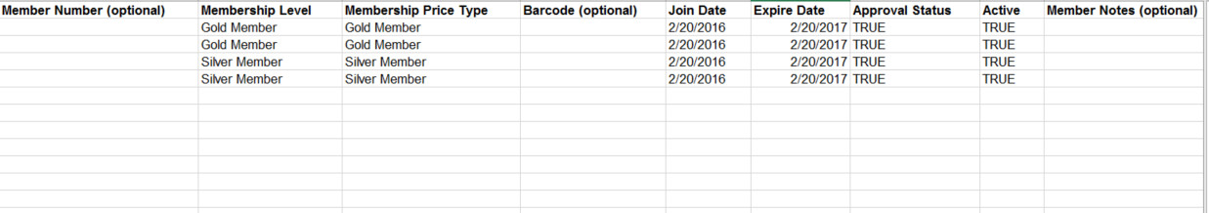
6. Save and close the completed spreadsheet.
7. When you are ready to import the Members/Passholders, go back to the Membership Program in AMS.
8. Right click on the Membership Program and select Import.
9. Click on the Load File button and select the completed spreadsheet.
10. All of the Member/Passholder information will appear within the window. You can scroll through to make any last-minute edits and check for any errors.
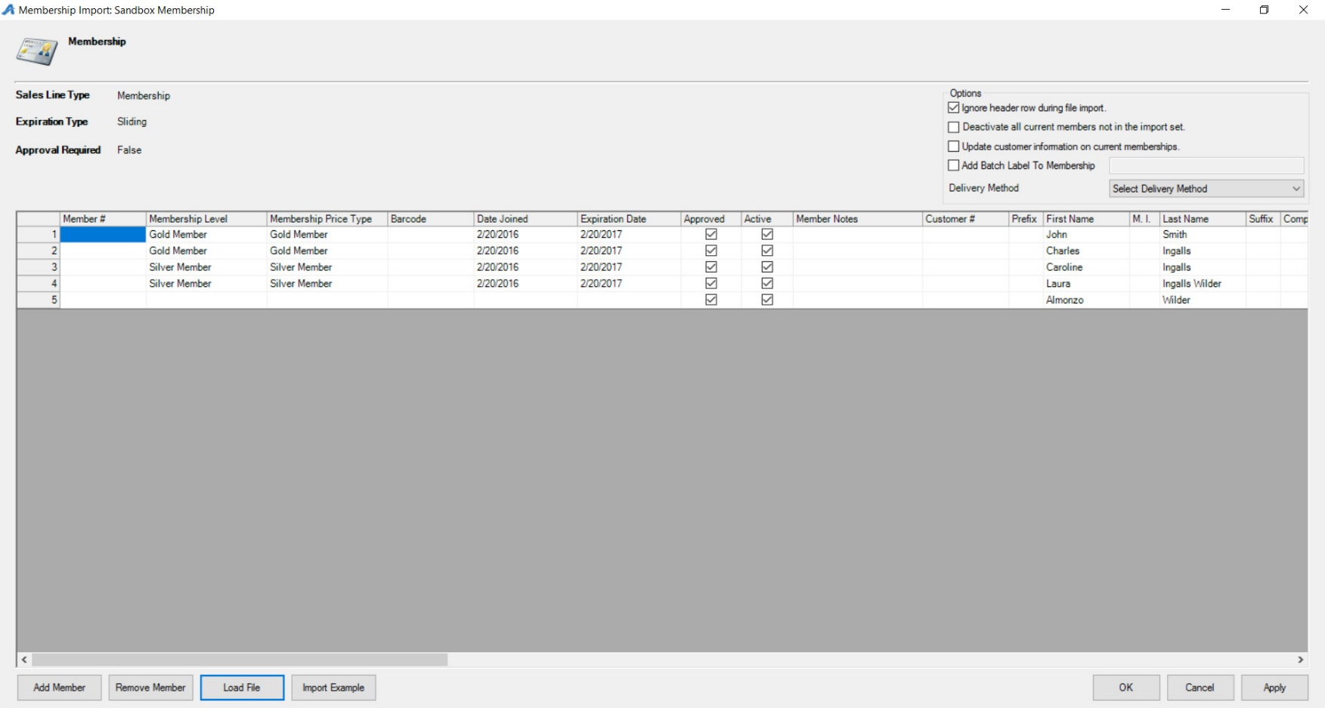
11. Check the box next to Add Batch Label to Membership and create a unique code that will appear on the response data spread sheet after the import.
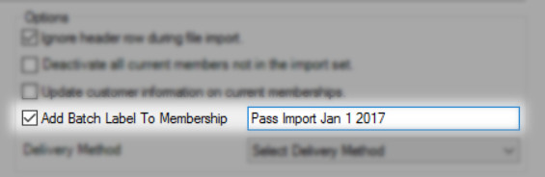
12. Select a Delivery Method from the drop down.
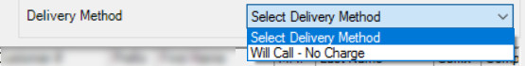
13. Click on Apply and then OK.
14. The Progress window will appear.
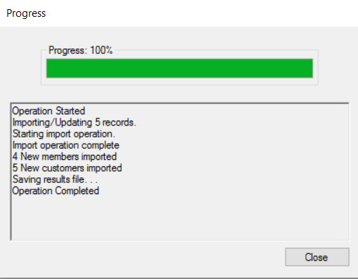
15. Once you have reached 100% the Save Import Results pop up window will appear. Save the results file to your computer for future reference.
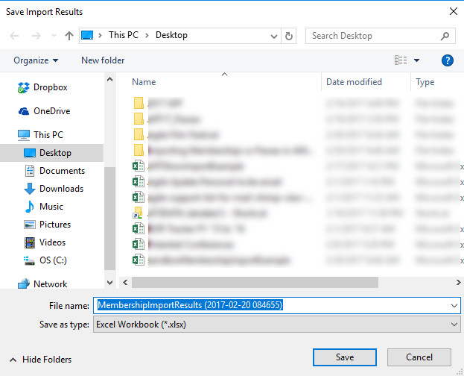
16. You can now go to Maintenance or the Fulfillment Batch to see that these orders have been processed and are ready to be fulfilled.
