Processing An Order Using An Account Balance

1. Log into Sales.
2. Click the Maintenance Icon. (Image 2)
Image 2
3. Search for the customer by entering the Order # or the customer’s Last Name. Then click the appropriate green check mark. Double click the correct order to bring up order contents on the Item Summary page. (Image 3)
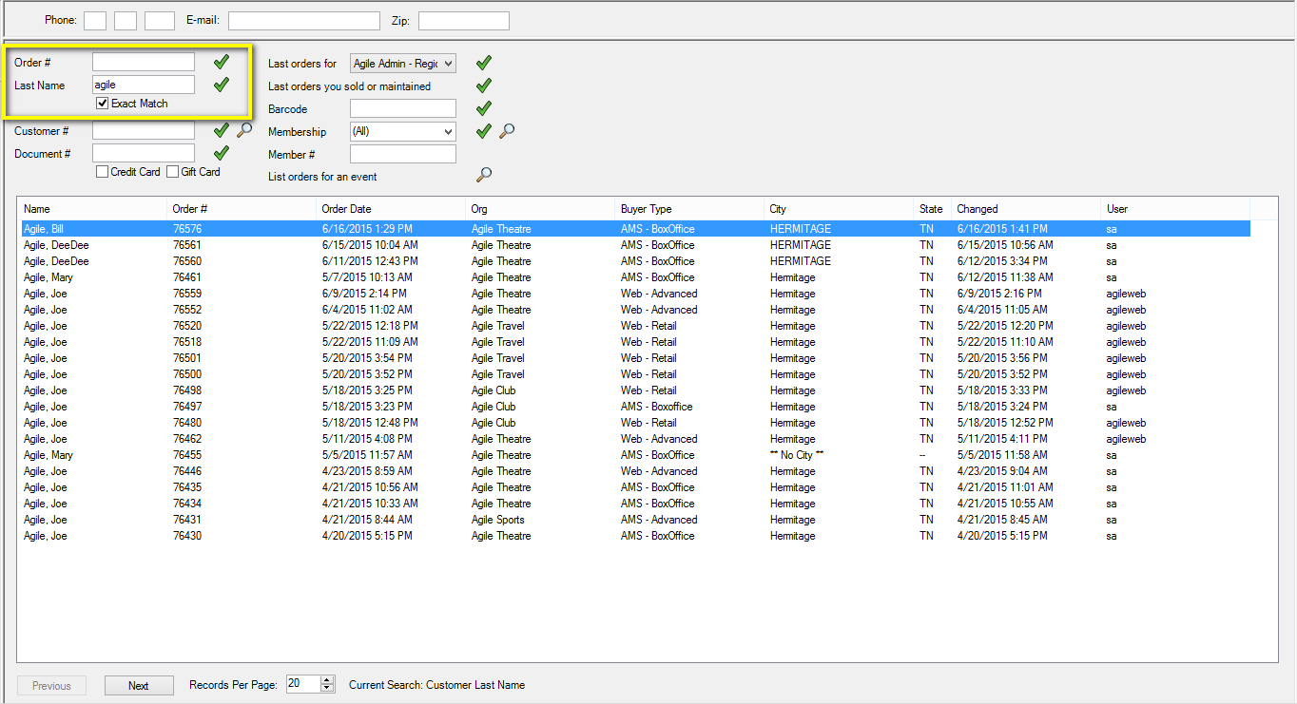
Image 3
4. Your order should have an Account Balance visible in the upper right-hand corner. (Image 4)
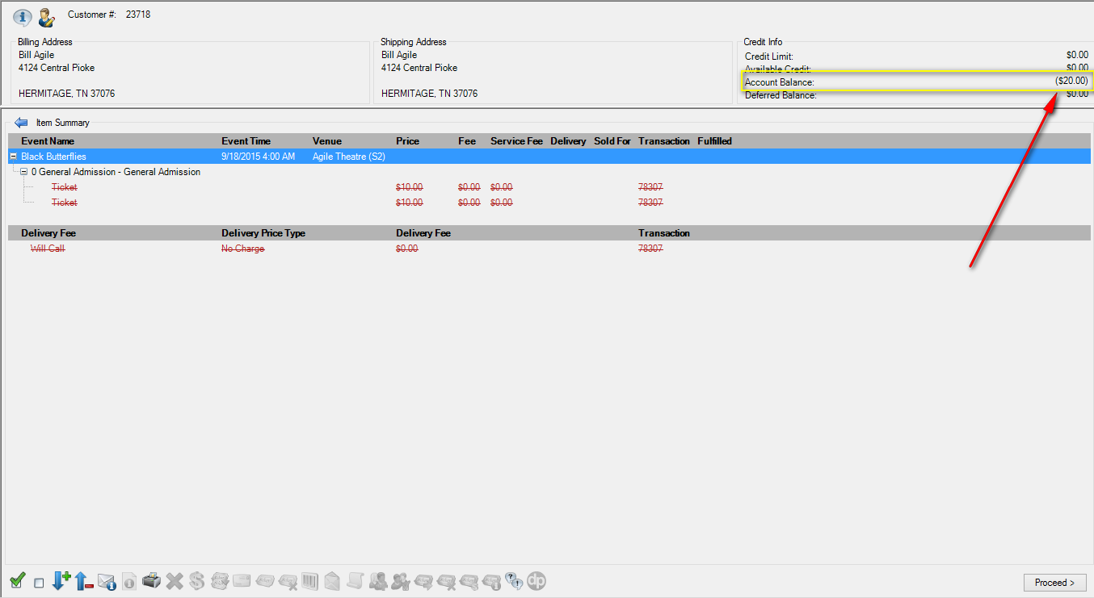
Image 4
5. Click on the Payments icon 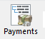 at the top of the page to verify the refund method. If it has been done through Account Balance, you will see the line item. (Image 5)
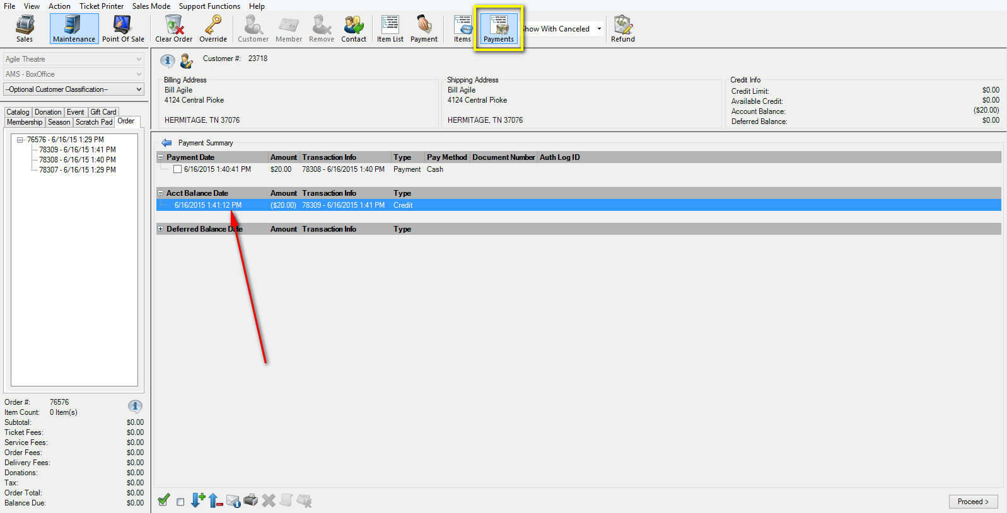
Image 5
6. Off to the side, select the Event tab and then the Line Item you wish to sell. (Image 6)
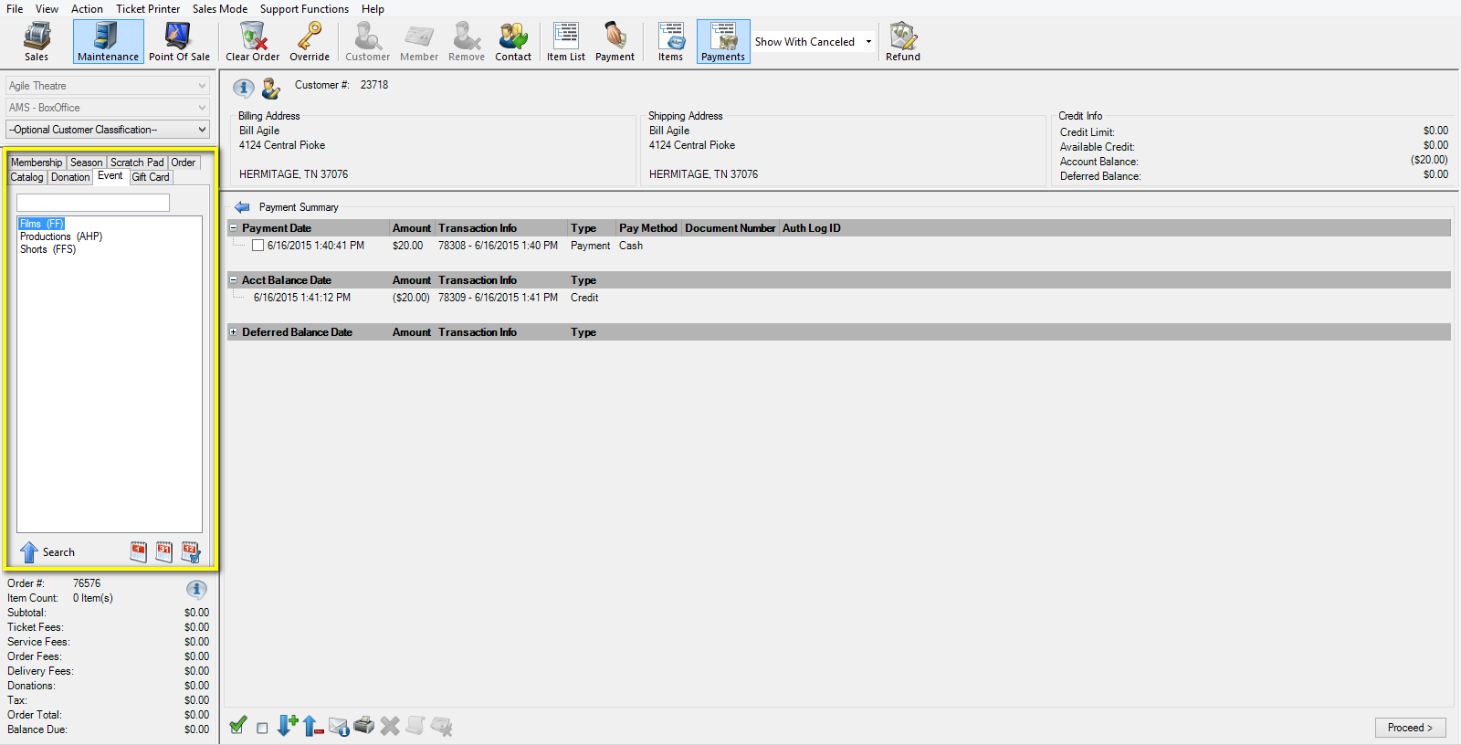
Image 6
7. Select the event or show from the list on the right. Add the quantity of tickets for your new event. Then click Proceed. (Image 7)
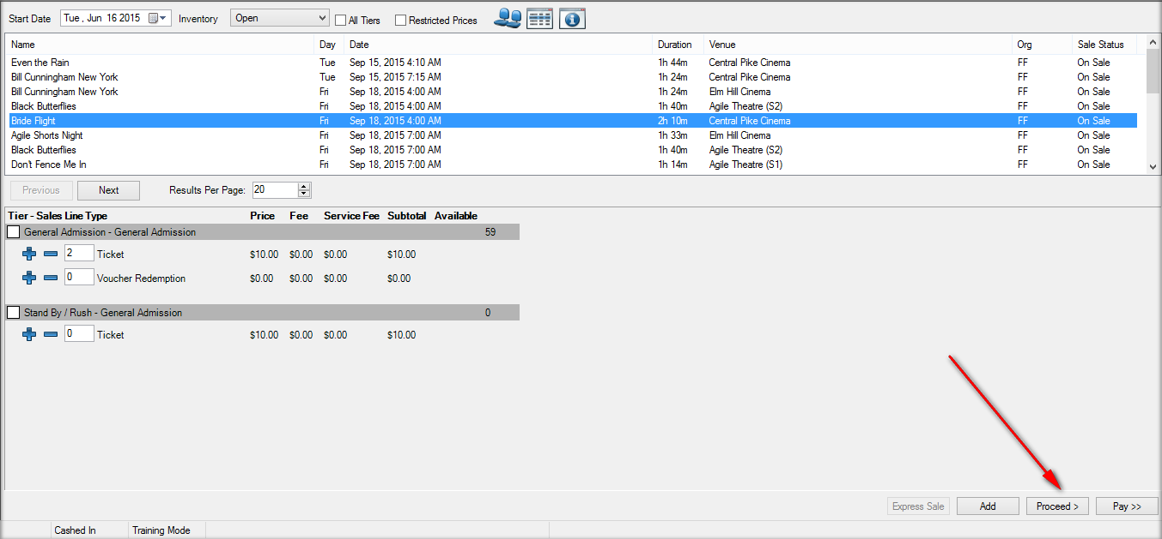
Image 7
8. You will then be brought back to the Line Item Summary, from there click Proceed. (Image 8)
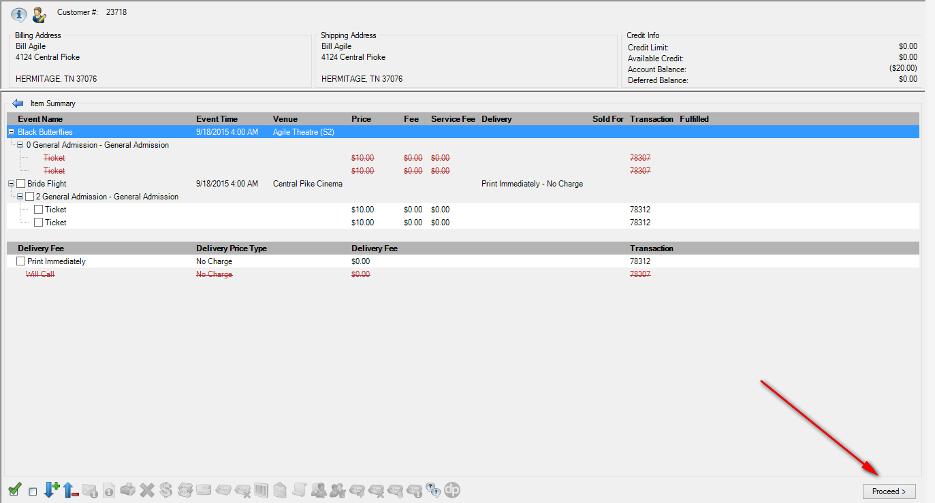
Image 8
9. On the Payment Information page under payment method select Apply Account Balance up to ...this will apply the Account balance to the new tickets. If the Account Balance only partially covers the full payment due, click Apply Payment. Then pay the remaining balance as normal. Click Finalize. (Image 9)
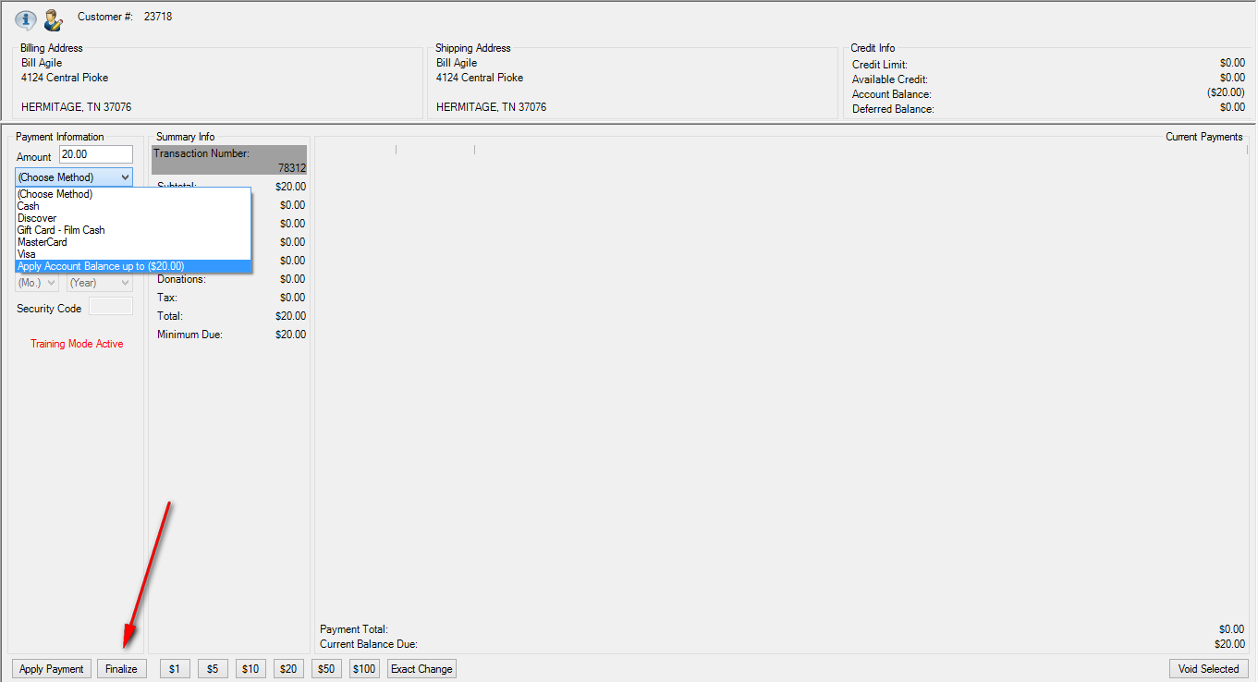
Image 9

