Selling Concessions/Merchandise In AMS.
1. Log into the Sales side of Agile.
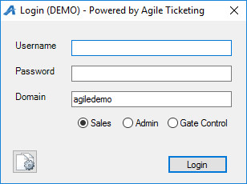
2. Cash In and create a daily user batch. Learn how to Cash in
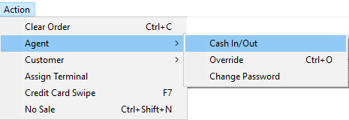
3. Select the correct Sales Organization from the left-hand drop-down, if applicable.
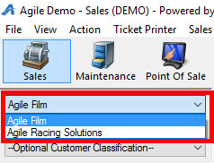
4. Select the correct Buyer Type from the drop down.
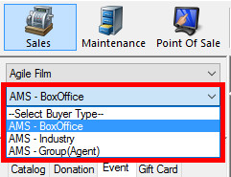
5. Select the Catalog Tab from the left-hand side, then click on the corresponding folder name.

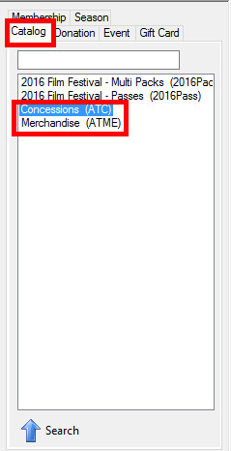
6. Select the Concession/Merchandise item from the list.
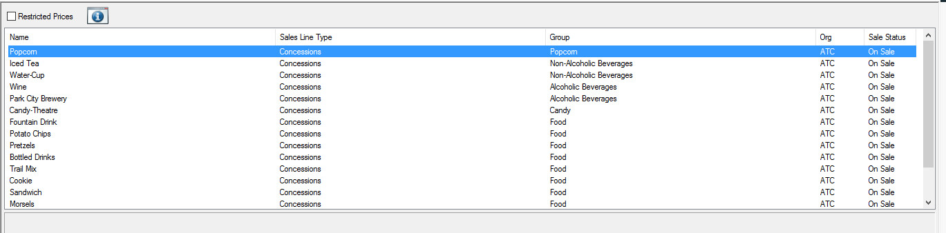
7. Enter in the quantity and type, then click Add.
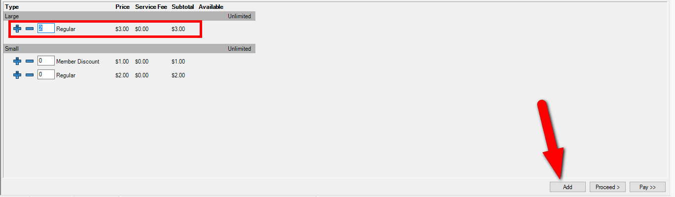
8. If adding more Concession/Merchandise items, add them to the cart. If finished, click Proceed.
9. Confirm all the correct items are in the cart. If something is missing, return to the item list by clicking on the Catolog tab on the left-hand side of the screen. Once you have completed adding items to your cart, click Proceed to go to the Payment Information page.
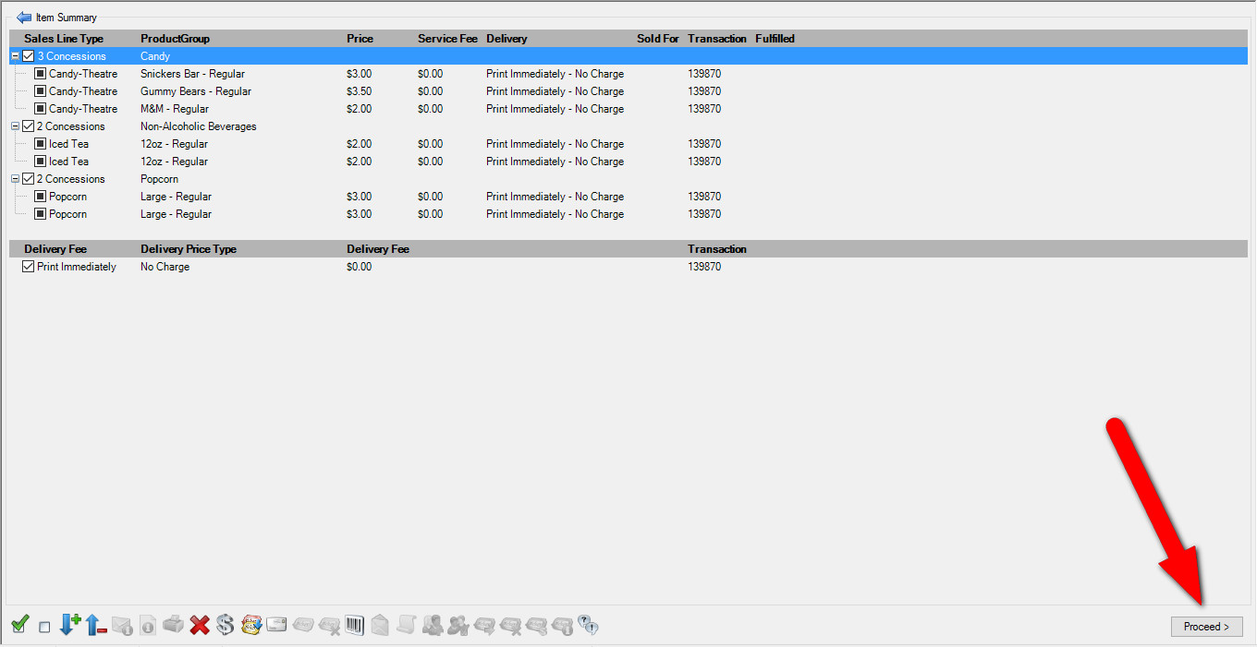
10.On the payment page, you will see the total amount due. If the customer is paying with cash or check, Choose the Method of payment type from the drop-down and click Apply Payment to complete the order.
11.If they are paying with a credit card and you have a credit card swipe attached to your computer, all you will need to do is swipe the credit card and the card information will populate and start the authorization process. If you do not have a card swipe, you can manually enter the credit card information and then click “Apply Payment” to authorize the credit card.

