Adding A Donation In POS
1. In the POS screen click on the Customer Search icon at the top of the screen.
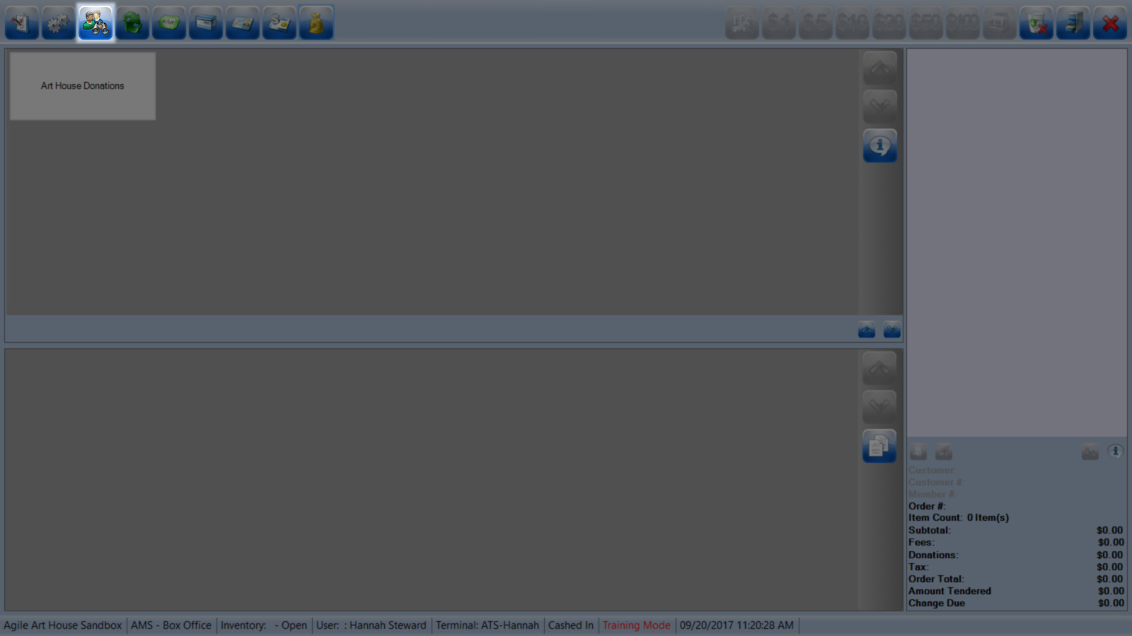
2. Search for the Customer or Add a New Customer.
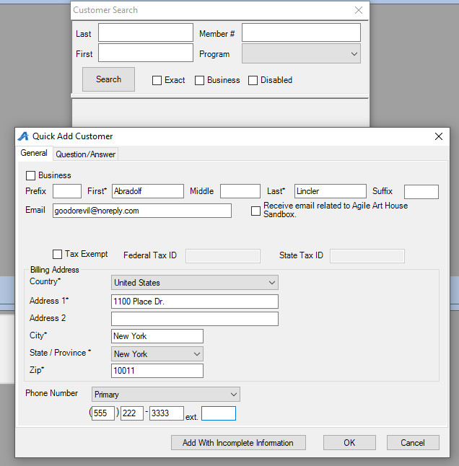
3. Click on the Donation Button.
4. Click on the Donation Program the customer is giving to.
5. Click on the amount of the donation. You can enter in the amount the customer would like to donate or select one of the predetermined amount buttons.
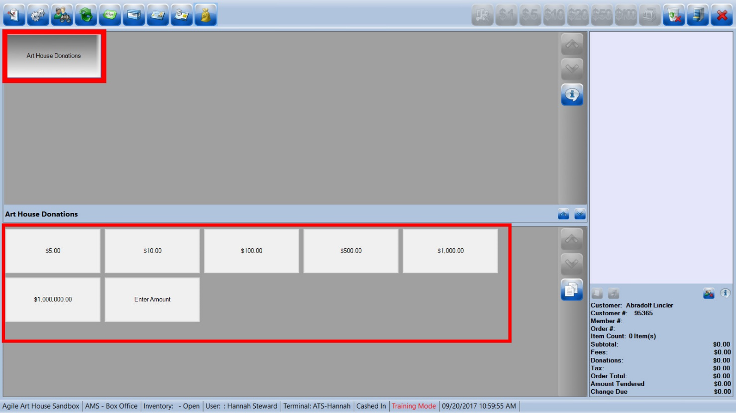
6. The Donation amount will appear in the right-hand column.
7. Click on the Cash Register to enter in the Payment method. If you have a credit card swipe connected to your station you can swipe the card at this time.
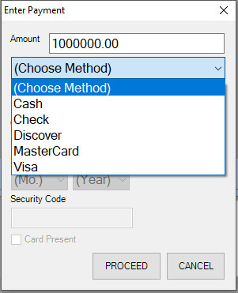
8. Once the payment has gone through the order information in the bottom right corner will turn orange.
