Sending Emails Through the Emails and Letter Tool
These instructions will show you how to generate email and marketing collateral to send to your customers using the Emails and Letters function area of the software. Before you get started, make sure that you have the Agile software downloaded on your computer and that you have received your log in credentials from your system administrator.
1. Log In to Administration. (image 1)

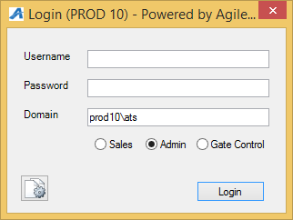

2. Click on the Corporate Organization icon to see all of your administrative folders.

3. Click and open the Customer Relations folder.
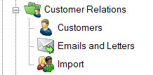
4. Select Emails and Letters.
5. To create a new email data set, right-click in the Emails and Letters area and select New. Select a Data Set from the Query Data Set drop-down. Each Data Set includes a short description and lists the Data Elements that are contained. After selecting the appropriate Data Set, click OK.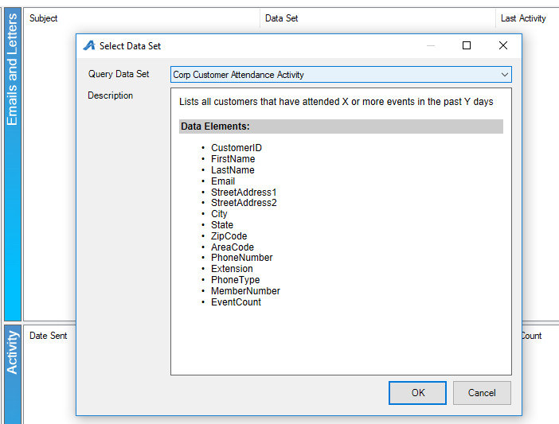

6. You are now in the Email/Letter tool. You will see 4 tabs: Data Set, Email / Letter Body, Description, and Preview.
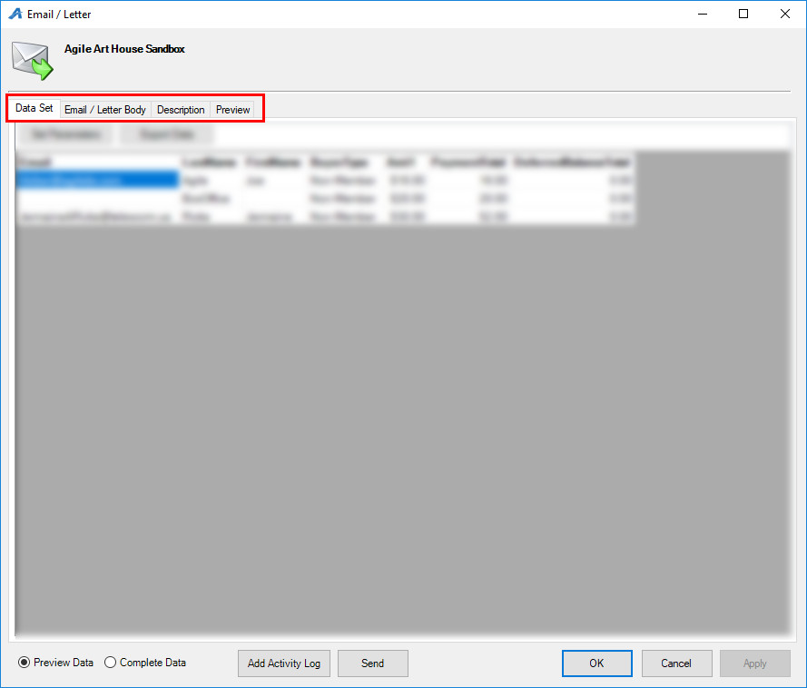
Image 4
7. The Data Set tab will populate customer information based on the Query setup from above (i.e. members, event list, opt-in customer database, etc.). Use the Set Parameters button to pull specific information. Set the variables and/or event from the appropriate tabs. The options available change depending on the Data Set chosen and may not be available at all.
8. The Email / Letter Body tab is where the email/letter content is created. In the From field, confirm that the email address is correct for the customer to respond to if they have any questions. We suggest using something familiar to customers such as an info@organization.com or boxoffice@organization.com email address.
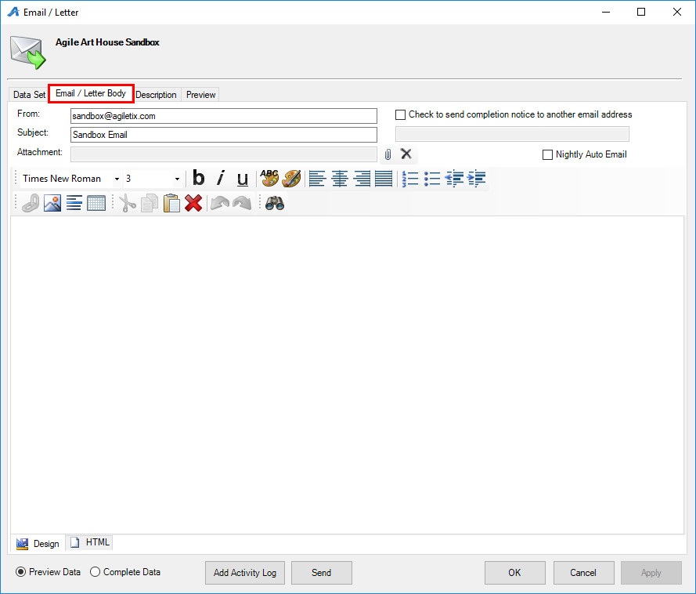

9. When creating your email you can add hyperlinks, text, and insert pictures into the body of the email by using the tool bar (Image 6).

10. Text fields from the Data Set tab are available to merge into the body of the email/letter. Right-click within the email body, select Insert, and select the desired field (i.e. First and last names, mailing address, and more.)
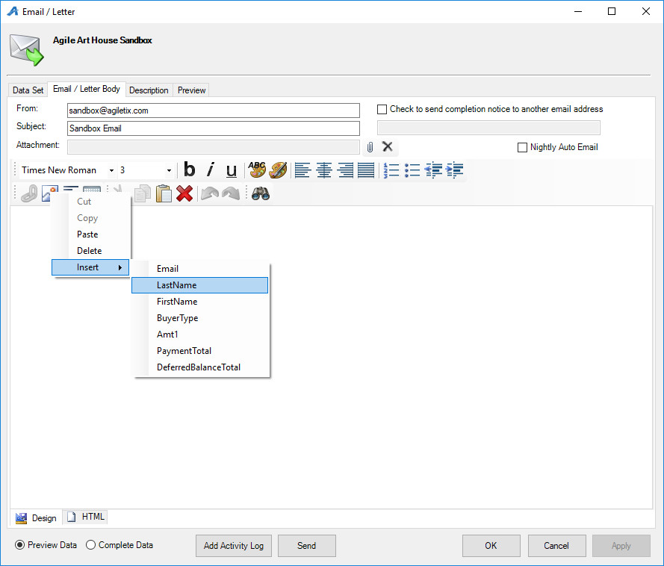

11. To create a Hyperlink within the email, highlight the text or image you would like to attach the URL to, and click on the chain link icon 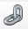 to create the link. Enter the URL and press OK to finalize this step.
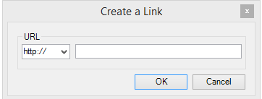

12. Click on the picture icon to upload an image or logo to your email. The image upload screen will pop up see (Image 9). You can select from any pre-saved image in the drop down menu or you can click on the import bottom to upload a new image from you library. This is also where you can adjust the alignment of you image.
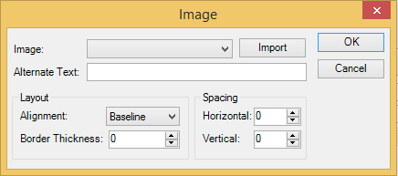

13. Once you have drafted your email/letter, click on the Description tab. The Description area will allow you to add internal notes about your email campaign. This typically includes a date, a short name, and any additional note you need for historical data. This is not seen by the customer.
14. The Preview tab will show you what the final email will look like as well as give you the option to send a test email to yourself before sending it out to your target group.
15. When everything looks correct, click the Send or Print button. (Image 10)
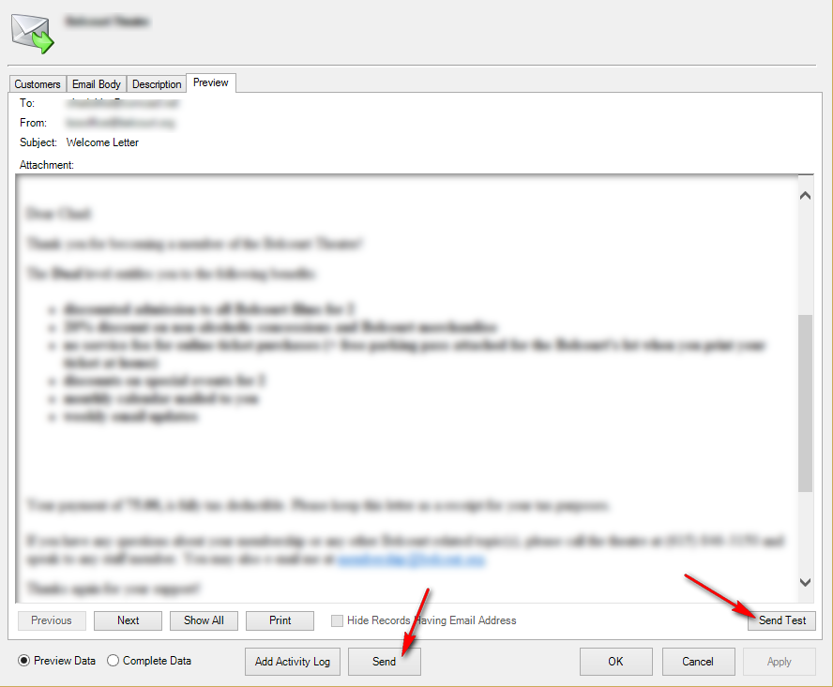

16. You may save your content at any time by clicking Apply then OK. Neither of these buttons will trigger an email to go out or a letter to print.

** Note: once your email campaign has been sent you can view the statistics in the Activity window
