1. Log into Administration
2. Click on House Icon
3. Select the blue folder that houses your shorts.
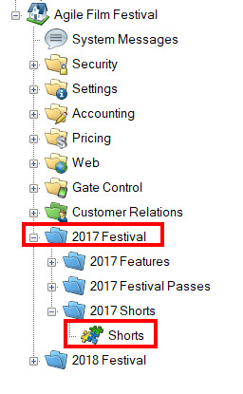
4. Right click in the shorts area and select the Import.
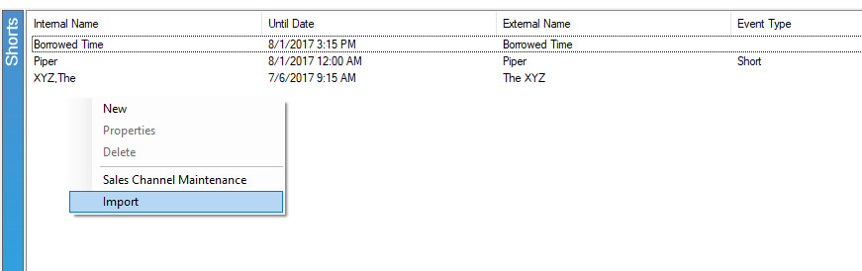
5. In the import page click Import Example.
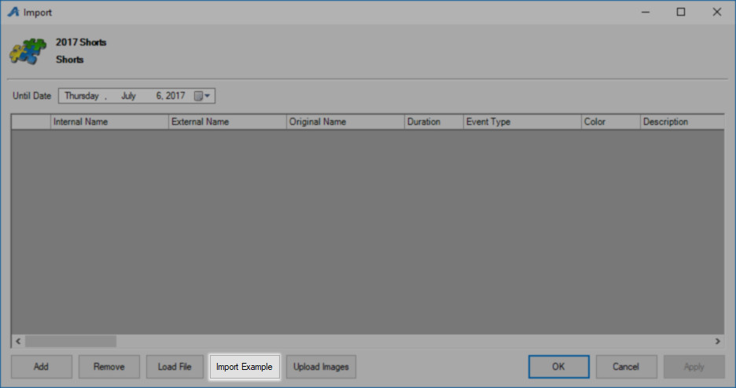
6. Rename and save the spreadsheet. Enter your Short information in the spreadsheet. Below are descriptions of each column on the spreadsheet. Some of the columns are required while others are optional 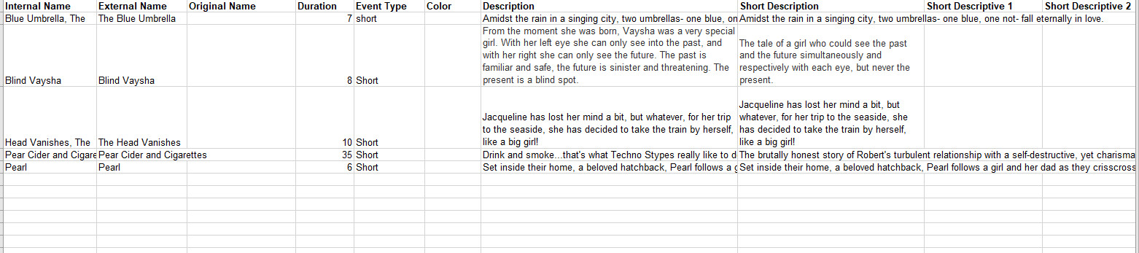
A. Internal Name – This is the name of the show/film that will appear in the Agile Sales application. This is a required field.
B. External Name – This is the name of the show/film that will appear on the web. This should be the proper title of the film or event. This is required.
C.Original Name - If the show/film has a foreign title, this is where you will list the original title in its native language. This is optional
D. Duration – This is the run time of the film in minutes. This is required.
E. Event Type - These are the different type of events (i.e. Feature, Opening Night Film, Short, Shorts Program, etc.). This is required.
F. Color – This will allow you to assign a color that will appear on the grid view online (i.e. Documentary films are all Red, while Shorts Programs are Blue, etc.). This is optional.
G. Description - This is where you will put a full-length synopsis of the film. This is optional for the import, but we highly recommend adding the information in the spreadsheet and import all at once.
H. Short Description - This is a short synopsis of the film. This is optional, but we highly recommend adding this information in the spreadsheet to import. (Image 6)
I. Short Descriptive 1 - Gives you an additional space to show the film type, the rating and the run time. This is optional.
J. Short Descriptive 2 – Can have additional information listed here (i.e. Doors Open at 6 PM, etc.) This is optional
K. Web Availability – This is an area to add additional information that you would want the customer to know when your inventory for that event/movie has reached zero (i.e. Rush Line Only, Sold Out, etc.). This is optional
L. Show Info – This can be used to add additional information about the show (i.e. Sponsored by XYZ Company, etc.) This is optional
M. Extra HTML – Can add additional information for this event and can have customer scripting and other HTML Text. This is optional
N. Confirmation – Can add specific confirmation text for this event. This is optional.
O. Ticket Verbiage 1 – Can place specific information that will appear on the ticket when printed. This is optional as most ticket formats now pull information from different elements in the database.
P. Ticket Verbiage 2 – Can place specific information that will appear on the ticket when printed. This is optional as most ticket formats now pull information from different elements in the database.
Q. Ticket Verbiage 3 – Can place specific information that will appear on the ticket when printed. This is optional as most ticket formats now pull information from different elements in the database.
R. Ticket Verbiage 4 – Can place specific information that will appear on the ticket when printed. This is optional as most ticket formats now pull information from different elements in the database.
S. Ticket Verbiage 5 – Can place specific information that will appear on the ticket when printed. This is optional as most ticket formats now pull information from different elements in the database.
T. Project Code – If you have specific codes associated with the film, you can place it here. Not required.
U. Distributor – You can place the Distributor’s name for this film. This is optional. Generally used by Art House or 1st Run Cinemas.
V. Rentrak – If you report to Rentrak, place “True” in the field. If you do not, then place “False” in these fields. Generally used by Art House or 1st Run Cinemas. This switch allows user to pull Gross Revenue to send Rentrak report.
W. External Event ID – External Event ID self-populates once you have imported the sheet. Leave this column blank.
X. Image - You show/film images can be imported at the same time as you import the spreadsheet. Make sure that all of your images are all the same size and have been named for ease of association. If you have multiple images for the film, the first image listed in the cell will be the main image for the film page and will also create the thumbnail using the main image. For multiple images, make sure to separate the image names with a comma.
**NOTE: We recommend that all of your images are sized to 560 pixels wide x 315 pixels high at 72 dpi.
Y. Thumbnail Image - You may leave the Thumbnail Column blank. When you import your spreadsheet, Agile will automatically create a thumbnail image using the 1st image from Image column.
Z. Ticket Image - This can be used on your print at home tickets if you need to have a sponsor logo on certain film’s tickets. Not required.
AA. Extra Image/Media – This is where you will put the link for your trailers via YouTube or Vimeo link.
**Note: Columns AB – AT are called Custom Properties. – These custom fields are designated by each film festival or organization to allow them to enter additional information about the film (i.e. Cast and Crew Information, Run Time, Country of Origin, etc. ) Even though these fields are created by the organization, if you do not add information into these cells, the information will not populate online. For more information on how to create Custom Properties, click here.
7. Once you have filled out the spreadsheet save your work and go back in the Import Short page in the software.
8. Click on the load file button and select your finished spreadsheet.
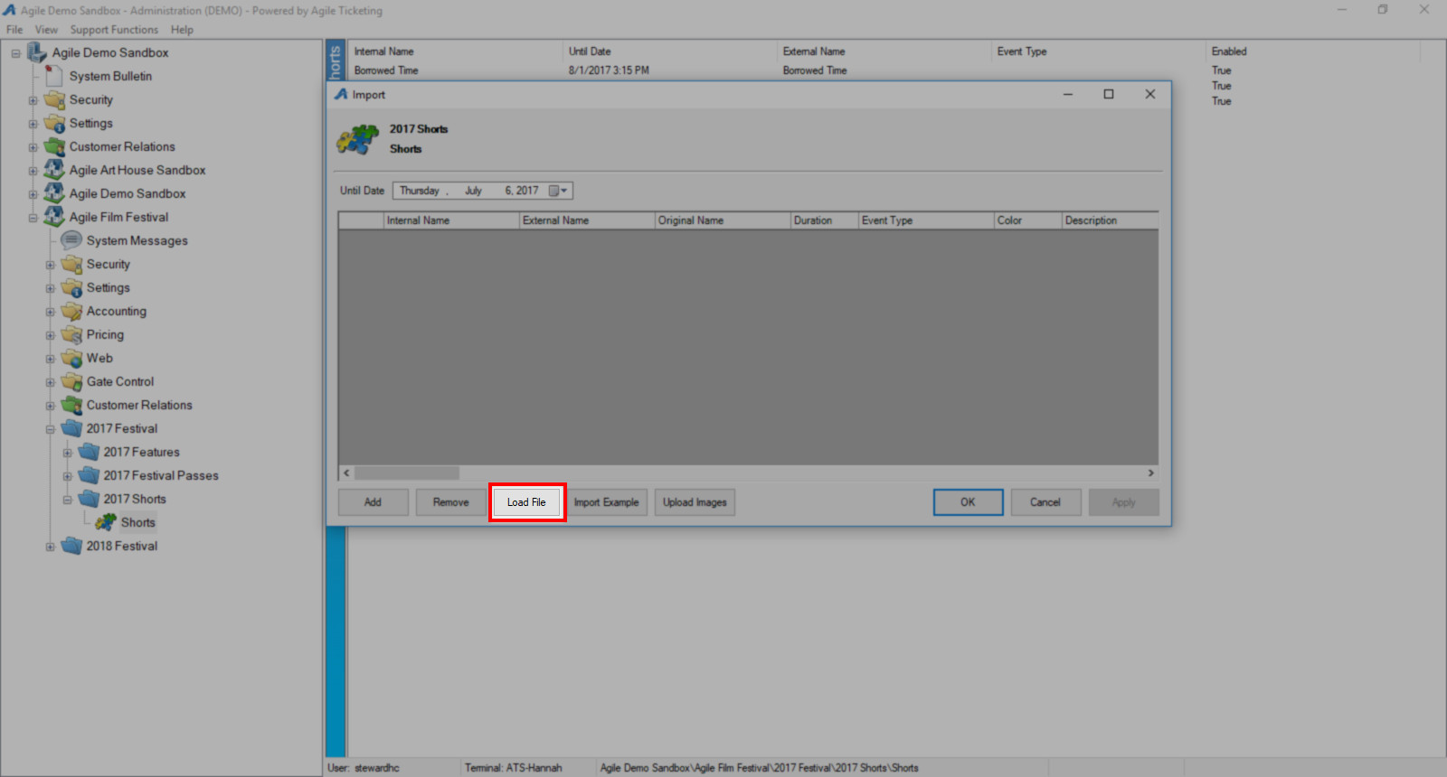
9. Your shorts should now appear in the Import window. Enter the Until Date (we recommend that you put the day after your festival as this will keep the information page available for each short online until after your festival is over). You will see all of the shorts that you have imported. You can proof and make edits to directly in each field as needed.
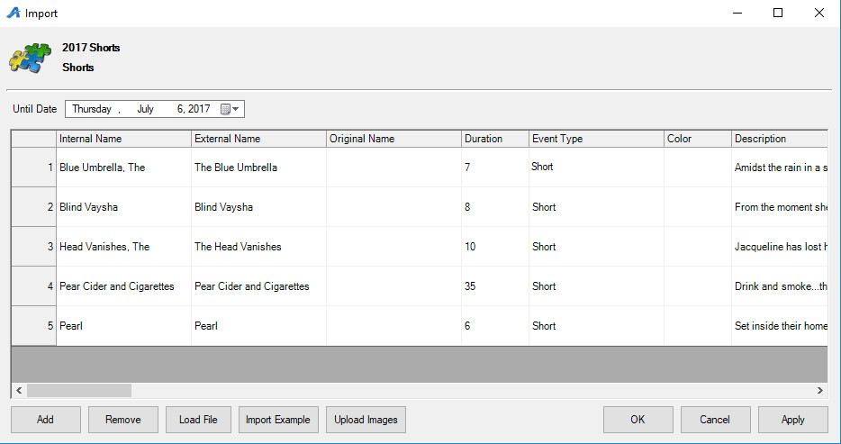
10.Next, click on Upload Images first to import your images folder.
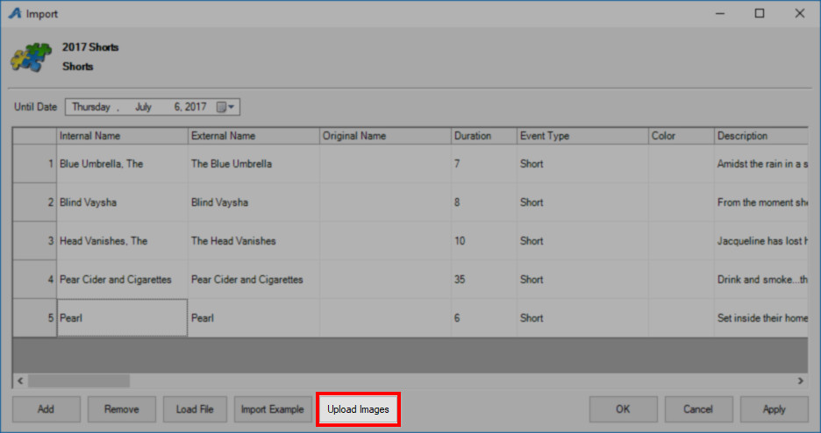
11. Select the image folder from your desktop.
12. When the images appear, in the text field at the top of the screen, name the folder for the image library (i.e. 2014 Feature Images) then click on Upload button at the bottom of the screen.
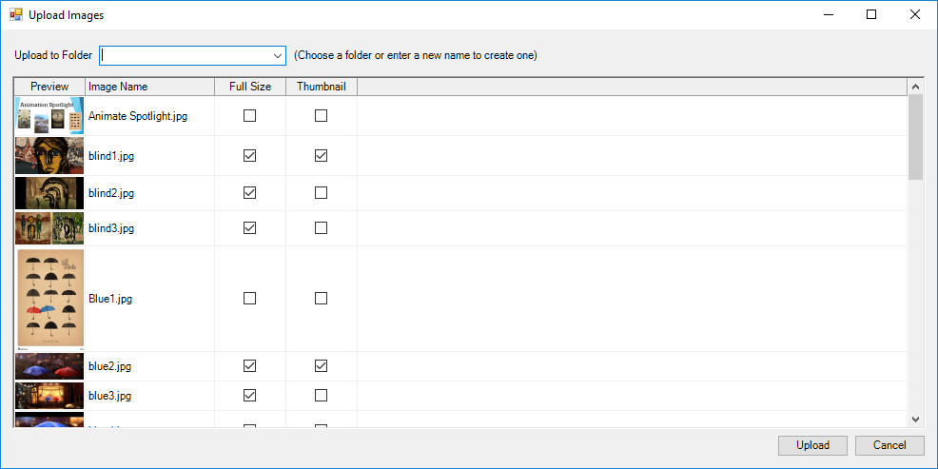
13. Once you have your images uploaded you can click Apply and Ok. You have now Imported you shorts into Agile.
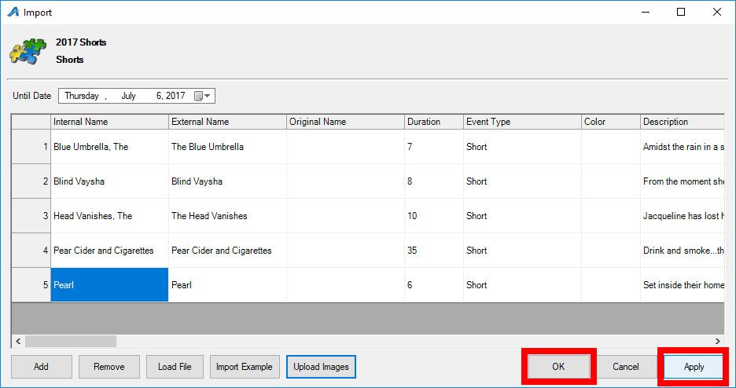

TO ADD SHORT(S) TO A SHOW OR FEATURE LENGTH PROGRAM:
1. Click on the Blue folder that houses your Shows.
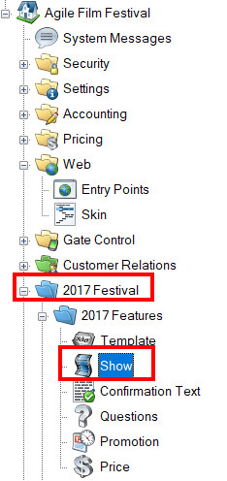
2. Right click on the Show you wish to add the short(s) to and click on Properties.
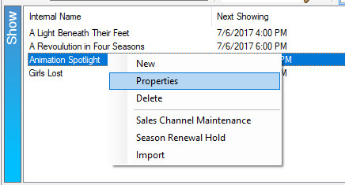
3.Go to the Included Shorts tab and click on the Green plus sign.
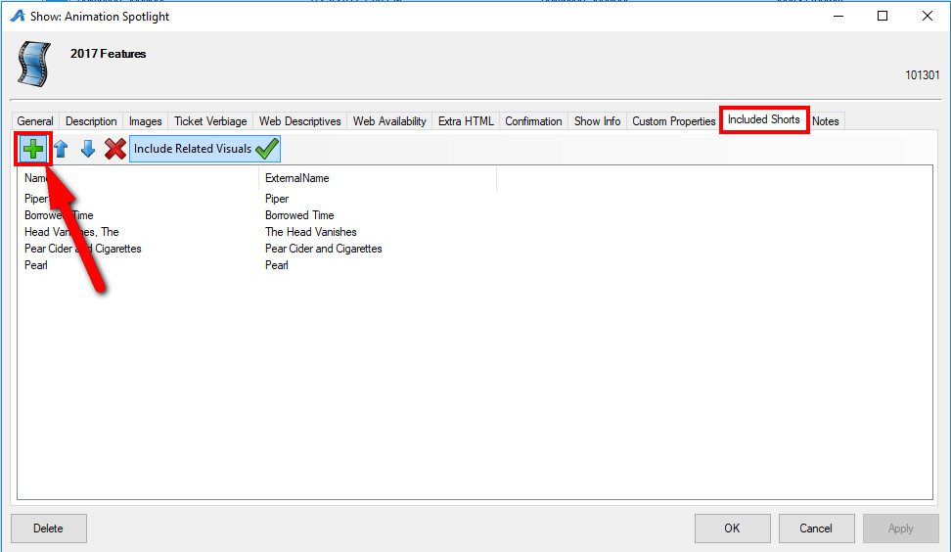
4. Select your Shorts folder.
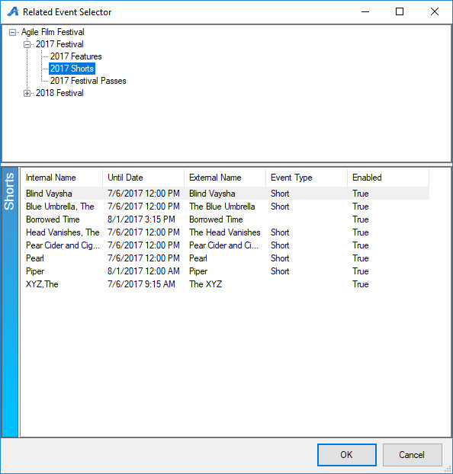
5.Highlight the Short(s) you want to add then click Ok.
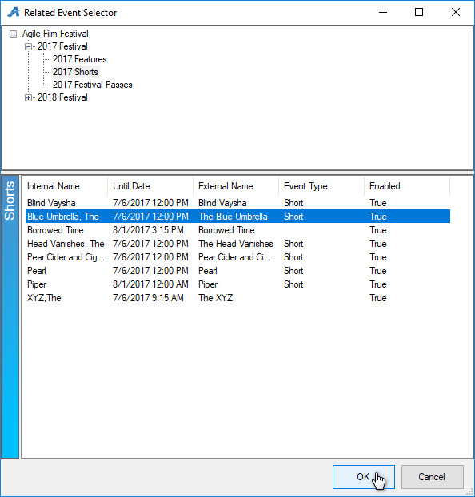
6. You will now see the Short(s) listed on the Included Shorts tab. You can adjust the order of the shorts by clicking the blue arrows at the top of the window. If you want the images and trailers that you have added to each Short film to appear on the Show carousel online, click on Include Related Visuals.
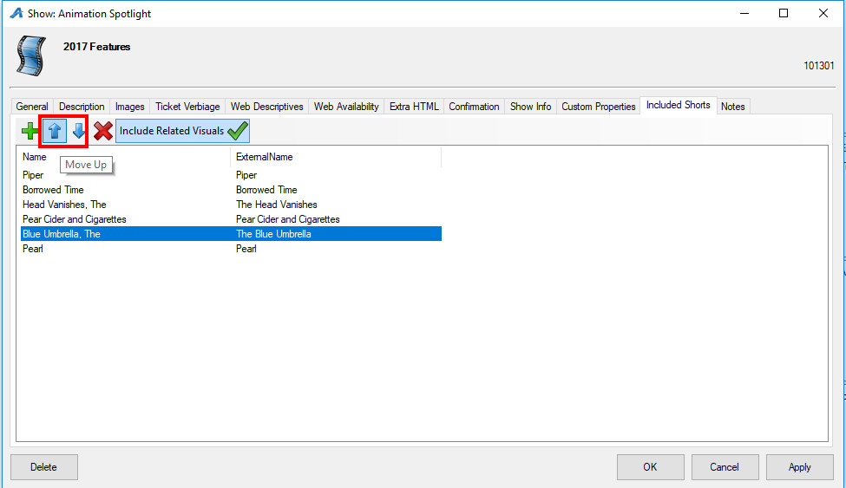
7. Once you have added all of your shorts click Apply and Ok.

