How to Redeem your Ticket Pack
Ticket Packs are a way for patrons to purchase non-dated tickets that then can be redeemed for tickets to certain events.
1. To redeem your ticket pack, click the Sign In button at the top of the right of the page. Enter your Username or the email address and the password.
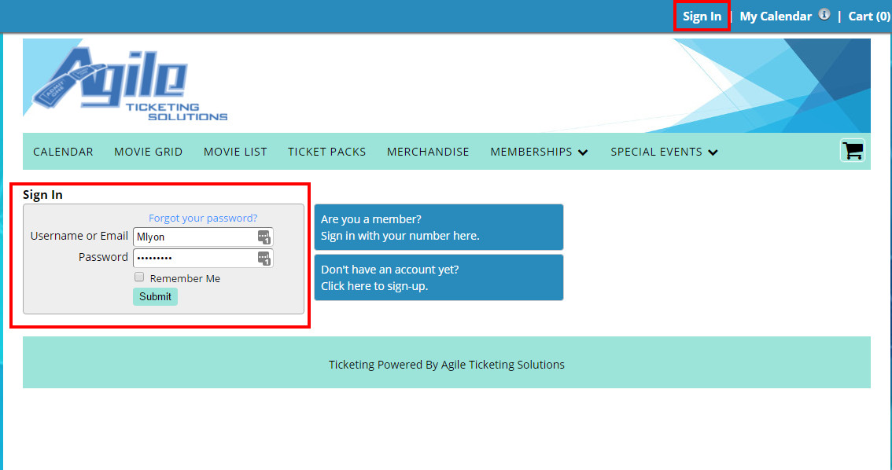
2.Next, go to the Calendar and select the event/film you wish to purchase and click the View More button.
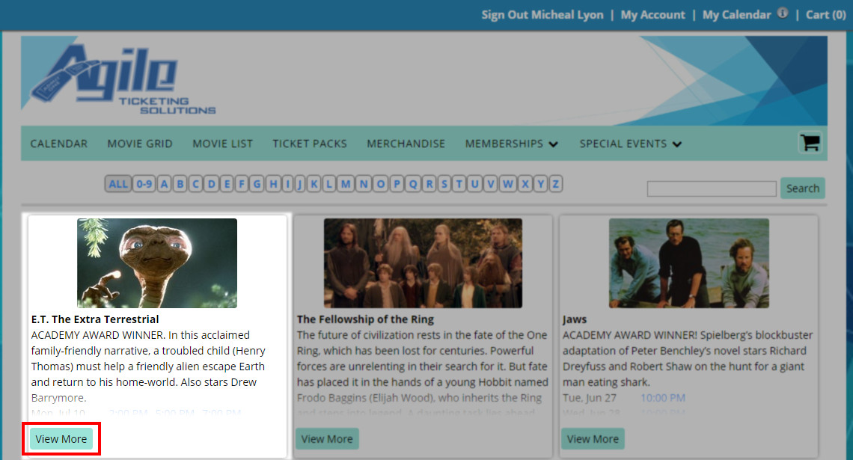
3. Select the Buy Tickets button next to the date and time that you wish to attend.
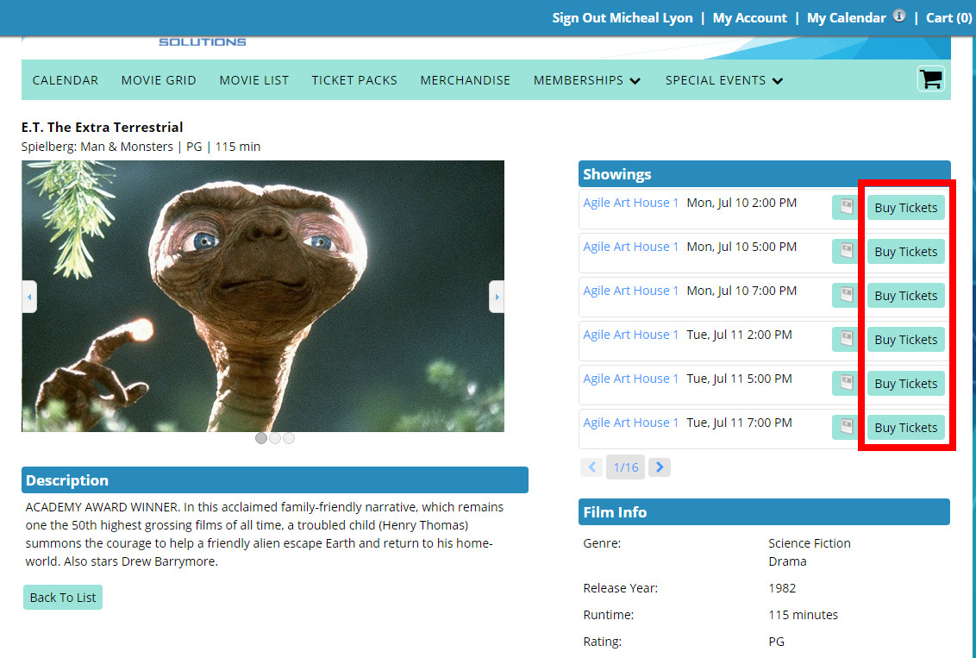
4. Click the drop down next to Ticket Pack Redemption to select the number of tickets then click Add to put the tickets in your cart.
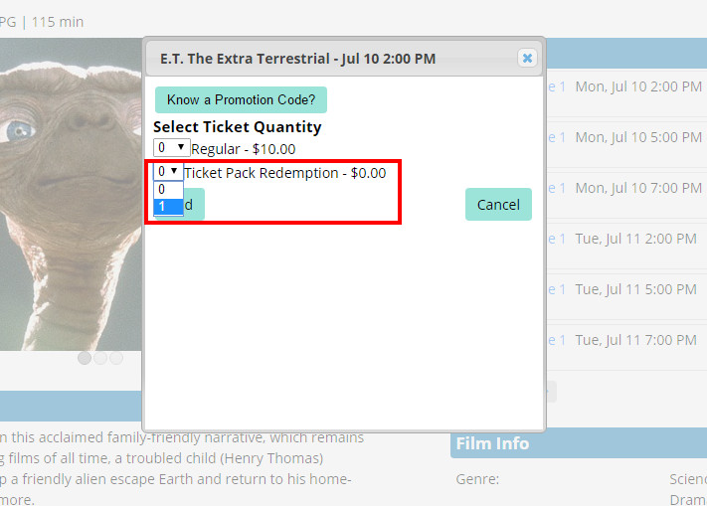
5. Once you have all of your tickets in your cart click on the Proceed to Checkout button.
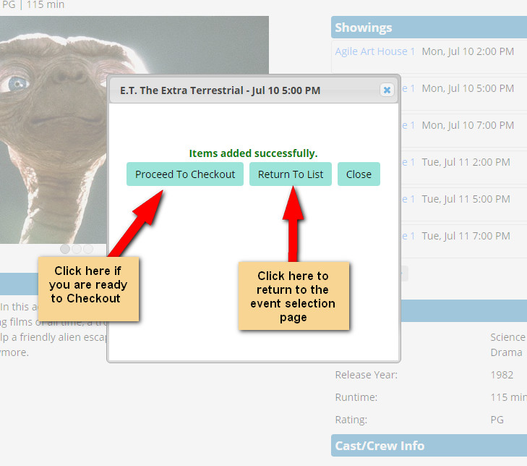
6. Select the method in which you wish to receive your tickets (Delivery Method). Review your order and select Checkout.
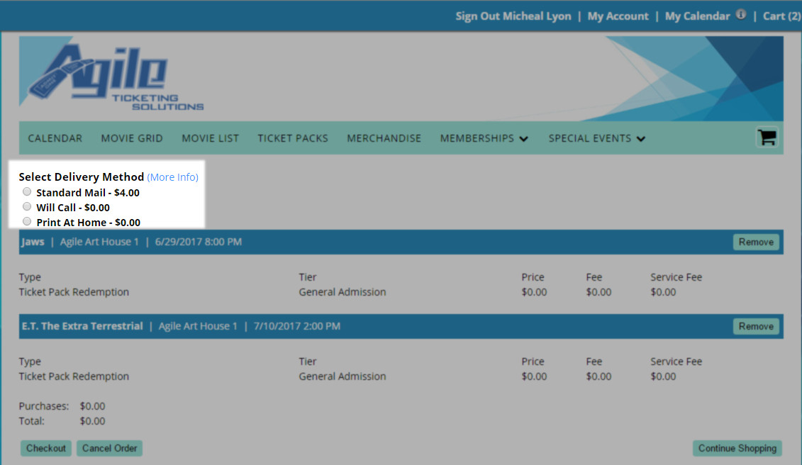
7. Check the box next to Terms and Conditions, and then select the Finalize Order button to complete your order.
