Logging into your Membership Account
Your Membership Account gives you access to all the benefits of your membership. By logging into this account you are able to view tickets, merchandise, passes or any items that you have benefits through your membership level.
1. Go to the Organizations website. Select the Calendar or Event List from the menu.
2. Click on the Sign In button at the top right of the page.
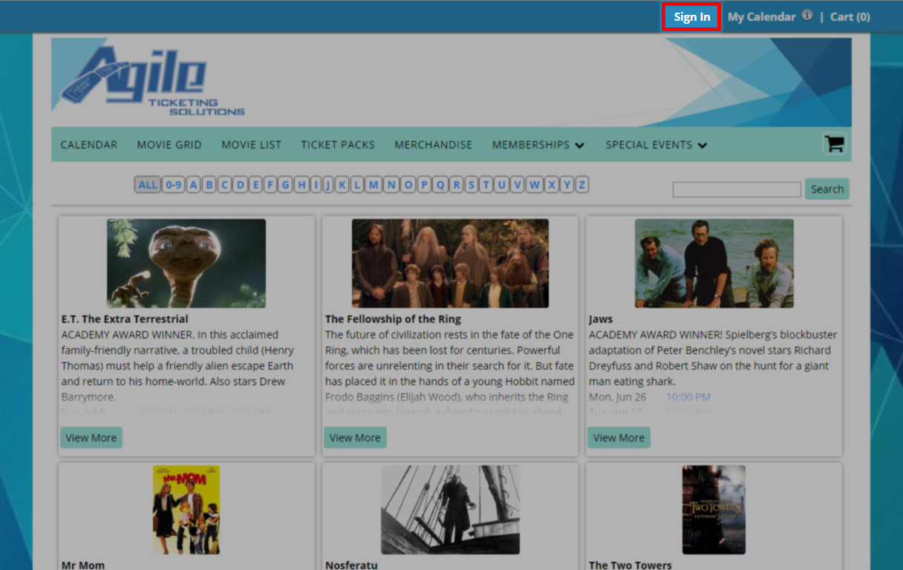
3. On the Sign In page select the Are you a Member? button.
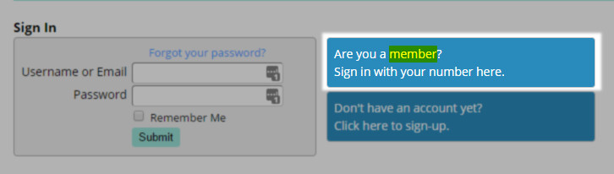

4. Enter your Member Number. This number can be found on your confirmation email or if you have a Membership Card you can find it on the back of the card.
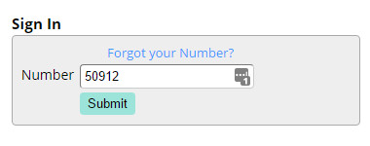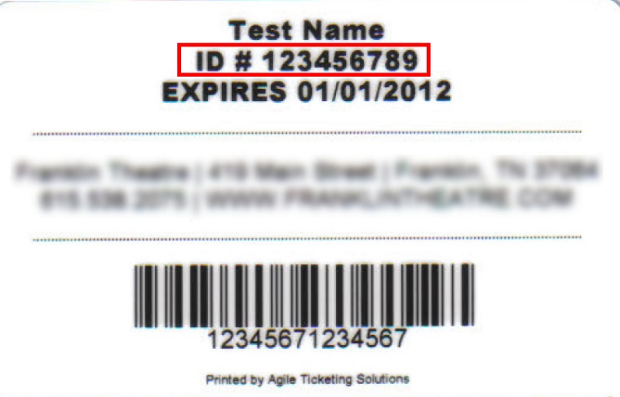
5. If you have a Dual Membership account (meaning more than one person is on your account) you will need to select your name from the drop down. Then click submit. NOTE: Each member on a Dual Membership Account can create their own online account.
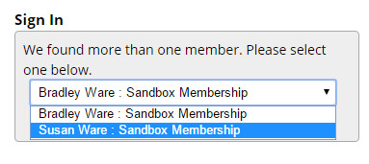

6. For first time users, you will be prompted to create an online account with a username and password. Passwords need to be between 6 and 15 characters long and should be something you can remember. Once you have created your username and password, click on Create Account.
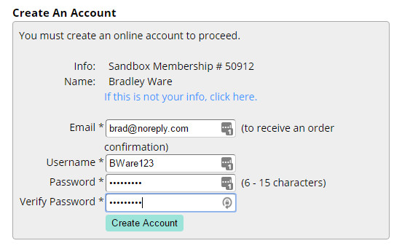
7. You are now able to select your events and redeem your membership benefits online.
