Agile POS users can process a discount to an existing catalog price at the time of purchase. Follow these steps to add a discount to an order.
- Select the Catalog icon at the top of the POS screen.
- Select the category group you will be selling.
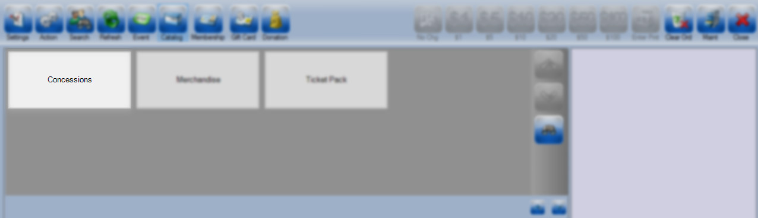
- Choose the Item Group
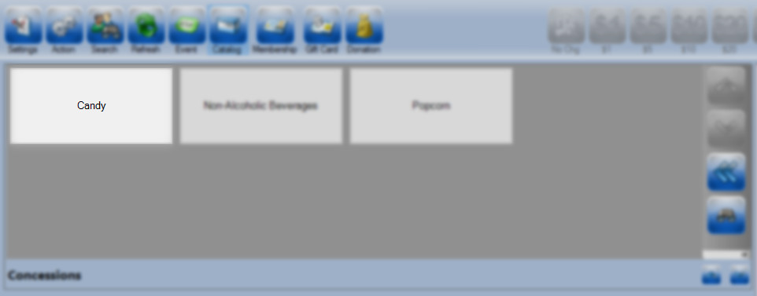
- Click on the Percentage Sign icon.
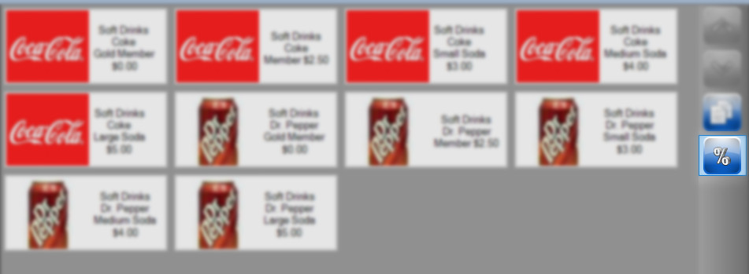

- Select the item that you will be discounting.
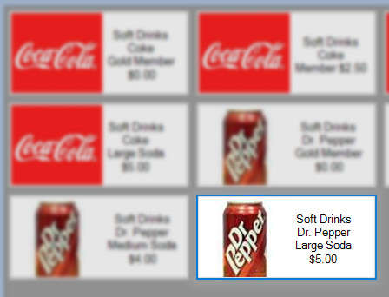

- In the Reduction Amount? window enter the discount you will be giving (in this example I'm entering in 50 as I'm creating a 50% discount off of the $5.00 drink.)
- Choose the top button if you want to give a percentage off the regular price
- Choose the middle button if you want to take a dollar amount off the regular price
- Choose the bottom button if you want this to be the price you want to charge.
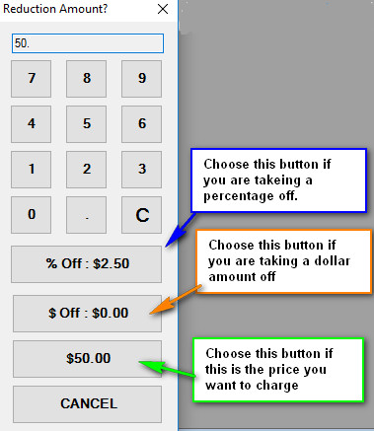

- The item will now be in the shopping cart at the discounted price.
- Complete the transaction once all items have been added to the cart.

