1. Log into Web Portal. portal.agiletix.com
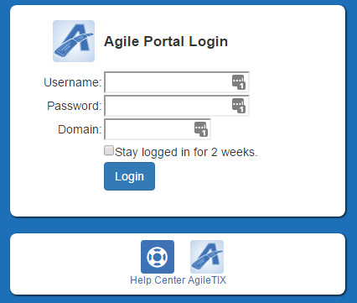
2. Click on the Events on the Menu on the left of the page.
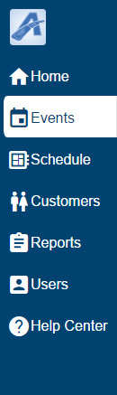
3. Click on the Showings button at the bottom of the screen.
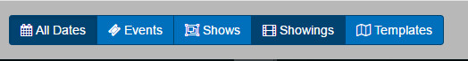
4. Click on the Name of the Showing that you wish to edit.
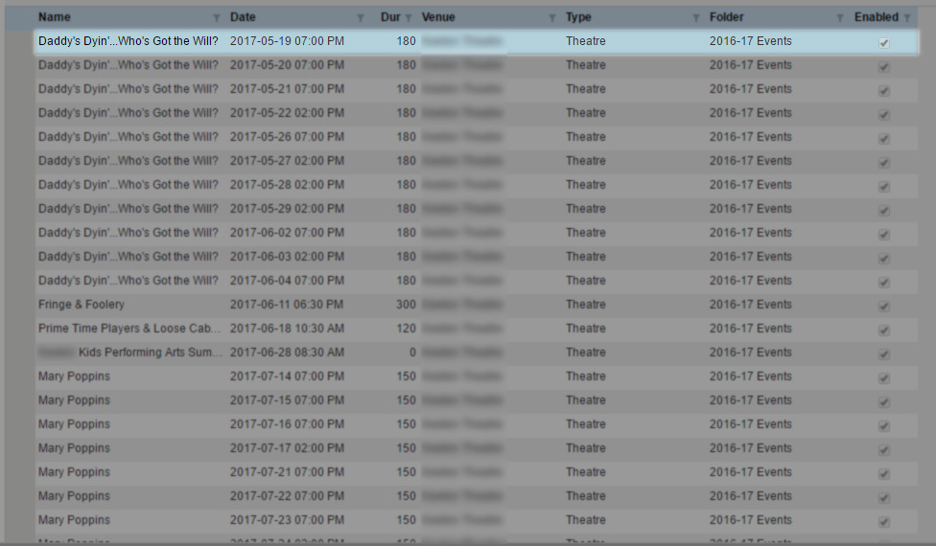
5. Click on the Manage button.
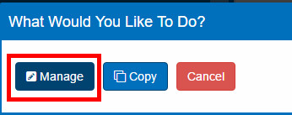
6. You are now on the Showing Edit page for that specific Date and Time. From here you can make your edits to your showing.
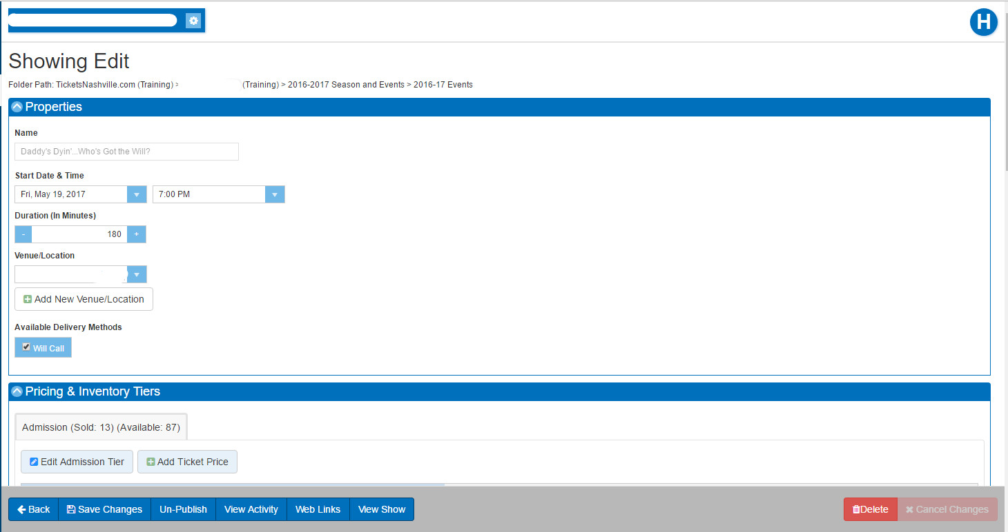
7. Once you have made your edits click on Save Changes.
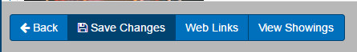
NOTE: If you need to make changes to the show information you can click on the View Show button at the bottom of the page to go to the Show Edit page.
