**Touch Point Tasks** allows you to create a task under a specific customer and then assign that task to a member of your staff to communicate with that customer.

Follow these steps to create **Touch Point Tasks** under a **Customer**record.

1. In **AMS**, search for a **Customer Record**.

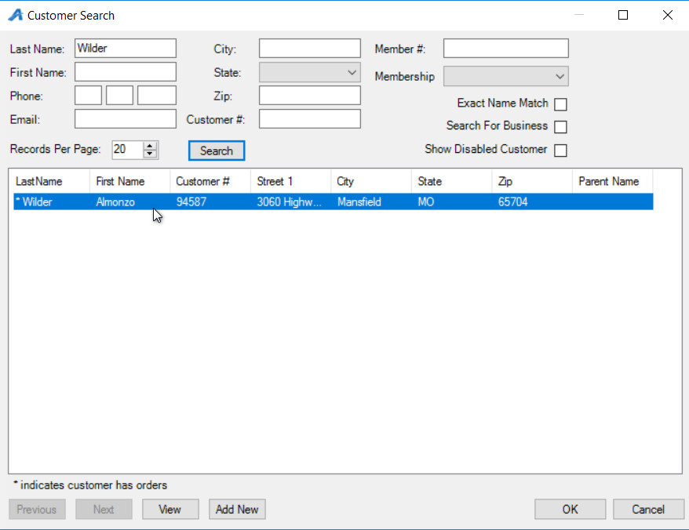

1. Once you have selected the **Customer**, click on the **Customer Number** to open the record.

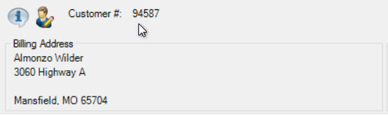

1. Click on the **Touch Points** tab

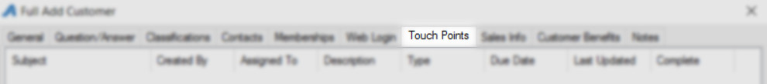

1. Right click on the **Touch Points** field and select **Add**.

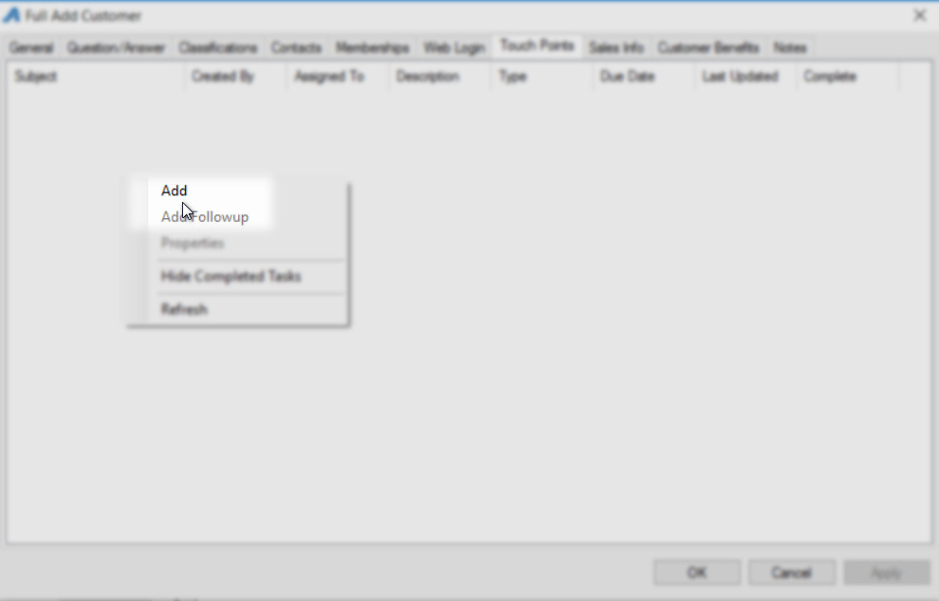

1. Enter the **Subject** of this task.

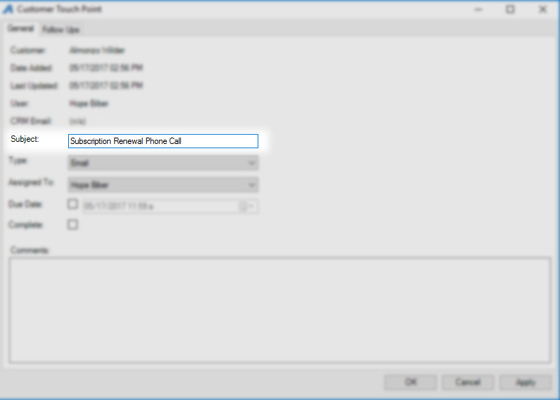

1. In the **Type** drop-down, select the type of communication that should be used to contact this customer (i.e **Email**, **Phone**, etc.).

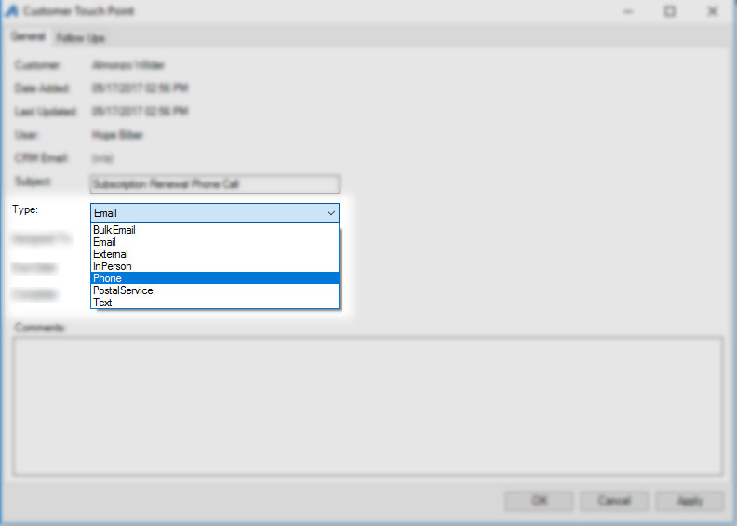

1. In the **Assigned To** drop-down, select the staff member that this task will be assigned.

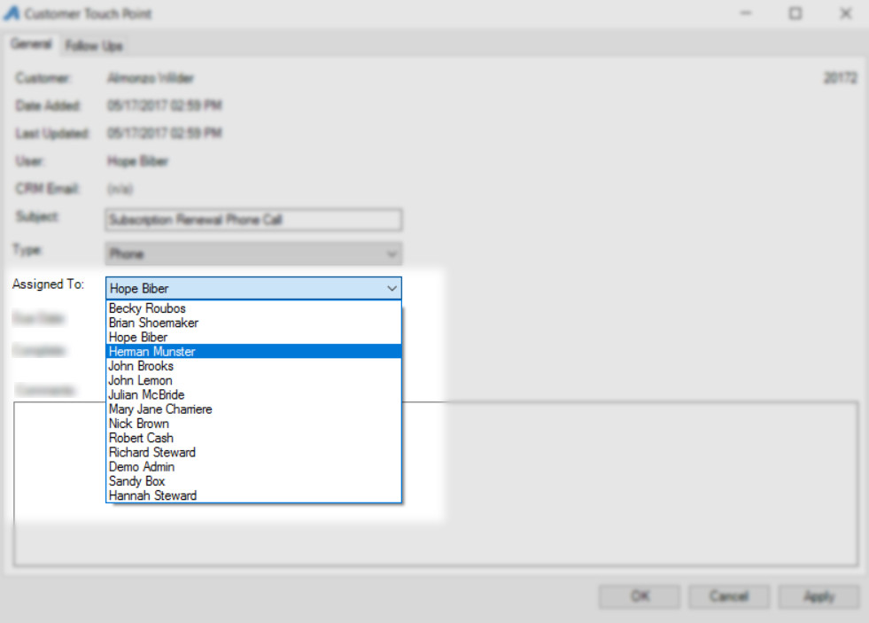

1. Check the **Due Date** box and select the **Date** that this task needs to be completed.

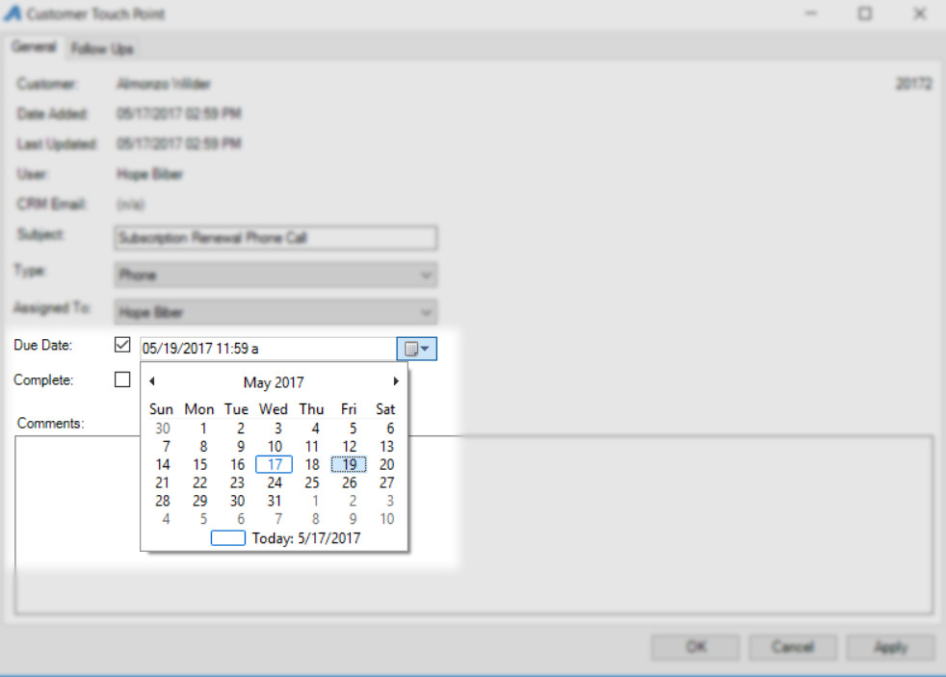

1. Add any additional information about this task in the **Comments** area.

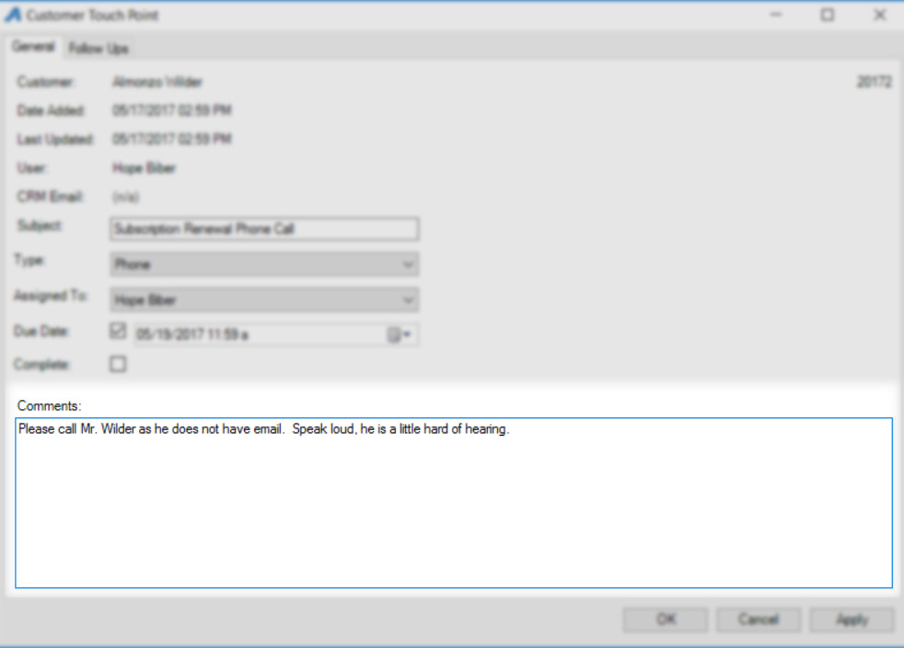

10. Click **Apply** to save and **OK** to close the window.

11. When the staff member is logged into **AMS**, they will see the list of tasks at the bottom of the screen.

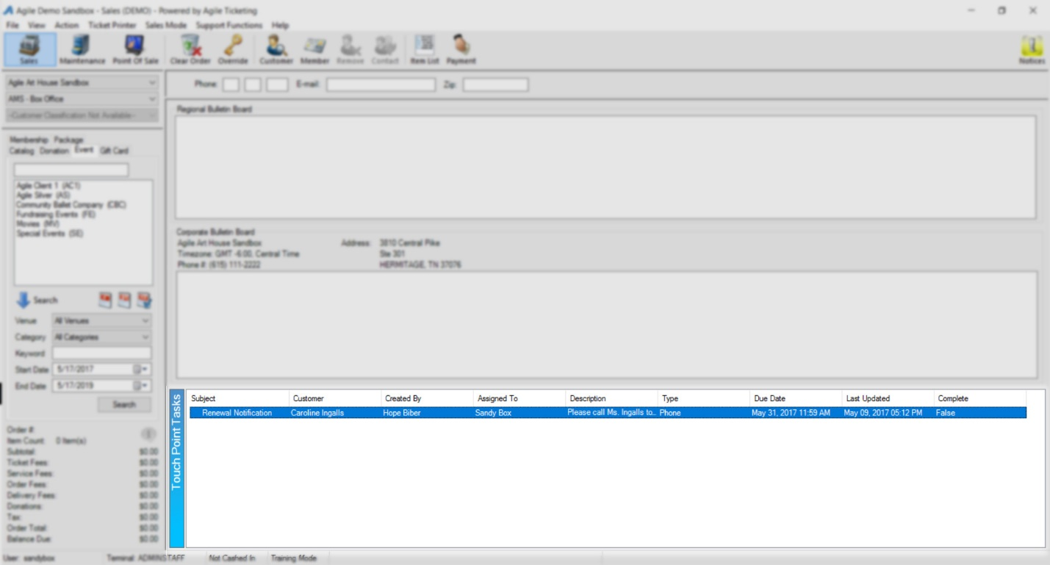

12. To look at the details of a specific task that you were assigned, simply double-click on the task and the task window will open.

13. If there needs to be a follow up on any of the tasks, simply open the task, click on the **Follow Ups** tab and add or adjust the notes.

14. Once the task is completed, the staff member can check mark the box next to **Complete.**

