- Log into Agile and click on Support Functions.
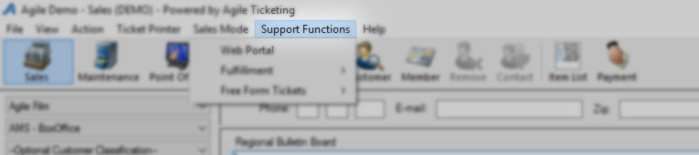
- Select Fulfillment and then Membership from the menu.
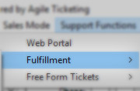
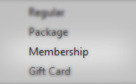
- On the Menu on the Left, select the Pass List that you will be printing.
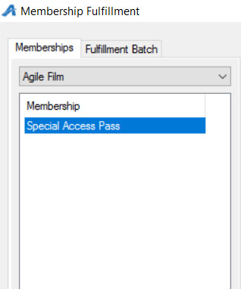

- Check mark the passes that you will be printing. NOTE: You can sort and filter the columns and print only what you need to print. We recommend that you do sort by the Pass Levels so that you can print all of the same type of pass in one print file.
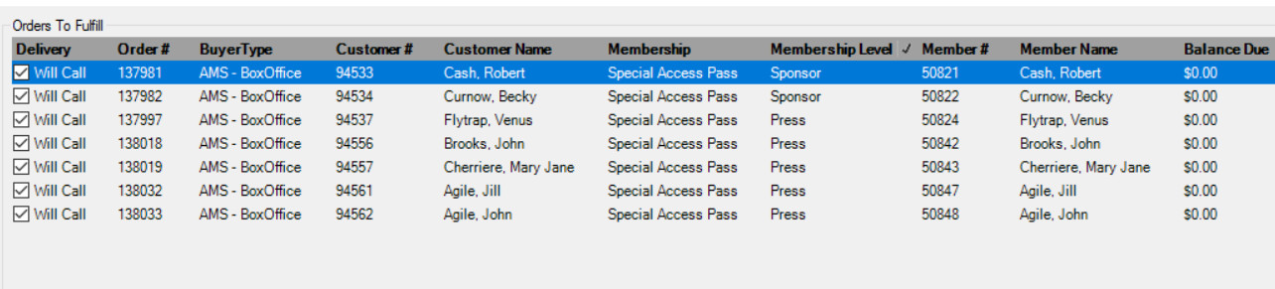
- Select the Ticket icon at the bottom of the screen.
- In the Header Format drop down, select No Header Print.
- In the Order Receipt drop down, select No Receipt Print.
- Uncheck the box next to Print Payment Receipts as you will not need to print the receipts.
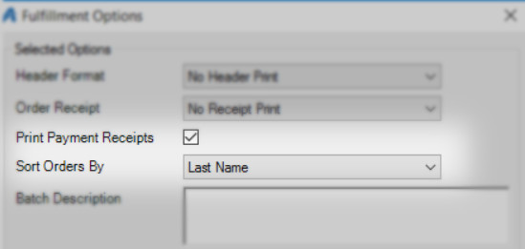

- In the Batch Description, create a name for the batch file (i.e. Sponsor Pass Jan 1, Press Pass Jan 1, etc.).

- In the Sort Orders By drop down, select Last Name.
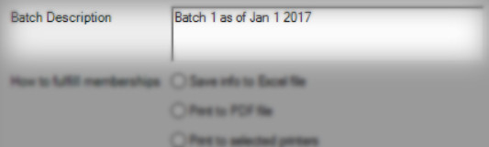
11. Depending on how you will be printing your passes will determine what radio buttons to select:
a. Save info to Excel file allows you to generate an excel spread sheet that will give you the name of the pass holder, barcode number, etc. that then can be sent to a professional printer.
b. Print to PDF allows you to create a PDF of all passes based on the format that is associated with the pass level. The PDF allows you to proof everything before sending it to a printer.
c. Print to selected printers allows you to immediately print the fulfillment list to your ink jet or laser printer. NOTE: If you would like to purchase perforated pass paper, please contact our ISS department for a quote.

NOTE: You will be asked to save the response file. Please choose a location on your computer.
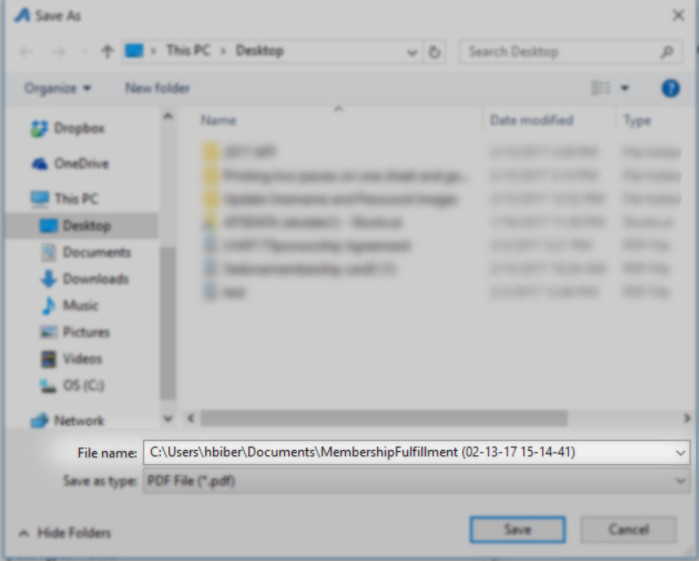

12. Check the box next to Print 2 Passes Per Page.
13. Move the printer from the Available Printers column to the Selected Printers column. If you have not set up a printer in Agile, contact your Client Support Rep for assistance.
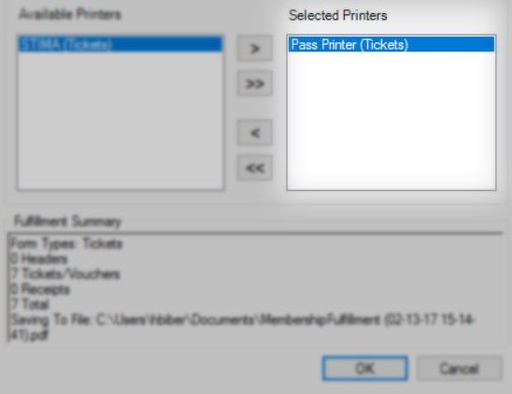
14. Click OK to start the fulfillment process.
15. You will see a results window that will tell you when the printing process is completed and sent to the printer. Click OK once completed.
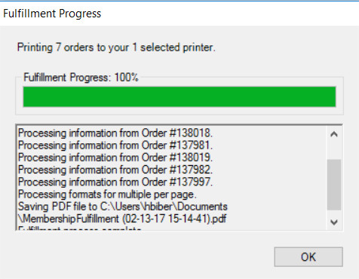
Now you can open the PDF and send to the printer
