As an administrator in the Agile Web Portal, you can edit User Profiles. The User Profile is where you can change passwords, manage security roles, and clear failed logins.
1. In your internet browser log into your organization --portal.agiletix.com.
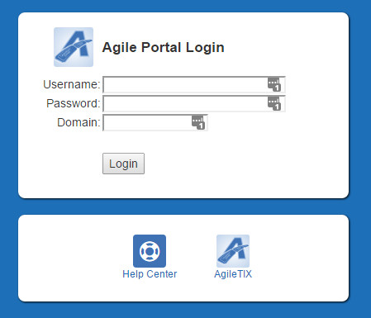

2. Click on the User icon at the menu on the left, or if you want to edit your own profile you can click one the letter in the top right corner.
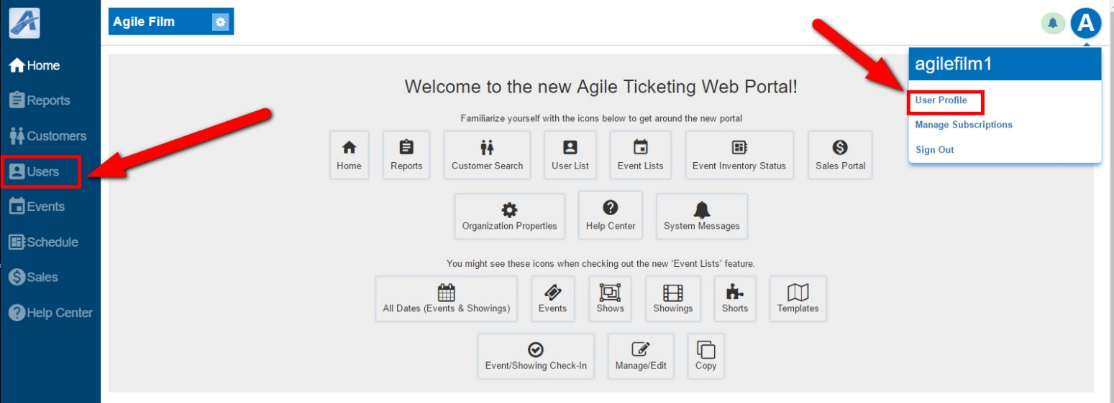
3. Select the User Profile that you need to edit.
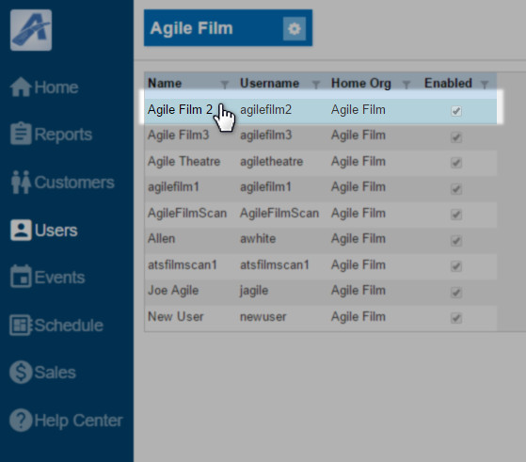
4. To change the password for a specific User click on the on the Change Password icon at the bottom of the screen. Enter the New Temporary Password for that user and then check mark the Require Password Change at Next Login box. This will force the user to create their own password when they next log in to the system.
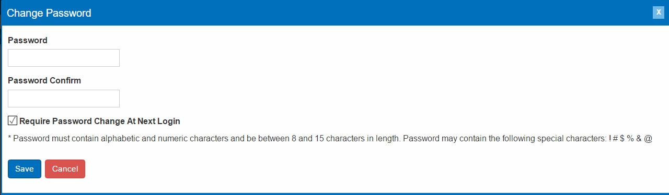
5. If the user has tried and failed to log on multiple times, you as the System Administrator can clear the failed attempts from the account by clicking on the Clear Failed Logins.
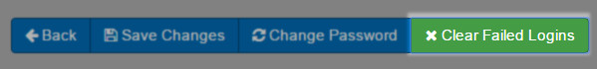

6. Within the user profile, you can edit the user's AKA Name, Email Address, Phone Number and Cell Number.
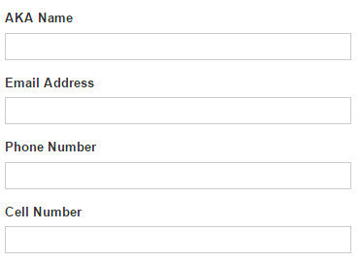
7. Check mark Receive Agile Communications if this user has permissions to receive emails pertaining to Agile and the Software Updates.
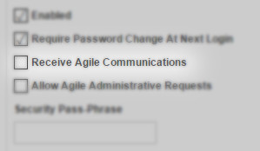
8. Check mark Allow Agile Administrative Requests if this person can make administrative decisions for our organization.
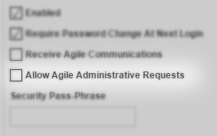

9. Entering in a Security Phrase allows the Agile Client Support staff to authenticate that they are the user and have permissions to make changes to that account.
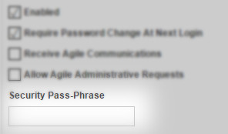
10.Within the customer profile, an Administrator has the ability to change the Security Role of a User. This will change the permissions of the user within the entire Agile Ticketing Solutions system.
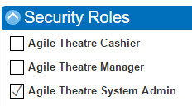

11. Once you have made all of your changes click on Save Changes

