Templates allow you to create basic venue, inventory and pricing information that can be used repeatedly and quickly build Showings or Events using the pre-built information in the template.
- Log into the Web Portal. portal.agiletix.com
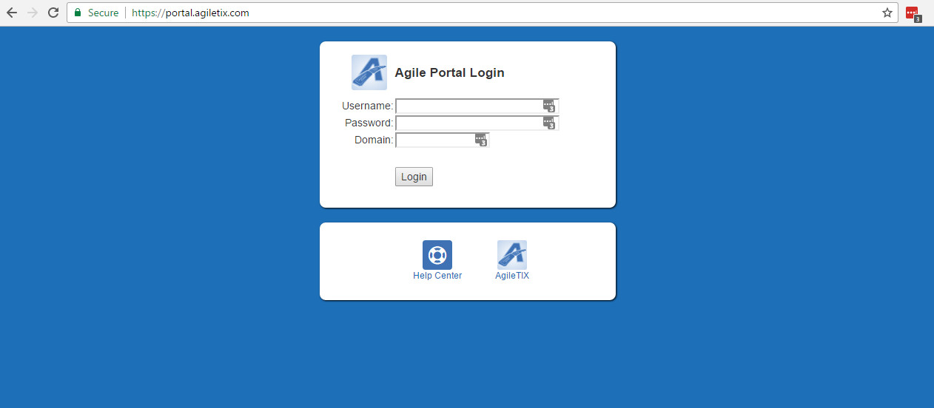
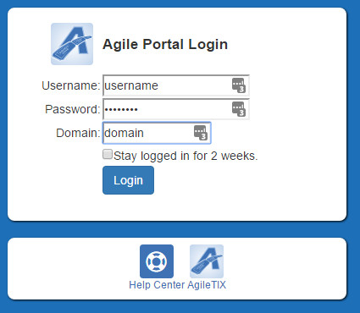
- Click on the Events on the menu to the left of the screen.
- Click on the Templates button.
- Click on the Templates+ button.
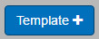
- Select the Folder that you wish to build the New Template in and then click on Continue.
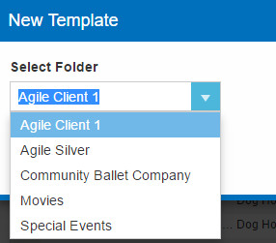
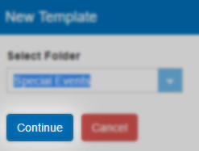
- In the Properties window enter in the Name of the Template and the Internal Name.
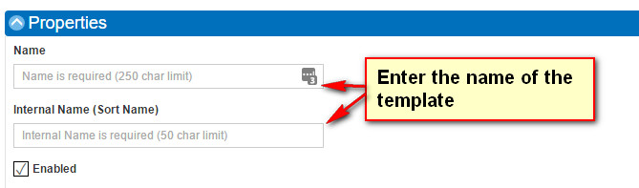
- Make sure that the Enabled box is checked.

- Next select what Type of Template you are building

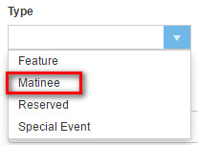

- Next select your Venue from the drop down menu OR click on the Add New Venue/Location button to add a new location. NOTE: When adding a new venue/location enter the Name of the venue and then fill out the address information. This information can be added to your tickets to let your customer know where your venue is located.
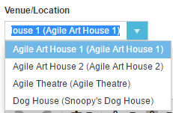
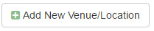
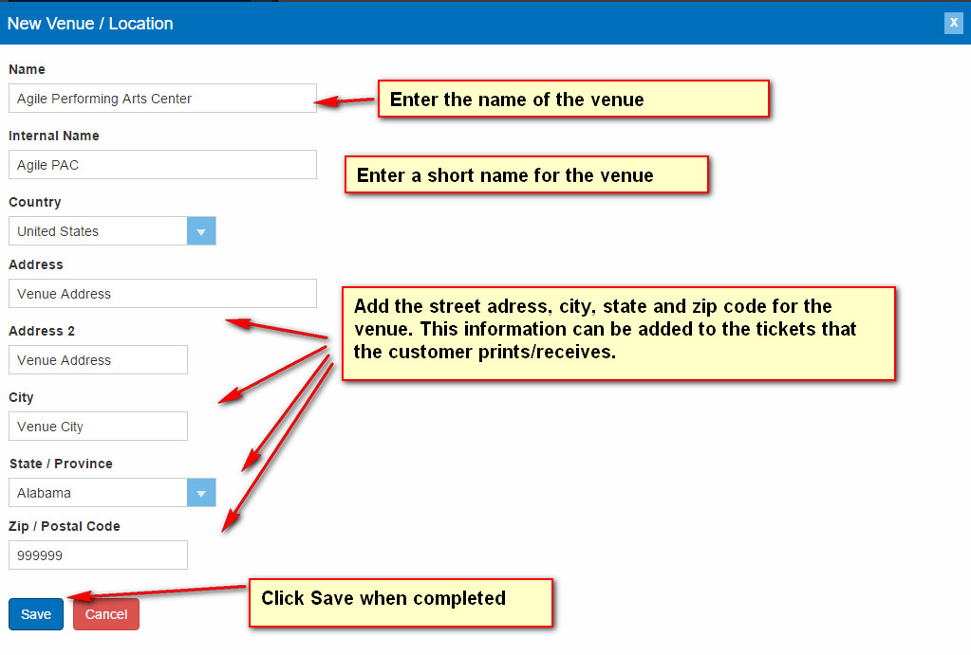
- Click the Save button to add your New Venue/Location.

- The Full Description and Brief Description can be filled out if the information is needed for every Event or Show that will use this Template. Leaving them blank in the Template will allow you to add the specific descriptions and information for each Event or Show that you will build. 12. Select the Available Delivery Methods that will be associated with this template. It will copy down to your Event/Shows. (You may choose more than one).

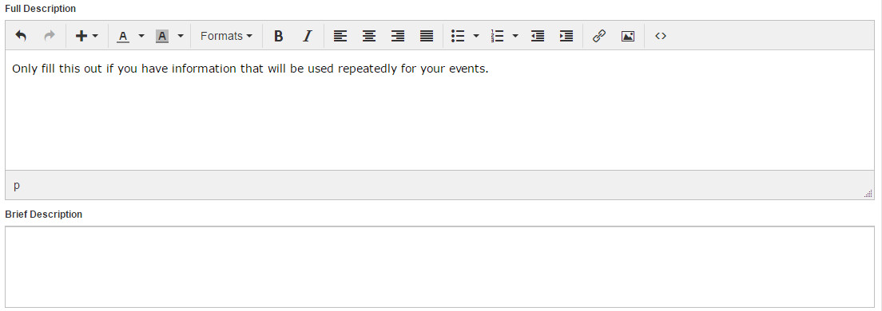

- Select the Available Delivery Methods that will be associated with this template. It will copy down to your Event/Shows. (You may choose more than one).
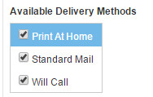
- Close the Properties area and then open the Pricing & Inventory Tiers section

- Open the Pricing & Inventory Tiers section and click on Add Pricing & Inventory Tier+ button.
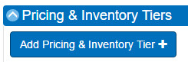

- Enter the Name of the Tier. (i.e. Admission, Floor, Balcony, Price Level 1, Price Level 2, etc.)
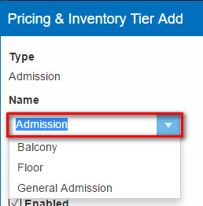
- Enter the Total Quantity that will be available for purchase in this Tier.
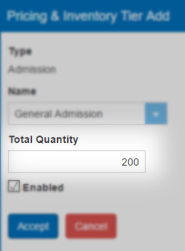
- Click the Accept button once you have completed adding your Inventory.
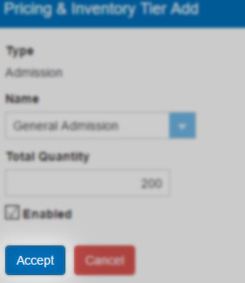

- Once you have created the Inventory, click the green Add Ticket Price button.
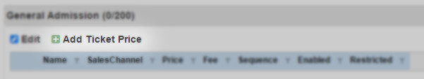
- Select your Ticket Type.
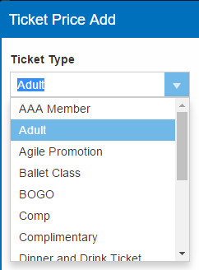
- Enter the Price for this Ticket Type.
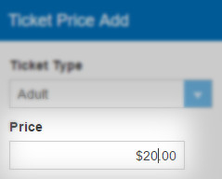
- Enter the Fee if any
- Once you have the price created choose a Sequence. The sequence will tell the system in what order you want the price to appear.

- Minimum and Maximum allows you to restrict the number of tickets that a customer can purchase per order. (i.e. a group price may have a minimum of 10 tickets per order).
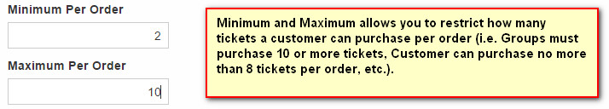

- Require Promotion Code allows you to assign a promotion code for a specific price that the customer will have to use to access the price.
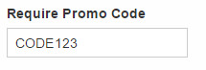
- Select the Ticket Format that the will either email to the customer or you will print at the box office.
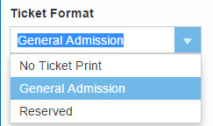
- Check the Restricted box if this price needs to be hidden from general public view.
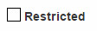
- Click Accept once you have completed adding your price(s).
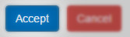
15. Once you have entered in your prices close the Pricing & Inventory Tiers section.
16. Since this is a Template, there is no need to add Media, Custom Properties, Include Shorts or Additional Information. These sections will only need to be added when building an actual Show or Event.
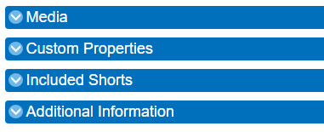
17. Click on the Save Changes button to save all of your information for the Template.
